Aiming for 9 – Spring 2020 practice paper
Instructions
- Use black ink or ball-point pen.
  - Fill in the boxes at the top of this page with your name,
centre number and candidate number.
- Answer all questions.
- Answer the questions in the spaces provided
– there may be more space than you need.
- You must show all your working.
- Diagrams are NOT accurately drawn, unless otherwise indicated.
- Calculators may be used.

Information
- The total mark for this paper is 80. There are 19 questions.
- Questions have been arranged in an ascending order of mean difficulty, as found by Grade 7 students in June and November examinations.
- The marks for each question are shown in brackets
– use this as a guide as to how much time to spend on each question.

Advice
- Read each question carefully before you start to answer it.
- Keep an eye on the time.
- Try to answer every question.
- Check your answers if you have time at the end.
Answer ALL questions.

Write your answers in the spaces provided.

You must write down all the stages in your working.

1 The straight line L has equation 3x + 2y = 17

The point A has coordinates (0, 2)
The straight line M is perpendicular to L and passes through A.

Line L crosses the y-axis at the point B.
Lines L and M intersect at the point C.

Work out the area of triangle ABC.
You must show all your working.

.......................................................
(Total for Question 1 is 5 marks)
___________________________________________________________________________
2 p and q are two numbers such that p > q
When you subtract 5 from p and subtract 5 from q the answers are in the ratio 5 : 1
When you add 20 to p and add 20 to q the answers are in the ratio 5 : 2
Find the ratio p : q
Give your answer in its simplest form.

..............................................................
(Total for Question 2 is 5 marks)
___________________________________________________________________________

3 The pie chart gives information about the ages, in years, of people living in two towns,
Adley and Bridford.

The ratio of the number of people living in Adley to the number of people living in
Bridford is given by the ratio of the areas of the pie charts.
What proportion of the total number of people living in these two towns live in Adley
and are aged 0 – 19?
Give your answer correct to 3 significant figures.

.....................................................
(Total for Question 3 is 3 marks)
___________________________________________________________________________

4 The points A, B, C and D lie in order on a straight line.
AB : BD = 1:5
AC : CD = 7:11
Work out AB : BC : CD

........................... : ........................... : ...........................
(Total for Question 4 is 3 marks)
___________________________________________________________________________

5 ABC and ADC are triangles.

The area of triangle ADC is 56 m²
Work out the length of AB.
Give your answer correct to 1 decimal place.

...................................................... m
(Total for Question 5 is 5 marks)
___________________________________________________________________________
6 The function f and g are such that
f(x) = 5x + 3 g(x) = ax + b where a and b are constants.
g(3) = 20 and f⁻¹(33) = g(1)
Find the value of a and the value of b.

a = ......................................................
b = ......................................................
(Total for Question 6 is 5 marks)
___________________________________________________________________________
7 The diagram shows triangle ABC.

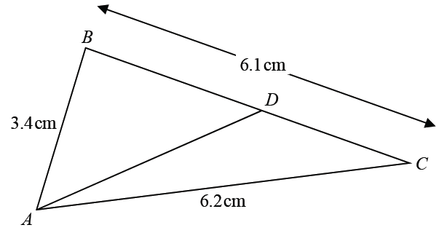

AB = 3.4 cm AC = 6.2 cm BC = 6.1 cm

D is the point on BC such that
size of angle DAC = × size of angle BCA

Calculate the length DC.

Give your answer correct to 3 significant figures.
You must show all your working.

.......................................................cm
(Total for Question 7 is 5 marks)
___________________________________________________________________________
8 50 people were asked if they speak French or German or Spanish.
Of these people,
31 speak French
2 speak French, German and Spanish
4 speak French and Spanish but not German
7 speak German and Spanish
8 do not speak any of the languages
all 10 people who speak German speak at least one other language
Two of the 50 people are chosen at random.
Work out the probability that they both only speak Spanish.

.......................................................
(Total for Question 8 is 5 marks)
___________________________________________________________________________
9 Cone A and cone B are mathematically similar.
The ratio of the volume of cone A to the volume of cone B is 27 : 8
The surface area of cone A is 297 cm²
Show that the surface area of cone B is 132 cm²

(Total for Question 9 is 3 marks)
___________________________________________________________________________
10 Prove algebraically that the straight line with equation x − 2y = 10 is a tangent to the
circle with equation x² + y² = 20

(Total for Question 10 is 5 marks)
___________________________________________________________________________
11 Marek has 9 cards.
There is a number on each card.

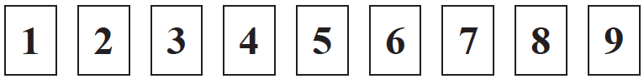

Marek takes at random two of the cards.
He works out the product of the numbers on the two cards.
Work out the probability that the product is an even number.

.......................................................
(Total for Question 11 is 3 marks)
___________________________________________________________________________

12 Sally used her calculator to work out the value of a number y.
The answer on her calculator display began
8.3
Complete the error interval for y.

............................ ≤ y < ............................
(Total for Question 12 is 2 marks)
___________________________________________________________________________

13 The diagram shows part of the graph of y = x² – 2x + 3

(a) By drawing a suitable straight line, use your graph to find estimates for the solutions
of x² – 3x – 1 = 0

............................................................................................................
(2)

P is the point on the graph of y = x² – 2x + 3 where x = 2
(b) Calculate an estimate for the gradient of the graph at the point P.

......................................................
(3)
(Total for Question 13 is 5 marks)
___________________________________________________________________________
14 Solve algebraically the simultaneous equations

x² − 4y² = 9
3x + 4y = 7

.....................................................................................................................................................
(Total for Question 14 is 5 marks)
___________________________________________________________________________
15

OAN, OMB and APB are straight lines.
AN = 2OA.
M is the midpoint of OB.
= a = b
= k where k is a scalar quantity.
Given that MPN is a straight line, find the value of k.

........................................................
(Total for Question 15 is 5 marks)
___________________________________________________________________________
16

ABCD is a parallelogram.
ABP and QDC are straight lines.
Angle ADP = angle CBQ = 90°
(a) Prove that triangle ADP is congruent to triangle CBQ.

(3)
(b) Explain why AQ is parallel to PC.

(2)
(Total for Question 16 is 5 marks)
___________________________________________________________________________
17 S is a geometric sequence.
(a) Given that 1 and are the first three terms of S, find the value of x.
You must show all your working.

......................................................
(3)
(b) Show that the 5th term of S is 7 +

(2)
(Total for Question 17 is 5 marks)
___________________________________________________________________________

18 Martin truncates the number N to 1 digit.
The result is 7
Write down the error interval for N.

..............................................................
(Total for Question 18 is 2 marks)
___________________________________________________________________________

19

A, B, R and P are four points on a circle with centre O.
A, O, R and C are four points on a different circle.
The two circles intersect at the points A and R.
CPA, CRB and AOB are straight lines.
Prove that angle CAB = angle ABC.

(Total for Question 19 is 4 marks)

TOTAL FOR PAPER IS 80 MARKS

BLANK PAGE

