Aiming for 9 – Spring 2020 practice paper
Instructions
- Use black ink or ball-point pen.
  - Fill in the boxes at the top of this page with your name,
centre number and candidate number.
- Answer all questions.
- Answer the questions in the spaces provided
– there may be more space than you need.
- You must show all your working.
- Diagrams are NOT accurately drawn, unless otherwise indicated.
- Calculators may be used.

Information
- The total mark for this paper is 80. There are 23 questions.
- Questions have been arranged in an ascending order of mean difficulty, as found by Grade 7 students in June and November examinations.
- The marks for each question are shown in brackets
– use this as a guide as to how much time to spend on each question.

Advice
- Read each question carefully before you start to answer it.
- Keep an eye on the time.
- Try to answer every question.
- Check your answers if you have time at the end.
Answer ALL questions.

Write your answers in the spaces provided.

You must write down all the stages in your working.

1 The equation of a curve is y = a^{x}
A is the point where the curve intersects the y-axis.
(a) State the coordinates of A.

( .......................... , ..........................)
(1)

The equation of circle C is x² + y² = 16
The circle C is translated by the vector to give circle B.
(b) Draw a sketch of circle B.
Label with coordinates
the centre of circle B
and any points of intersection with the x-axis.

(3)
(Total for Question 1 is 4 marks)
___________________________________________________________________________
2 Here is a speed-time graph for a train.

(a) Work out an estimate for the distance the train travelled in the first 20 seconds.
Use 4 strips of equal width.

...................................................... m
(3)
(b) Is your answer to (a) an underestimate or an overestimate of the actual distance the
train travelled?
Give a reason for your answer.
......................................................................................................................................................
......................................................................................................................................................(1)
(Total for Question 2 is 4 marks)
___________________________________________________________________________
3 At time t = 0 hours a tank is full of water.
Water leaks from the tank.
At the end of every hour there is 2% less water in the tank than at the start of the hour.
The volume of water, in litres, in the tank at time t hours is V_{t}
Given that
V₀ = 2000
V_{t + 1} = kV_{t}
write down the value of k.

k = ......................................................
(Total for Question 3 is 1 mark)
___________________________________________________________________________

4
OAC is a sector of a circle, centre O, radius 10 m.
BA is the tangent to the circle at point A.
BC is the tangent to the circle at point C.
Angle AOC = 120°
Calculate the area of the shaded region.
Give your answer correct to 3 significant figures.

......................................................m²
(Total for Question 4 is 5 marks)
___________________________________________________________________________
5 Sketch the graph of y = tan x° for 0 ≤ x ≤ 360

(Total for Question 5 is 2 marks)
___________________________________________________________________________

6 can be written as a single fraction in the form

where a and b are integers.

Work out the value of a and the value of b.

a = ......................................................

b = ......................................................
(Total for Question 6 is 4 marks)
___________________________________________________________________________

7

Work out the exact value of x.

......................................................
(Total for Question 7 is 3 marks)
___________________________________________________________________________

8 The distance-time graph shows information about part of a car journey.

Use the graph to estimate the speed of the car at time 5 seconds.

...................................................... m/s
(Total for Question 8 is 3 marks)
___________________________________________________________________________

9 Here are two similar solid shapes.

surface area of shape A : surface area of shape B = 3 : 4
The volume of shape B is 10 cm³
Work out the volume of shape A.
Give your answer correct to 3 significant figures.

....................................................... cm³
(Total for Question 9 is 3 marks)
___________________________________________________________________________
10 When a biased coin is thrown 4 times, the probability of getting 4 heads is
Work out the probability of getting 4 tails when the coin is thrown 4 times.

.......................................................
(Total for Question 10 is 2 marks)
___________________________________________________________________________
11 A, B, C and D are four points on the circumference of a circle.

AEC and BED are straight lines.
Prove that triangle ABE and triangle DCE are similar.
You must give reasons for each stage of your working.

(Total for Question 11 is 3 marks)
___________________________________________________________________________

12 The nth term of a sequence is 2n² − 1
The nth term of a different sequence is 40 − n²
Show that there is only one number that is in both of these sequences.

(Total for Question 12 is 3 marks)
___________________________________________________________________________
13

Triangle A is transformed by the combined transformation of a rotation of 180° about the
point (−2, 0) followed by a translation with vector $\left(\begin{matrix}−3 \\ 2\end{matrix}\right)$
One point on triangle A is invariant under the combined transformation.
Find the coordinates of this point.

(............................ , ............................)
(Total for Question 13 is 2 marks)
__________________________________________________________________________
14 Here are two right-angled triangles.

Given that
tan e = tan f
find the value of x.
You must show all your working.

.......................................................
(Total for Question 14 is 5 marks)
___________________________________________________________________________
15 The diagram shows 3 identical circles inside a rectangle.
Each circle touches the other two circles and the sides of the rectangle, as shown in
the diagram.

The radius of each circle is 24 mm.
Work out the area of the rectangle.
Give your answer correct to 3 significant figures.

...................................................... mm²
(Total for Question 15 is 4 marks)
___________________________________________________________________________

16 The diagram shows the positions of three towns, Acton (A), Barston (B) and Chorlton (C).

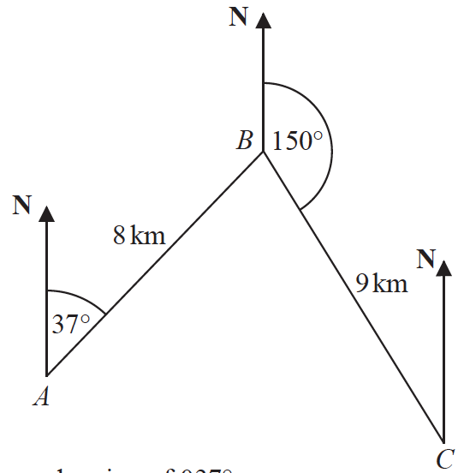


Barston is 8 km from Acton on a bearing of 037°
Chorlton is 9 km from Barston on a bearing of 150°
Find the bearing of Chorlton from Acton.
Give your answer correct to 1 decimal place.
You must show all your working.

.......................................................°
(Total for Question 16 is 5 marks)
___________________________________________________________________________
17 The diagram shows a parallelogram.

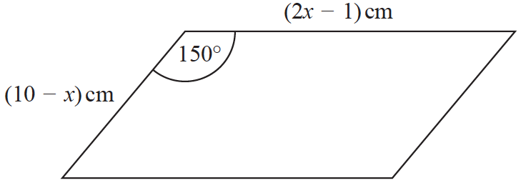

The area of the parallelogram is greater than 15 cm²
(a) Show that 2x² – 21x + 40 < 0

(3)
(b) Find the range of possible values of x.

.......................................................
(3)
(Total for Question 17 is 6 marks)
___________________________________________________________________________
18 The diagram shows a rectangle, ABDE, and two congruent triangles, AFE and BCD.

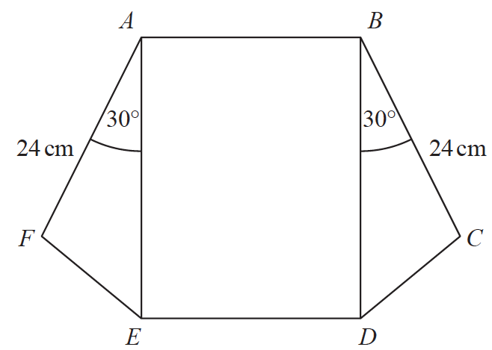

area of rectangle ABDE = area of triangle AFE + area of triangle BCD
AB : AE = 1 : 3
Work out the length of AE.

....................................................... cm
(Total for Question 18 is 4 marks)
___________________________________________________________________________

19 The diagram shows a circle, centre O.

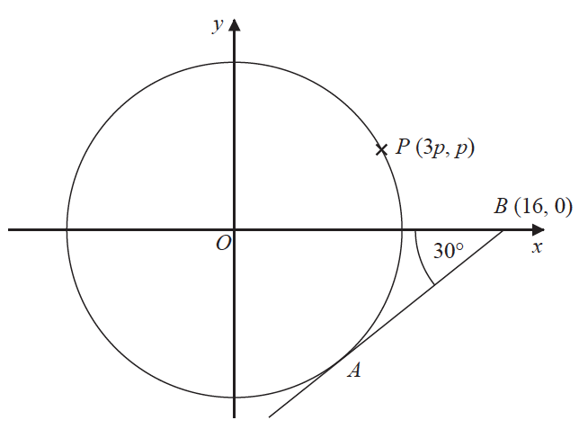

AB is the tangent to the circle at the point A.
Angle OBA = 30°
Point B has coordinates (16, 0)
Point P has coordinates (3p, p)
Find the value of p.
Give your answer correct to 1 decimal place.
You must show all your working.

p = .......................................................
(Total for Question 19 is 4 marks)
___________________________________________________________________________

20
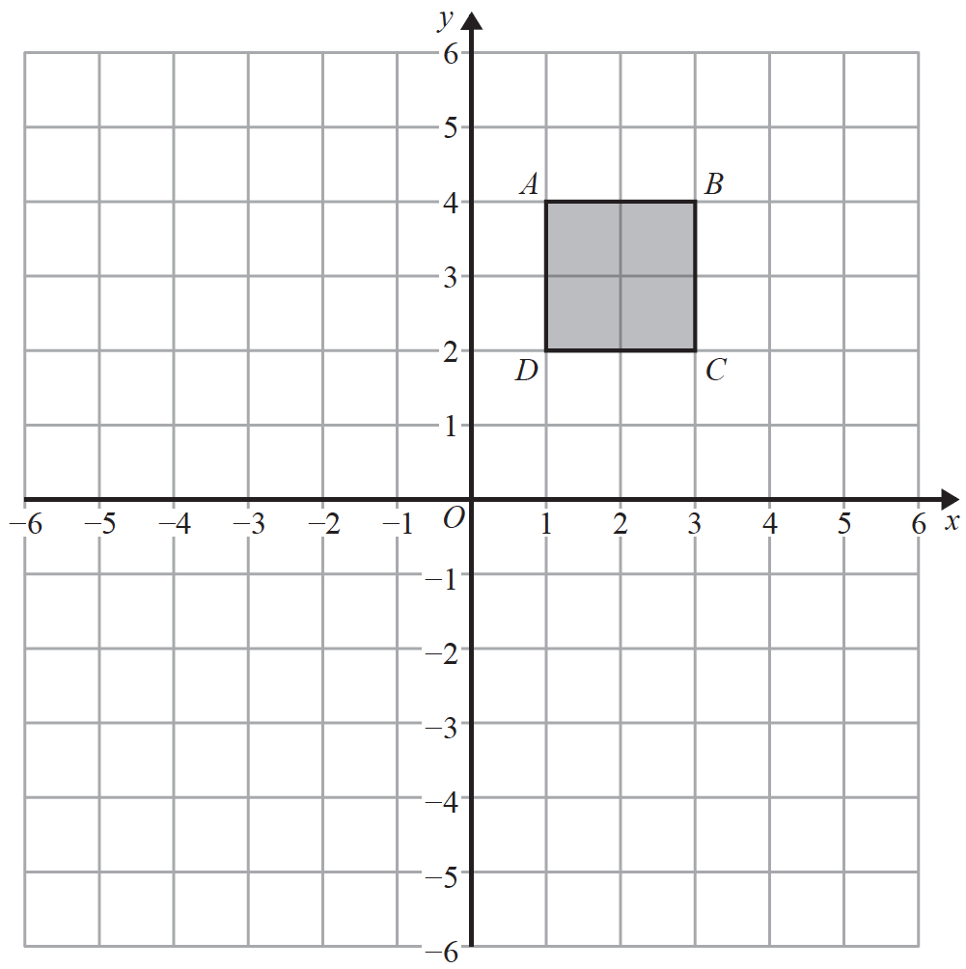

Square ABCD is transformed by a combined transformation of a reflection in the line x = −1
followed by a rotation.

Under the combined transformation, two vertices of the square ABCD are invariant.
Describe fully one possible rotation.

......................................................................................................................................................
(Total for Question 20 is 2 marks)
___________________________________________________________________________

21 L is the circle with equation x² + y² = 4
P $\left(\frac{3}{2}, \frac{\sqrt{7}}{2}\right)$ is a point on L.
Find an equation of the tangent to L at the point P.

......................................................
(Total for Question 21 is 3 marks)
___________________________________________________________________________
22
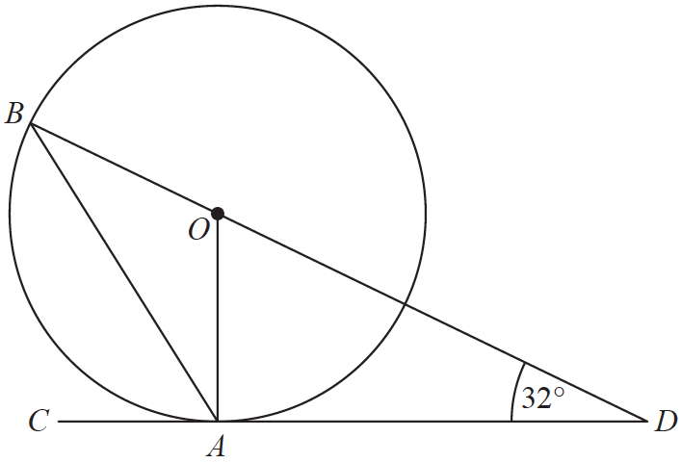

A and B are points on a circle with centre O.
CAD is the tangent to the circle at A.

BOD is a straight line.
Angle ODA = 32°

Work out the size of angle CAB.
You must show all your working.

.......................................................°
(Total for Question 22 is 3 marks)
___________________________________________________________________________
23

A, B and C are points on the circumference of a circle, centre O.
AOB is a diameter of the circle.
Prove that angle ACB is 90°
You must not use any circle theorems in your proof.

(Total for Question 23 is 4 marks)

TOTAL FOR PAPER IS 80 MARKS

