Aiming for 4
Autumn 2019 Practice Paper
Instructions
- Use black ink or ball-point pen.
  - Fill in the boxes at the top of this page with your name,
centre number and candidate number.
- Answer all questions.
- Answer the questions in the spaces provided
– there may be more space than you need.
- You must show all your working.
- Diagrams are NOT accurately drawn, unless otherwise indicated.
- Calculators may be used.
- If your calculator does not have a π button, take the value of π to be 3.142
unless the question instructs otherwise.
Information
- The total mark for this paper is 80. There are 44 questions.
- Questions have been arranged in an ascending order of mean difficulty, as found by all students in the June 2019 examinations.
- The marks for each question are shown in brackets
– use this as a guide as to how much time to spend on each question.
Advice
- Read each question carefully before you start to answer it.
- Keep an eye on the time.
- Try to answer every question.
- Check your answers if you have time at the end.

Answer ALL questions.

Write your answers in the spaces provided.

You must write down all the stages in your working.

1 Write a number in each box so that each calculation is correct.

(i) |  | + 357 = 486

(ii) |  | × 23 = 1840

(Total for Question 1 is 2 marks)
___________________________________________________________________________

2 The pictogram shows information about the number of vinyl records sold in a shop on
Monday and on Tuesday.

Monday |  |  | Key:  represents  8 vinyl records
Tuesday

Write down the number of vinyl records sold
(a) on Monday,

.......................................................
(1)
(b) on Tuesday.

.......................................................
(1)

(Total for Question 2 is 2 marks)
___________________________________________________________________________
3 The bar chart gives information about the area, in millions of hectares, of the land used in
five countries to grow rice.

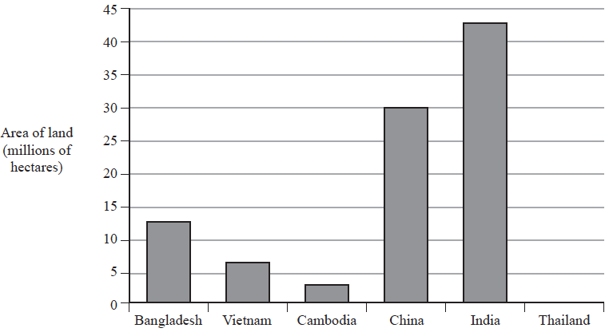

(a) In which of these five countries are 7 million hectares of land used to grow rice?

.......................................................
(1)
(b) How many millions of hectares of land are used to grow rice in China?

.................................................... millions of hectares
(1)

In Thailand 10 million hectares of land are used to grow rice.
(c) Draw a bar on the bar chart to show this information.
(1)
(Total for Question 3 is 3 marks)
___________________________________________________________________________

4 Write the following numbers in order of size.
Start with the smallest number.
–3 | 4 | 0 | –1 | 2

.............................................................................................................
(Total for Question 4 is 1 mark)
___________________________________________________________________________
5 Here is part of a train timetable.

Brighton | 07 22 | 07 29 | 07 32
London | 09 00 | 08 32 | 08 48

Graham gets to the station in Brighton at 07 15
Work out how many minutes he has to wait until 07 22

....................................................... minutes
(Total for Question 5 is 1 mark)
___________________________________________________________________________

6 Here are four cards.
Each card has a number on it.
The four cards are arranged to make the number 2745

Show how the cards can be arranged to make the smallest number using all four cards.

(Total for Question 6 is 1 mark)
___________________________________________________________________________

7 Write down two factors of 15

.......................................................
(Total for Question 7 is 1 mark)
___________________________________________________________________________
8 Dave goes into a cafe and buys 2 cups of coffee and a piece of cake.
Each cup of coffee costs £2.75
The cake costs £2.90
Dave pays with a £10 note.
He thinks he will get more than £1.50 in change.
Is Dave correct?
You must show how you get your answer.

(Total for Question 8 is 3 marks)
___________________________________________________________________________

9 The diagram shows a circle with centre O.
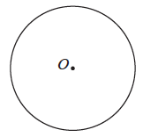

On the diagram, draw a radius of the circle.
(Total for Question 9 is 1 mark)
___________________________________________________________________________

10 Write 0.25 as a fraction.

.......................................................
(Total for Question 10 is 1 mark)
___________________________________________________________________________

11 Write as a percentage.

.......................................................%
(Total for Question 11 is 1 mark)
___________________________________________________________________________

12 Here is a number machine.

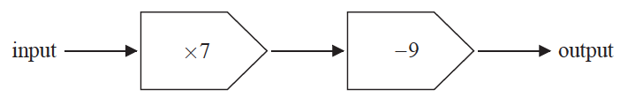

Work out the output when the input is 8

.......................................................
(Total for Question 12 is 1 mark)
___________________________________________________________________________

13 Work out 65% of 720

.......................................................
(Total for Question 13 is 2 marks)
___________________________________________________________________________

14 Write 0.72 as a fraction.
Give your fraction in its simplest form.

.......................................................
(Total for Question 14 is 2 marks)
___________________________________________________________________________

15 Solve x – 9 = 14

x = .......................................................
(Total for Question 15 is 1 mark)
___________________________________________________________________________

16 The table shows the temperature in each of five Canadian cities one day in January.

City | Temperature
Vancouver | 6 °C
Edmonton | −8 °C
Yellowknife | −23 °C
Quebec | −20 °C
Ottawa | −5 °C

(a) Work out the difference between the temperature in Vancouver and the temperature in
Edmonton.

....................................................°C
(1)

The temperature in Yellowknife is lower than the temperature in Ottawa.
(b) How much lower?

....................................................°C
(1)
(Total for Question 16 is 2 marks)
___________________________________________________________________________

17
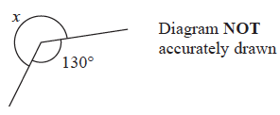

Work out the size of the angle marked x.

....................................................°
(Total for Question 17 is 1 mark)
___________________________________________________________________________

18 Simplify a × b × 7

.......................................................
(Total for Question 18 is 1 mark)
___________________________________________________________________________

19 A bag of 11 counters contains
3 purple counters
2 orange counters
6 white counters
A counter is going to be taken at random from the bag.
Find the probability that the counter will be
(i) orange

.......................................................
(1)
(ii) not white

.......................................................
(1)
(iii) green

.......................................................
(1)
(Total for Question 19 is 3 marks)
___________________________________________________________________________

20 Four biased coins, A, B, C and D are thrown.
The probability that each coin will land on Heads is shown in the table.

Coin | Probability
A | 0.33
B | 0.033
C
D | 30%

Which coin is least likely to land on Heads?

.......................................................
(Total for Question 20 is 1 mark)
___________________________________________________________________________

21 Here are four cards.
Each card has a number on it.
The four cards are arranged to make the number 2745

Show how the cards can be arranged to make an even number using all four cards.

(Total for Question 21 is 1 mark)
___________________________________________________________________________

22 Here is a number machine.

Work out the input when the output is 82

.......................................................
(Total for Question 22 is 1 mark)
___________________________________________________________________________

23 The temperature in Quebec one day in January was –20 °C.

The temperature in Winnipeg was 8 °C greater than the temperature in Quebec.
Work out the temperature in Winnipeg.

....................................................°C
(Total for Question 23 is 1 mark)
___________________________________________________________________________

24 Simplify 3e + 7g + 5e – 4g

.......................................................
(Total for Question 24 is 2 marks)
___________________________________________________________________________

25 Here is a centimetre grid.
On the grid, draw a rectangle with a perimeter of 14 cm.

(Total for Question 25 is 2 marks)
___________________________________________________________________________
26 Bella buys
4 packets of sandwiches at £2.40 each packet
a bottle of water for £1.20
and 3 packets of crisps.
Bella pays with a £20 note.
She gets £5.75 change.
Each packet of crisps has the same price.
Work out the price of each packet of crisps.

£ .......................................................
(Total for Question 26 is 3 marks)
___________________________________________________________________________

27 Write the number two million in figures.

.......................................................
(Total for Question 27 is 1 mark)
___________________________________________________________________________

28 Here are three symbols.

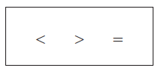

Write one of these symbols in each box to make four true statements.

14 |  |  |  | 21
4 + 7 |  |  |  | 103 − 92
2² |  |  |  | 2 × 2
−3 |  |  |  | −5

(Total for Question 28 is 2 marks)
___________________________________________________________________________

29 Here is part of a train timetable.

Ipswich | 07 22 | 07 29 | 07 32
London | 09 00 | 08 32 | 08 48

Work out how long it will take the 07 22 train to get to London.

.......................................................................................
(Total for Question 29 is 2 marks)
___________________________________________________________________________

30 P = 7r + 3q
Work out the value of P when r = 5 and q = –4

.......................................................
(Total for Question 30 is 2 marks)
___________________________________________________________________________

31 Simplify w⁵ × w⁷

.......................................................
(Total for Question 31 is 1 mark)
___________________________________________________________________________

32 Write 1.452 × 10³ as an ordinary number.

.......................................................
(Total for Question 32 is 1 mark)
___________________________________________________________________________

33 Write these numbers in order of size.
Start with the smallest number.

0.43 |  | 40.5% |  | 0.427

..............................................................................................................

(Total for Question 33 is 2 marks)
___________________________________________________________________________
34 (a) Simplify a + a + a + a

.......................................................
(1)
(b) Simplify t ⁹ ÷ t ³

.......................................................
(1)
(c) Simplify y × y × y

.......................................................
(1)
(Total for Question 34 is 3 marks)
___________________________________________________________________________

35 Machine A and machine B both make car parts.
Machine A makes 6 parts every 10 minutes.
Machine B makes 13 parts every 15 minutes.
On Monday
machine A makes parts for 12 hours
machine B makes parts for 10 hours
Work out the total number of parts made by the two machines on Monday.

.......................................................
(Total for Question 35 is 4 marks)
___________________________________________________________________________

36 Lorenzo increases all the prices on his restaurant menu by 8%
Before the increase, the price of a dessert was £4.25
Work out the price of the dessert after the increase.

£ .......................................................
(Total for Question 36 is 3 marks)
___________________________________________________________________________

37 On the grid, draw the graph of y = 2x – 3 for values of x from –1 to 5

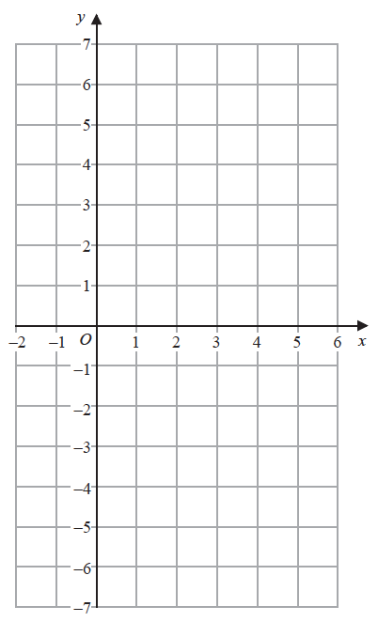

(Total for Question 37 is 3 marks)
___________________________________________________________________________

38 The diagram shows a circle with centre O.

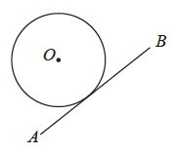

Write down the word from the box that describes the line AB.

sector | segment | tangent | chord | diameter

.......................................................
(Total for Question 38 is 1 mark)
___________________________________________________________________________

39 Find the highest common factor (HCF) of 21 and 35

.......................................................
(Total for Question 39 is 1 mark)
___________________________________________________________________________

40 Factorise 5y + 15

.......................................................
(Total for Question 40 is 1 mark)
___________________________________________________________________________

41 The diagram shows nine identical squares inside a rectangle.

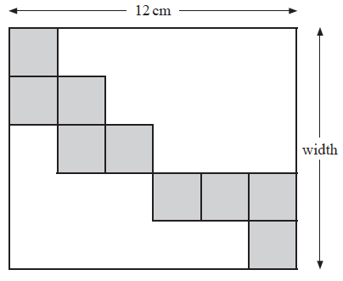

The length of the rectangle is 12 cm.
Work out the width of the rectangle.

.......................................................cm
(Total for Question 41 is 3 marks)
___________________________________________________________________________

42 Potatoes cost £2 per kg.
Carrots cost £3 per kg.
Alfred buys p kg of potatoes and c kg of carrots.
The total cost is £T.
Write down a formula for T in terms of p and c.

T = .......................................................
(Total for Question 42 is 3 marks)
___________________________________________________________________________

43 A garden is in the shape of a rectangle 90 m by 60 m.
Flowers are grown in 40% of the garden.
The rest of the garden is grass.
Work out the area of the garden that is grass.

.......................................................m²
(Total for Question 43 is 4 marks)
___________________________________________________________________________

44 Change 1756 grams to kilograms.

.......................................................kg
(Total for Question 44 is 1 mark)

TOTAL FOR PAPER IS 80 MARKS

