Aiming for 4
Autumn 2019 Practice Paper
Instructions
- Use black ink or ball-point pen.
  - Fill in the boxes at the top of this page with your name,
centre number and candidate number.
- Answer all questions.
- Answer the questions in the spaces provided
– there may be more space than you need.
- You must show all your working.
- Diagrams are NOT accurately drawn, unless otherwise indicated.
- Calculators may not be used.

Information
- The total mark for this paper is 80. There are 52 questions.
- Questions have been arranged in an ascending order of mean difficulty, as found by all students in the June 2019 examinations
- Questions marked with an asterisk (*) also appear on the Higher Tier paper.
- The marks for each question are shown in brackets
– use this as a guide as to how much time to spend on each question.

Advice
- Read each question carefully before you start to answer it.
- Keep an eye on the time.
- Try to answer every question.
- Check your answers if you have time at the end.
Answer ALL questions.

Write your answers in the spaces provided.

You must write down all the stages in your working.

1 The bar chart gives information about the population, in millions, of each of five cities.

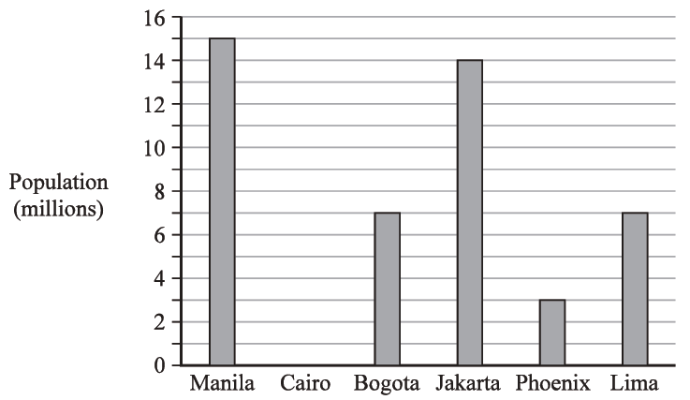

The populations of two cities are equal.
(a) Write down the names of these two cities.

............................................ and ............................................
(1)
(b) Write down the name of the city with a population of 15 million.

.......................................................
(1)
(Total for Question 1 is 2 marks)
___________________________________________________________________________

2 Write the number 6405 in words.

......................................................................................................................................................
(Total for Question 2 is 1 mark)
___________________________________________________________________________

3 Write these numbers in order.
Start with the smallest number.

3 | −8 | 1 | −5 | 0

.......................................................
(Total for Question 3 is 1 mark)
___________________________________________________________________________

4 In a game, a fair 3-sided spinner is spun once and a fair dice is rolled once.

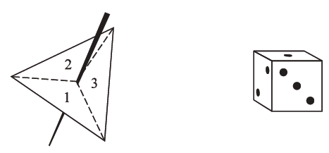

The spinner can land on 1, 2 or 3
The dice can land on 1, 2, 3, 4, 5 or 6
In the game, the score is found by multiplying the number the spinner lands on by the
number the dice lands on.
Complete the table to show all possible scores.
Eleven of the scores have been done for you.

 |  | Dice
 |  | 1 | 2 | 3 | 4 | 5 | 6
 | 1 | 1 | 2 | 3 | 4
Spinner | 2 |  | 4 |  | 8 | 10
 | 3 | 3 | 6 |  | 12 |  | 18

(Total for Question 4 is 2 marks)
___________________________________________________________________________

5 The table gives the surface areas, in square kilometres, of six lakes in Africa.

Lake | Surface area (square kilometres)
Albert | 5299
Malawi | 29 500
Mweru | 5120
Tanganyika | 32 600
Turkana | 6405
Victoria | 68 879

Which of these lakes has the least surface area?

.......................................................
(Total for Question 5 is 1 mark)
___________________________________________________________________________

6 Solve t + t + t = 12

t = .......................................................
(Total for Question 6 is 1 mark)
___________________________________________________________________________

7 Solve x – 2 = 6

x = .......................................................
(Total for Question 7 is 1 mark)
___________________________________________________________________________
8 Which one of these fractions is equivalent to ?

.......................................................
(Total for Question 8 is 1 mark)
___________________________________________________________________________

9 Write 180 minutes in hours.

....................................................... hours
(Total for Question 9 is 1 mark)
___________________________________________________________________________

10 In Adam’s garden, the flowers are only red or white or yellow or blue.
The chart shows the number of red flowers, the number of white flowers and the number
of yellow flowers.

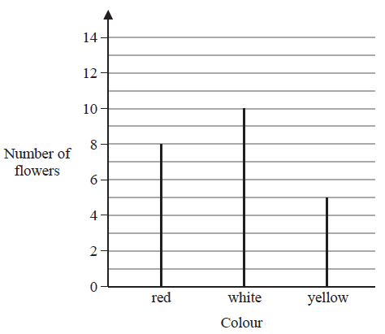

The total number of flowers is 30
Work out the number of blue flowers.

.......................................................
(Total for Question 10 is 2 marks)
___________________________________________________________________________

11 Write 0.73 as a percentage.

....................................................... %
(Total for Question 11 is 1 mark)
___________________________________________________________________________
12 Work out 10 × (3 + 5)

.......................................................
(Total for Question 12 is 1 mark)
___________________________________________________________________________

13 The diagram shows a fair 6-sided spinner.

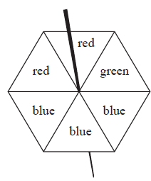

Rami is going to spin the spinner once.
Circle the word in the box below that best describes the likelihood that the spinner will land on green.

impossible | unlikely | evens | likely | certain

(Total for Question 13 is 1 mark)
___________________________________________________________________________

14 Find the number that is exactly halfway between 7 and 15

.......................................................
(Total for Question 14 is 1 mark)
___________________________________________________________________________
15 Here are the shoe sizes of 11 people.

7 | 8 | 4 | 4 | 4 | 10 | 5 | 7 | 7 | 4 | 4

Write down the mode.

.......................................................
(Total for Question 15 is 1 mark)
___________________________________________________________________________

16 Here is a sequence of patterns made from sticks.

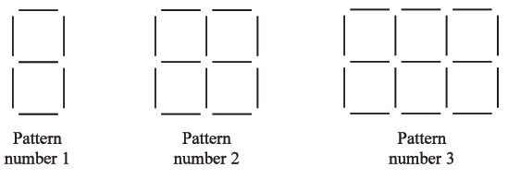

In the space below, draw Pattern number 4

(Total for Question 16 is 1 mark)
___________________________________________________________________________

17
 | 3 | 8 | 16 | 19 | 24 | 51 | 60 | 81

From the numbers in the box, write down an odd number

.......................................................
(Total for Question 17 is 1 mark)
___________________________________________________________________________
18 Harry is planning a holiday for 4 people for 7 days.
Here are the costs for the holiday for each person.
Travel £150
Hotel £50 for each day
Spending money £250
Work out the total cost of the holiday for 4 people for 7 days.

£.......................................................
(Total for Question 18 is 4 marks)
___________________________________________________________________________

19 Write as a percentage.

....................................................... %
(Total for Question 19 is 1 mark)
___________________________________________________________________________

20 Solve 6w + 2 = 20

w = .......................................................
(Total for Question 20 is 2 marks)
___________________________________________________________________________

21 There are only blue cubes, red cubes and yellow cubes in a box.
The table shows the probability of taking at random a blue cube from the box.

Colour | blue | red | yellow
Probability | 0.2

The number of red cubes in the box is the same as the number of yellow cubes in the box.
Complete the table.

(Total for Question 21 is 2 marks)
___________________________________________________________________________

22 Simplify 6e × 2f

.......................................................
(Total for Question 22 is 1 mark)
___________________________________________________________________________
23 Here are the shoe sizes of 11 people.

7 | 8 | 4 | 4 | 4 | 10 | 5 | 7 | 7 | 4 | 4

Work out the range.

.......................................................
(Total for Question 23 is 2 marks)
___________________________________________________________________________

24 Write 5.7 × 10⁶ as an ordinary number.

....................................................................
(Total for Question 24 is 1 mark)
___________________________________________________________________________

25 Here is a shape made of squares.
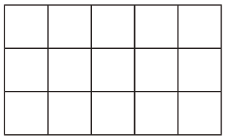
Shade of the shape.
(Total for Question 25 is 1 mark)
___________________________________________________________________________

26 Write the number 68 879 correct to the nearest thousand.

.......................................................
(Total for Question 26 is 1 mark)
___________________________________________________________________________

27 The diagram shows a fair 6-sided spinner.

Rami is going to spin the spinner once.
On the probability scale below, mark with a cross (×) the probability that the spinner
will land on blue.

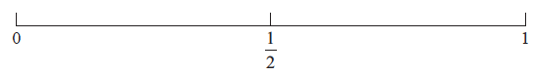

(Total for Question 27 is 1 mark)
___________________________________________________________________________

28 P = 2g + 3h
Work out the value of P when g = 7 and h = −4

.......................................................
(Total for Question 28 is 2 marks)
___________________________________________________________________________

29 Complete the following statement by writing a number on the dotted line.

1 kilometre = ....................................................... metres.
(Total for Question 29 is 1 mark)
___________________________________________________________________________

30 Simplify 5m + 7k − 2m + k

.......................................................
(Total for Question 30 is 2 marks)
___________________________________________________________________________

31 Solve 5y + 3 = 14

y = .......................................................
(Total for Question 31 is 2 marks)
___________________________________________________________________________

32 Write these fractions in order of size.
Start with the smallest fraction.

.....................................................................................................................................................
(Total for Question 32 is 2 marks)
___________________________________________________________________________

33 Write down the name of a polygon with 8 sides.

.......................................................
(Total for Question 33 is 1 mark)
___________________________________________________________________________

34 AB and BC are perpendicular lines.
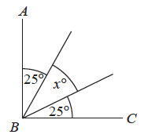
Find the value of x.

x = .......................................................
(Total for Question 34 is 2 marks)
___________________________________________________________________________

35 Deon needs 50 g of sugar to make 15 biscuits.
She also needs
three times as much flour as sugar
two times as much butter as sugar
Deon is going to make 60 biscuits.
Work out the amount of flour she needs.

....................................................... g
(Total for Question 35 is 3 marks)
___________________________________________________________________________

36 Here are the shoe sizes of 11 people.

7 | 8 | 4 | 4 | 4 | 10 | 5 | 7 | 7 | 4 | 4

Find the median.

.......................................................
(Total for Question 36 is 2 marks)
___________________________________________________________________________

37 The pictogram gives information about the number of emails Sami sent on each of five
days last week.

Monday
Tuesday
Wednesday
Thursday
Friday

represents 8 emails

Work out the mean number of emails Sami sent on these 5 days.

.......................................................
(Total for Question 37 is 4 marks)
___________________________________________________________________________
38 Write down the value of

.......................................................
(Total for Question 38 is 1 mark)
___________________________________________________________________________

39 Work out the value of 5³

.......................................................
(Total for Question 39 is 1 mark)
___________________________________________________________________________

40 Complete the following statement by writing a number on the dotted line.

A pentagon has ....................................................... sides.

(Total for Question 40 is 1 mark)
___________________________________________________________________________

41 In Mansfield, there are 90 badminton clubs and 60 football clubs.
Find the ratio of the number of badminton clubs to the number of football clubs.
Give your ratio in its simplest form.

.......................................................
(Total for Question 41 is 2 marks)
___________________________________________________________________________

42 Ruth left her home and walked to the library.
She got to the library at 10 30 am.
She stayed at the library for 50 minutes.
Then she walked home.
Ruth took 1 hours to walk home.
At what time did Ruth get home?

.......................................................
(Total for Question 42 is 2 marks)
___________________________________________________________________________

43 There are 40 students in a class.
Each student walks to school or cycles to school or gets the bus to school.
There are 22 girls in the class.
9 of the girls walk to school.
7 of the boys cycle to school.
6 of the 10 students who get the bus to school are boys.
Find the number of these students who walk to school.

.......................................................
(Total for Question 43 is 4 marks)
___________________________________________________________________________

44 Work out 74 × 58

.......................................................
(Total for Question 44 is 2 marks)
___________________________________________________________________________

45 Expand 5(2m – 3)

.......................................................
(Total for Question 45 is 1 mark)
___________________________________________________________________________

46 A, B and C are points on a circle, centre O.
AOC is a straight line.
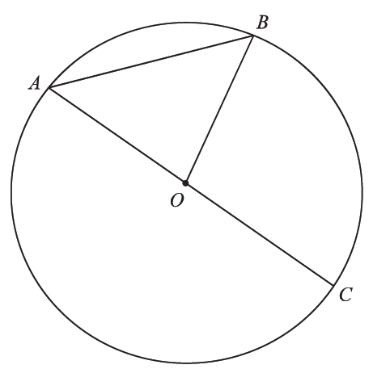
Write down the mathematical name for the line AC.

.......................................................
(Total for Question 46 is 1 mark)
___________________________________________________________________________

47 Work out of 70

.......................................................
(Total for Question 47 is 1 mark)
___________________________________________________________________________

48 Complete the following statement by writing a number on the dotted line.

The size of each angle in an equilateral triangle is ....................................................... °
(Total for Question 48 is 1 mark)
___________________________________________________________________________

49 Write these numbers in order of size.
Start with the smallest number.

2.5 | 2.85 | 2.082 | 2.28 | 2.805

.............................................................................................................
(Total for Question 49 is 1 mark)
___________________________________________________________________________

50 Simplify e⁹ ÷ e⁵

.......................................................
(Total for Question 50 is 1 mark)
___________________________________________________________________________

51 Write down a prime number that is between 20 and 30

.......................................................
(Total for Question 51 is 1 mark)
___________________________________________________________________________
52 On the grid, draw the graph of y = 3x − 1 for values of x from −2 to 3

(Total for Question 52 is 3 marks)

TOTAL FOR PAPER IS 80 MARKS

