A Level Psychology
Course Guide

UNIT | Exam Length | EXAM DETAILS (Examination board = AQA)
Paper 1 | 2 hours | You must answer a series of structured questions (which may include an essay) on:  - Social Influence  - Cognitive Psychology - Memory  - Developmental – Attachment  - Individual Differences – Psychopathology
Paper 2 | 2 hours | You must answer a series of structured questions (which may include an essay) on:  - Approaches in Psychology (25% OF PAPER)  - Biopsychology (25% OF PAPER)  - Research Methods (50% OF PAPER)
Paper 3 | 2 hours | You must answer a series of structured questions (which may include an essay) on:  - Issues and debates in Psychology  - Relationships  - Schizophrenia  - Aggression

Get to know the Exam Board’s website from day 1:
https://www.aqa.org.uk/subjects/psychology/as-and-a-level/psychology-7181-7182

Teaching staff: Ms McDermott, Ms Glanville, Ms Leigh and Ms Ximinies

Psychology Learning Journey at LPGS

Yr. 1:

 | Teacher 1 | Teacher 2
Autumn Term | Research methods  + Memory | Approaches  + Social Influence
Spring Term | Research methods  + Memory  Psychopathology | Social Influence  + Attachment
Summer Term | Psychopathology  + Y1 Biopsychology | Attachment + revision

Yr. 2:

 | Teacher 1 | Teacher 2
Autumn Term | Biopsychology + Issues and debates | Schizophrenia
Spring Term | Y2 RM + Aggression | Relationships
Summer Term | Aggression +  Exam Preparation | Exam Preparation

Key expectations:
- Keep your work organised
- Complete all classwork and homework to the best of your ability
- Begin revision work independently under guidance of your teachers from day one of the course (as you will learn in the memory module, retrieval practice is crucial for your exam success!)

Wider Reading is important to develop your literacy skills and enjoyable!
Suggested books:
- Inventing Ourselves: The Secret Life of the Teenage Brain (Dr Sarah-Jayne Blakemore)
- The Memory Illusion: Remembering, Forgetting, and the Science of False Memory (Dr Julia Shaw)
- The Chimp Paradox: The Mind Management Programme to Help You Achieve Success, Confidence and Happiness (Prof. Steve Peters)
- Attached: The New Science of Adult Attachment and How it Can Help You Find - and Keep - Love (Amire Levene & Rachel Heller)
- Mind Change: How digital technologies are leaving their mark on our brains (Dr Susan Greenfield ) ·
- Blueprint: How DNA Makes Us Who We Are (Dr Robert Plomin) ·
- Quiet: The Power of Introverts in a World That Can't Stop Talking (Susan Cain)
Suggested websites to find articles:
- Aeon: https://aeon.co/psychology
- BPS Research Digest: https://digest.bps.org.uk/
- Nautilus: https://nautil.us/
Tips for success on this course:
- Read beyond the class notes and textbook. There are a variety of psychology textbooks and magazines in the library and classrooms. Reading about the same topic/ content in a different book is a great way to consolidate your learning and helps you to better understand concepts we study.
- Make sure you know the specification – refer this in this very handbook frequently, tick off/ highlight each section covered, be familiar with the wording (as this is the basis of exam questions).
- Exam practice – use practice papers from the AQA website and Tutor2U’s excellent exam question help videos
https://www.aqa.org.uk/subjects/psychology/as-and-a-level/psychology-7181-7182
https://www.tutor2u.net/psychology
- Start revision early: The most successful students are those that start their revision early. The best way is to revise as you go. Regular retrieval practice is crucial to success.
- Do not plagiarise (i.e. copying other people’s work and passing it off as your own, or simply copy from your textbook when completing assignments). Firstly, this is cheating (if you do this at University you will be expelled), secondly it stops you learning (it may get you a good homework grade but when in the exam you will suddenly find yourself without a clue) and thirdly you will get caught (your teachers are savvy and can usually spot plagiarised work instantly).
- Read questions analytically – the wording of exam questions is not insignificant! Work out exactly what you are being asked to do and circle key words. This will help you to answer the question – refer back to it throughout the essay and at the end when you conclude.
- Make your answers psychological – try to write in an objective and informed manner.
- Quality not quantity – it is not about how much, it is about what you write! Tailoring what you write to the question being asked is crucial to success in the tight time constraints of the exam!
- Good time management – Spend a proportionate amount of time on each question, depending on how many marks it is worth.

Paper 1:
SPECIFICATION CONTENT

Paper 2:

Paper 3

PREPARING YOU FOR THE FUTURE ...
Each year, many students go on to study psychology at university. All degree courses cover the main areas of psychological knowledge, but will differ in the additional topics of study that they offer (depending on the specialisms of their staff). If you wish to study Psychology further, investigate your courses carefully, ensure that they are BPS accredited for GBR (Graduate Basis for Registration). This is essential if you think you might want to go on to post-graduate training to practice as a specialist psychologist in the future.

Staff in the department have lots of experience with helping students make excellent applications for some of the best psychology courses in the country!

The guardian website ranks Psychology courses and may be a useful place to start. In 2019, these were the rankings:

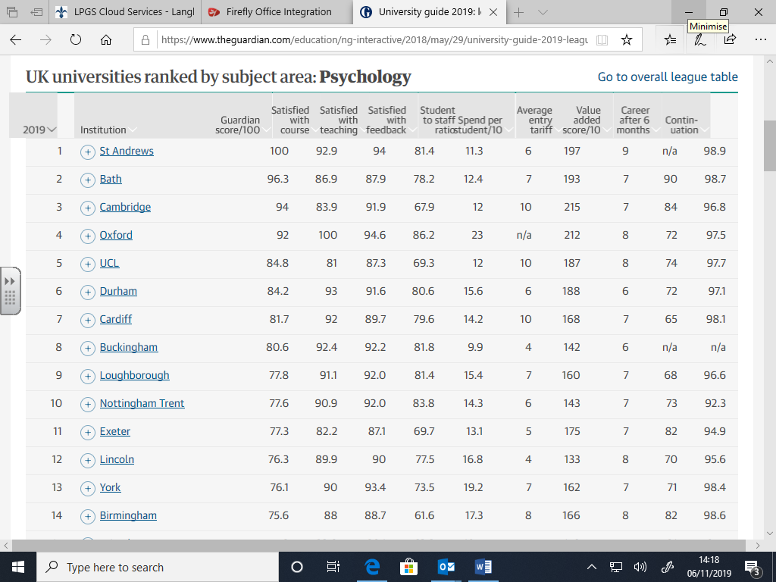

COMMITMENT TO LEARNING

- Attend all lessons. Should you miss any lessons it is your responsibility to catch up on both the missed lesson work and homework set before your next lesson. Ensure you contact someone in your class to ask them to collect sheets for you and make sure you copy up before the next lesson. You also need to make sure you are prepared to hand in any work that is expected next lesson or sit any tests that will be sat (not being in the previous lesson is not an excuse!).
- You are expected to be on time for lessons, if you are late it is courteous to apologise to your teacher and you may be kept behind after the lesson to catch up on the work missed.
- Once your assessment tasks have been marked and handed back you will be expected to respond to the teacher’s feedback – completing corrections and demonstrating where you have acted upon advice.
- Make sure that you arrive at lessons ready to learn, be prepared by always bring your exercise books and appropriate stationary/ equipment. It is your responsibility to keep your exercise book well organised.
- In class, you will both enhance your skills and enjoy the course more if you participate fully in group activities (listening and contributing), complete the individual tasks, challenge yourself to undertake extension activities and contribute to discussion.
- Outside of class you should consolidate your learning e.g. test your recall of key information (retrieval practice is crucial to success), look up key terms/ studies/ theories on the internet. You should also aim to do some wider reading to deepen your subject knowledge and enhance your literacy skills.

If you fail to make the expected progress on this course or fail to demonstrate the behaviours for learning we expect, you will be placed on psychology subject report for two weeks. It is expected that after two weeks, you will know and be well practiced in what is expected.

EXAM TERMS

AO1 - Knowledge and Understanding of scientific ideas, techniques, processes and procedures,

AO2 – Apply knowledge and understanding in theoretical and practical context, including when handling quantitative and qualitative data.

AO3 – Analyse, interpret and evaluate scientific ideas, information and evidence. Including in relation to issues and debates. Make judgements and reach conclusions. Be able to develop and refine practical design and procedures.

IAO1/2 Terms
Consider | Show knowledge and understanding of …
Define | Explain what is meant by …
Describe | Show knowledge of …
Examine | Give a detailed description of …
Explain | Show understanding of …
Outline/ state | Offer a brief description/ summary of …
Apply to/refer to (AO2) | Make reference to the scenario you have been given to show your understanding of…

AO3 Terms
Analyse/ Critically analyse | Show understanding through a consideration of different attributes of the research/ theories/ studies/ concepts.
Assess/ Critically Assess | Consider the strengths and weaknesses and come to a judgement
Critique | Evaluate in terms of strengths and weaknesses
Evaluate/ Critically evaluate | Come to an informed judgement of the value of the research/ theories/ studies/ concepts to the topic area
Compare and Contrast | Consider the similarities and the differences in the theories/research and the relative strengths and weaknesses
Critically consider | Show knowledge and understanding and discuss the strengths and weaknesses
Discuss | Describe and evaluate with reference to different points of view
ANALYSIS & EVALUATION CHECKLIST

Use the following checklist to help you evaluate studies and theories:
METHODS – key things to reflect on
Sample | Demand characteristics | Quantitative vs. Qualitative data
Research method | Generalisability | Ecological validity
Research tool | Location | Determinism
Realism | Controls | Reductionism

Ultimately, when we are evaluating a theory or explanation, we are deciding whether…

The theory is plausible (does it seem correct?) | The theory is valuable to society (is it helpful to society in some way?)

