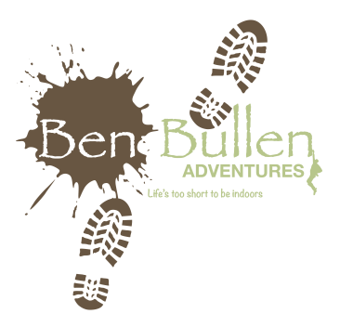
DofE Expedition Kit List

Group Kit:
- Tent (Provided – ours weigh 4.2kg)
- Trangia (Provided – ours weigh 900g)
- Gas (Provided – ours weigh 220g)
- Tin Foil (Optional but can be used to line pans and therefore save on washing-up)
- Food and drink – All food and drink is to be provided by the participant, we go through this in the training sessions.
- Map (Provided)
- Compass (Two per group – these can be bought fairly cheaply on line – check training notes)
- Mobile Phone (Two per group for emergencies only)
- Camera (optional)
- Washing Up Liquid and Metal Scouring Pad e.g. Brillo Pad
- T-Towel (2 for Bronze, 4 for Silver)
- 2 Different coloured sharpies.

Personal Kit
- Clothes (no jeans)
- Waterproof jacket
- Waterproof Trousers (optional)
- Warm jumper
- Strong shoes / walking boots (something supportive with a thick sole)
- Hat and Gloves
- Rucksack (provided but bring your own if you have one – minimum size 55 litres – ours weigh 2kg)
- Sleeping Bag
- Roll Mat
- Torch and spare batteries
- Packed lunches
- Dinner for evening meals and breakfasts
- Bin liners (for rubbish and for dirty clothes)
- Personal Medication (including paracetamol/Ibuprofen, hayfever tablets, plasters etc.)
- Sweets
- Cutlery
- Plate (optional – could use Trangia pans)
- Cup
- Bowl (optional)
- 2 litres of drink for during walk (preferably squash or water – not a fizzy drink)
- Sun cream
- Hand Cleansing gel
- Matches
- If we’re expecting wet weather you may want to put your sleeping bag in a bin liner/rubble sack and clothes in ziplock bags – spread clothes between bags so they go into small spaces in rucksack.

