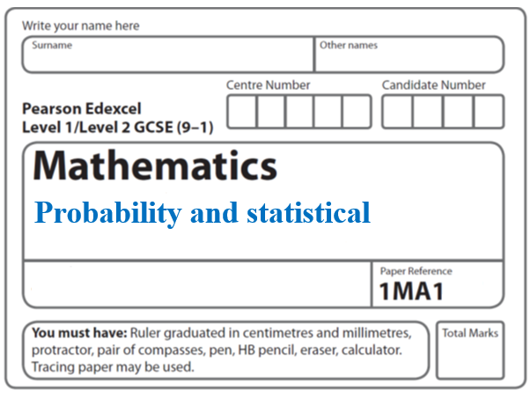**Instructions**

**Probability and Statistical diagrams**

* Use **black** ink or ball-point pen.
  + **Fill in the boxes** at the top of this page with your name,  
    centre number and candidate number.
* Answer **all** questions.
* Answer the questions in the spaces provided  
  *– there may be more space than you need.*
* You must **show all your working.**
* Diagrams are **NOT** accurately drawn, unless otherwise indicated.
* If your calculator does not have a *π* button, take the value of *π* to be3.142

unless the question instructs otherwise.

**Information**

* The total mark for this paper is **41**. There are **9** questions.
* Questions have been arranged in an ascending order of mean difficulty, as found by all students in the June 2017–November 2019 examinations.
* The marks for **each** question are shown in brackets  
  *– use this as a guide as to how much time to spend on each question.*

**Advice**

* Read each question carefully before you start to answer it.
* Keep an eye on the time.
* Try to answer every question.
* Check your answers if you have time at the end.

**1** A darts team is going to play a match on Saturday and on Sunday.

The probability that the team will win on Saturday is 0.45

If they win on Saturday, the probability that they will win on Sunday is 0.67

If they do **not** win on Saturday, the probability that they will win on Sunday is 0.35

(*a*)Complete the probability tree diagram.



(**2**)

(*b*)Find the probability that the team will win exactly one of the two matches.

......................................................

(**3**)

(**Total for Question 1 is 5 marks**)

**___________________________________________________________________________**

**2** Mary travels to work by train every day.

The probability that her train will be late on any day is 0.15

(*a*)Complete the probability tree diagram for Thursday and Friday.

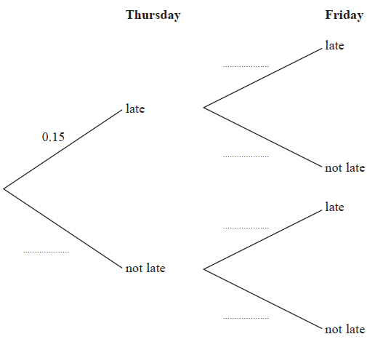

**(2)**

(*b*) Work out the probability that her train will be late on at least one of these two days.

.......................................................

**(3)**

**(Total for Question 2 is 5 marks)**

**___________________________________________________________________________**

**3** 60 people were asked if they prefer to go on holiday in Britain or in Spain or in Italy.

38 of the people were male.

11 of the 32 people who said Britain were female.

8 males said Italy.

12 people said Spain.

One of the females is chosen at random.

What is the probability that this female said Spain?

......................................................

(**Total for Question 3 is 4 marks**)

**___________________________________________________________________________**

**4** E = {1, 2, 3, 4, 5, 6, 7, 8, 9}

*A* = {1, 5, 6, 8, 9}

*B* = {2, 6, 9}

|  |  |
| --- | --- |
| E |  |
|  |  |

(*a*)Complete the Venn diagram to represent this information.

**(3)**

A number is chosen at random from the universal set E.

(*b*)Find the probability that the number is in the set *A*  *B*

.......................................................

**(2)**

**(Total for Question 4 is 5 marks)**

**___________________________________________________________________________**

**5 E** = {odd numbers less than 30}

*A* = {3, 9, 15, 21, 27}

*B* = {5, 15, 25}

(*a*)Complete the Venn diagram to represent this information.



**(4)**

A number is chosen at random from the universal set, **E**.

(*b*)What is the probability that the number is in the set *A*  *B*?

.......................................................

**(2)**

**(Total for Question 5 is 6 marks)**

**___________________________________________________________________________**

**6** E= {even numbers between 1 and 25}

*A* = {2, 8, 10, 14}

*B* = {6, 8, 20}

*C* = {8, 18, 20, 22}

(*a*)Complete the Venn diagram for this information.

|  |
| --- |
| E |

**(4)**

A number is chosen at random from E.

(*b*)Find the probability that the number is a member of *A*  *B*.

.......................................................

**(2)**

**(Total for Question 6 is 6 marks)**

**___________________________________________________________________________**

**7** There are 30 students in Mr Lear’s class.

16 of the students are boys.

Two students from the class are chosen at random.

Mr Lear draws this probability tree diagram for this information.



(*a*)Write down **one** thing that is wrong with the probabilities in the probability tree diagram.

......................................................................................................................................................

......................................................................................................................................................

**(1)**

Owen and Wasim play for the school football team.

The probability that Owen will score a goal in the next match is 0.4.

The probability that Wasim will score a goal in the next match is 0.25.

Mr Slater says,

“The probability that both boys will score a goal in the next match is 0.4 + 0.25”

(*b*)Is Mr Slater right?

Give a reason for your answer.

......................................................................................................................................................

......................................................................................................................................................

**(1)**

**(Total for Question 7 is 2 marks)**

**___________________________________________________________________________**

**8** The probability tree diagram shows the probabilities that Bismah will be late for work on

two days next week.

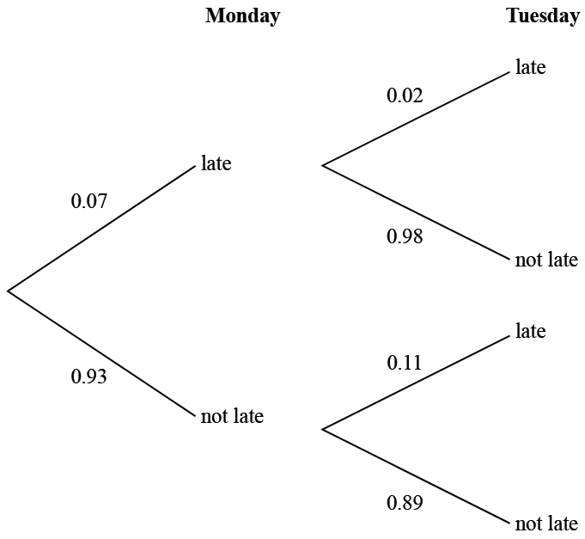

Calculate the probability that Bismah will be late on exactly one of the two days.

.......................................................

**(Total for Question 8 is 3 marks)**

**___________________________________________________________________________**

**9** 50 people were asked if they speak French or German or Spanish.

Of these people,

31 speak French

2 speak French, German and Spanish

4 speak French and Spanish but not German

7 speak German and Spanish

8 do not speak any of the languages

all 10 people who speak German speak at least one other language

Two of the 50 people are chosen at random.

Work out the probability that they both only speak Spanish.

.......................................................

(**Total for Question 9 is 5 marks**)

**___________________________________________________________________________**

**TOTAL MARKS FOR PAPER: 41**