**Week 3 and 4: Part 2**

**Activity 4**

**Unit 3 Health and Safety**

Hazards are things which have the potential to cause harm. We study the hazards identified in this table. You have one example, add two more to each box.

|  |  |  |
| --- | --- | --- |
| Hazard | Definition | Examples |
| Environmental | Things in the area around you that may not have been maintained well | Slipping on a wet floor in a care home bathroom |
| Biological | Natural waste products and bodily fluids that can spread infections | Vomit from a child in a nursery play area |
| Chemical | Where there is the potential for exposure to Chemicals such as cleaning agents and medication | An unlocked medicine trolley in a hospital |
| Psychological | Things which has the potential to harm a person’s mental health and well-being | Tiredness caused by high workload |
| Musculoskeletal | Things which have the potential to injure the musculoskeletal system and effect the body’s movement | Moving heavy people in and out of bed without the winch/equipment |
| Working conditions and practices | Conditions refer to the environment a person is expected to work in. Practices include policies that particular workplaces put into place | People working double shifts when there are staff shortages in a hospital |
| Lack of security systems | Equipment and strategies to prevent unauthorised access or harm to the individuals receiving care the settings themselves and the equipment/resources within them. | Faulty smoke alarms in a crèche |

**Activity 5**

Annotate the pictures below by identifying the hazards and where possible labelling which type of hazard it is.

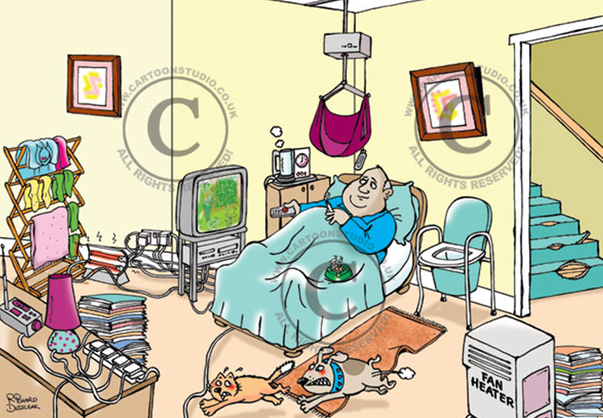

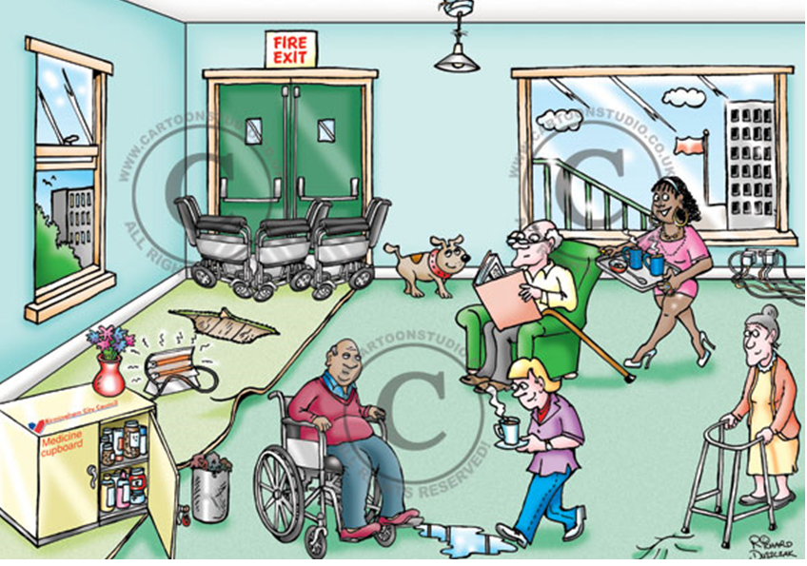

**Activity 6**

**Your environment**

Look around your environment and take pictures to create a college of potential hazards. *Challenge: categorise them and annotate ways in which these hazards are dealt with so that they do not cause harm.* 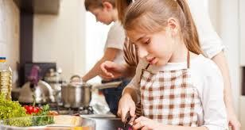

**Response to hazards**

Once a hazard has caused harm and someone has become ill or injured a 1st aider will be called upon. Using the following link give advice to a new 1st aider what they would do in the following situation. [www.sja.org.uk/get-advice/i-need-to-know/the-role-of-the-first-aider/](http://www.sja.org.uk/get-advice/i-need-to-know/the-role-of-the-first-aider/)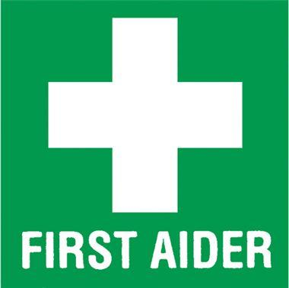

Three children in a care home were making a meal for themselves and their care worker without supervision. One of the children cut themselves severely with a knife while chopping vegetables. Their friend turned to look and in shock dropped a pan of hot water over themselves. When the 1st aider arrives what should they do?



**Part 3**

**Activity 7**

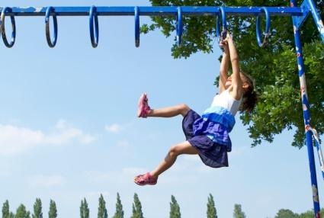

**Building Positive Relationships.** To deliver safe and effective care and support professionals must work together. This involves studying how these relationships are formed and maintained.

Maddie is a 6-year-old girl; she was playing with her friends in the park and attempted to complete the monkey bars by herself. She fell to the ground landing awkwardly; banging her head. She was initially knocked unconscious but now she has come round and is in a lot of pain and it looks like she has broken her leg.

Maddie is lucky because she lives in the United Kingdom where the welfare state will support her treatment and recovery. List the different types of services that will be available to Maddie as she recovers. Challenge; decide which ones are health care services, social care services or child care services. What do you notice about the number and variety of different services?

________________________________________________________________________________________________________________________________________________________________________________________________________________________________________________________________________________________________________________________________________________________________________________________________________________________________________________________________________________________________________________________________________________________________________________________________________________________________________________________________________________________________________________________________________________________________________________________________

**Activity 8**

These services must all work together. Fill in the diagram on the next page. Add a description of how someone from each category could support Maddie on her road to recovery. Challenge: annotate onto the diagram how and why it is important that they have a positive relationship with each other, to enable Maddie to receive the best care.





**Activity 9**

**B Communication skills**. When building positive relationships effective communication skills are vital. Explain what each of these skills involves.

|  |  |
| --- | --- |
| Skill | Definition |
| Tone and pitch |  |
| Pace |  |
| Eye contact |  |
| Facial expressions |  |
| Gestures |  |
| Volume |  |
| Posture |  |

Imagine you are a nursery nurse working with young children. You are going to perform for them a popular children’s rhyme or song such as incy wincy spider, twinkle twinkle little star, 5 little ducks or even Peter Rabbit had a fly upon his nose (it can be any of your choice.)

* Firstly perform the song / rhyme using no communication skills whatsoever.
* Next perform the song/rhyme using the skills you have defined in your table

What difference does using communication skills have on your performance? Why do you think it is so important for professional such as nursery nurses to use effective communication skills?

________________________________________________________________________________________________________________________________________________________________________________________________________________________________________________________________________________________________________________________________________________________________________________________________________________________________________________________________

**GP behind closed doors** 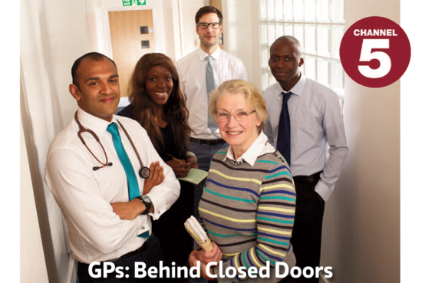

**Activity 10**

**www.my5.tv/gps-behind-closed-doors/season-3**

Watch an episode of this program and analyse the strategies the doctors use to build up positive relationships with their patients and deliver the best possible care. Challenge explain the impact of the strategies. Consider;

1. The verbal communication skills such as tone, pitch, pace, volume, choice of language/words
2. The non-verbal communication skills such as eye contact, facial expressions, gestures and posture
3. The management of environmental factors such as how they construct a supportive and positive environment

|  |  |  |
| --- | --- | --- |
| Category | Strategy | Impact |
| Verbal communication skills |  |  |
| Non-verbal communication skills |  |  |
| Environmental factors |  |  |

Why is it important for GPs to develop positive relationships with service users?