**GCSE Mathematics**

**Practice Tests: Set 7**

**Paper 3H (Calculator)**

**Time: 1 hour 30 minutes**

You should have: Ruler graduated in centimetres and millimetres, protractor, pair of compasses, pen, HB pencil, eraser, calculator. Tracing paper may be used.

**Instructions**

* Use **black** ink or ball-point pen.
* **Fill in the boxes** at the top of this page with your name,  
  centre number and candidate number.
* Answer **all** questions.
* Answer the questions in the spaces provided

– *there may be more space than you need*.

* **Calculators may be used.**
* Diagrams are NOT accurately drawn, unless otherwise indicated.
* You must **show all your working out.**

**Information**

* The total mark for this paper is 80
* The marks for **each** question are shown in brackets  
  – *use this as a guide as to how much time to spend on each question*.

**Advice**

* Read each question carefully before you start to answer it.
* Keep an eye on the time.
* Try to answer every question.
* Check your answers if you have time at the end.

**Answer ALL questions.**

**Write your answers in the spaces provided.**

**You must write down all the stages in your working.**

**1.** The diagram shows the position of a lighthouse L and a harbour H.

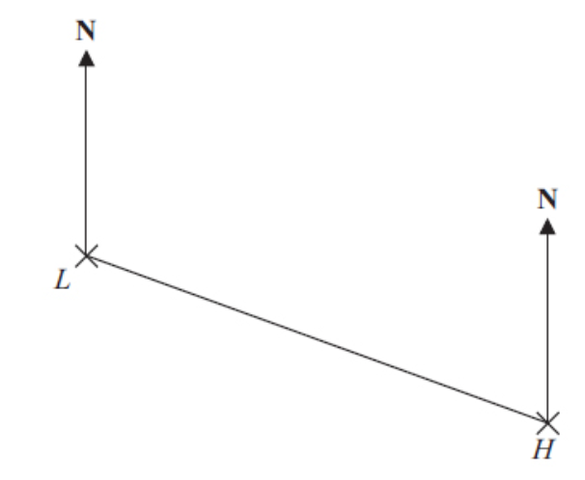

The scale of the diagram is 1 cm represents 5 km.

(a) Work out the real distance between L and H.

…………………………….. km

**(1)**

(b) Measure the bearing of H from L.

…………………………….. °

**(1)**

A boat B is 20 km from H on a bearing of 040°.

(c) On the diagram, mark the position of boat B with a cross (×).  
Label it B.

**(2)**

**(Total for Question 1 is 4 marks)**

**___________________________________________________________________________**

**2.** A mixture of sugar and salt is in the ratio 3 : 2

The weight of the mixture is 150 grams.

(a) Calculate the weight of sugar and the weight of salt in the mixture.

Sugar ……………………g

Salt …………………….g

**(3)**

30 grams of sugar and 10 grams of salt are added to the mixture.

(b) Calculate the ratio of sugar to salt in the new mixture.

………………………………….

**(2)**

**(Total for Question 2 is 5 marks)**

**___________________________________________________________________________**

**3.** *A* = 22 × 3 × 52

*B* = 23 × 5

(a)  Find the Highest Common Factor (HCF) of *A* and *B*.

...........................................................

**(1)**

(b)  Find the Lowest Common Multiple (LCM) of *A* and *B*.

...........................................................

**(2)**

**(Total for Question 3 is 3 marks)**

**___________________________________________________________________________**

**4.** Here are the ages, in years, of 15 women at West Ribble Tennis Club.

16,     18,     18,     20,     25,     25,     27,     28,     30,     35,     38,     42,     45,     46,    50

(a)   On the grid, draw a box plot for this information.

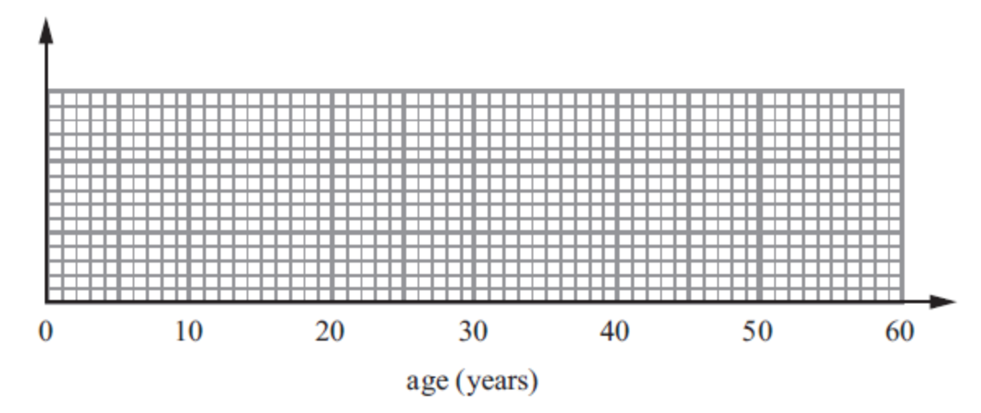

**(3)**

The box plot below shows the distribution of the ages of the men at West Ribble Tennis Club.

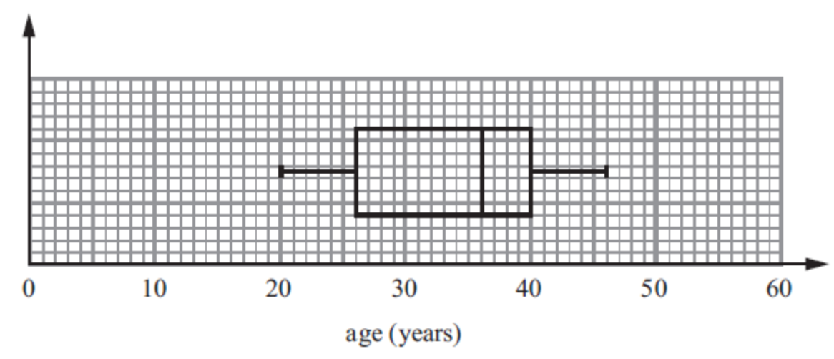

(b)   Use the box plots to compare the distributions of the ages of these women and the distributions of the ages of these men.

**(2)**

**(Total for Question 4 is 5 marks)**

**___________________________________________________________________________**

**5.**



Enlarge shape **S** with scale factor  and centre (1, 3).

**(Total for Question 5 is 2 marks)**

**___________________________________________________________________________**

**6.** Given that, for all values of *x*,

6*x*3 + 7*x*2 – 56*x* + 48 = (2*x*2 + *kx* – 12)(3*x* – 4), where *k* is a constant,

find the value of *k*.

*k* = .......................................................

**(Total for Question 6 is 2 marks)**

**___________________________________________________________________________**

**7.**



*A*, *B*, *C* and *D* are points on a circle.

*ABCD* is a square of side 7 cm.

Work out the total area of the shaded regions.

Give your answer correct to the nearest whole number.

......................................... cm2

**(Total for Question 7 is 5 marks)**

**___________________________________________________________________________**

**8.** Danielle invested £2800 for *n* years in a savings account.

She was paid 2.5% per annum compound interest.   
The interest is paid into the account at the end of each year.

At the end of *n* years, the amount of money in the savings account is greater than £3000 for the first time.

Work out the value of *n*.

…………………………….. .

**(Total for Question 8 is 3 marks)**

**___________________________________________________________________________**

**9.** *n* is an integer greater than 1

Prove algebraically that *n*2 − 2 − (*n* − 2)2 is always an even number.

**(Total for Question 9 is 2 marks)**

**___________________________________________________________________________**

**10.** Make *e* the subject of 

.......................................................

**(Total for Question 10 is 4 marks)**

**___________________________________________________________________________**

**11.** (a) Show that the equation  has a solution between *x* = 0 and *x* = 1

**(2)**

(b) Show that the equation  can be arranged to give 

**(1)**

(c) Starting with ****, use the iteration formula  twice,

to find an estimate for the solution of *x*3 + 4*x* = 1

.................................

**(3)**

**(Total for Question 11 is 6 marks)**

**___________________________________________________________________________**

**12.**

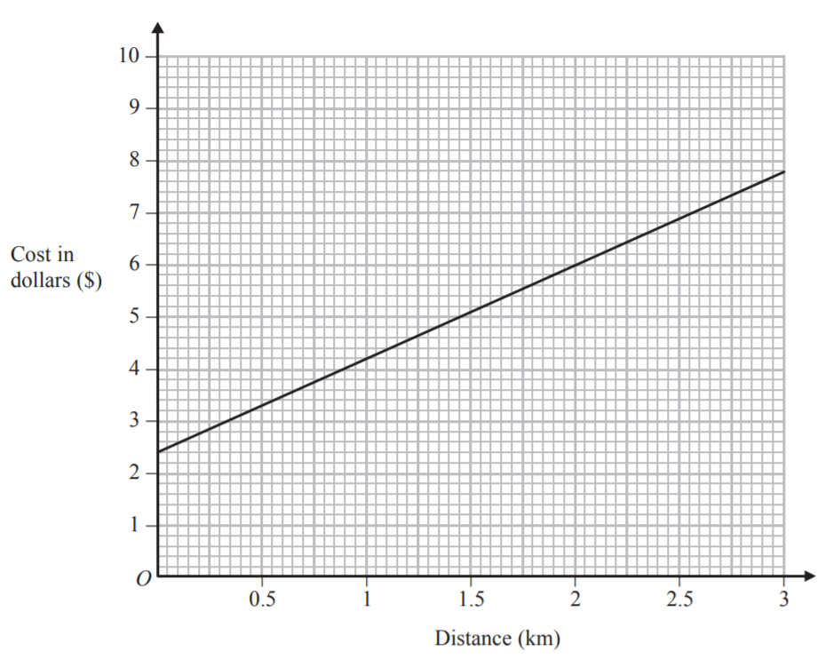

The graph gives information about the costs of taxi journeys of different distances.

The cost of a taxi journey consists of a fixed initial charge and a charge per km.

1. Give an interpretation of the intercept of the graph on the *y*-axis.

.............................................................

**(1)**

1. Give an interpretation of the gradient of the graph.

.............................................................

**(1)**

**(Total for Question 12 is 2 marks)**

**___________________________________________________________________________**

**13. ** 

(*a*)Express the inverse function f −1 in the form f −1(*x*) = ...

f −1(*x*) = .........................................

**(3)**

(*b*)Solve fg(*a*)= 1

You must show your working.

*a* = .........................................

**(3)**

**(Total for Question 13 is 6 marks)**

**___________________________________________________________________________**

**14.** Here is a solid bar made of metal.



The bar is in the shape of a cuboid.

The height of the bar is *h* cm.

The base of the bar is a square of side *d* cm.

The mass of the bar is *M* kg.

*d* = 8.3 correct to 1 decimal place.

*M* = 13.91 correct to 2 decimal places.

*h* = 84 correct to the nearest whole number.

Find the value of the density of the metal to an appropriate degree of accuracy.

Give your answer in g/cm3.

You must explain why your answer is to an appropriate degree of accuracy.

**(Total for Question 14 is 5 marks)**

**___________________________________________________________________________**

**15.** 60 apples are shared between Abbie, Betty and Carol in the ratios 1 : 3 : *x*, where *x* > 3.

The number of apples in Carol’s share is 18 more than the number of apples in Betty’s share.

Find the value of *x.*

*x* = .......................................................

**(Total for Question 15 is 4 marks)**

**__________________________________________________________________________**

**16.** Ali has two solid cones made from the same type of metal.

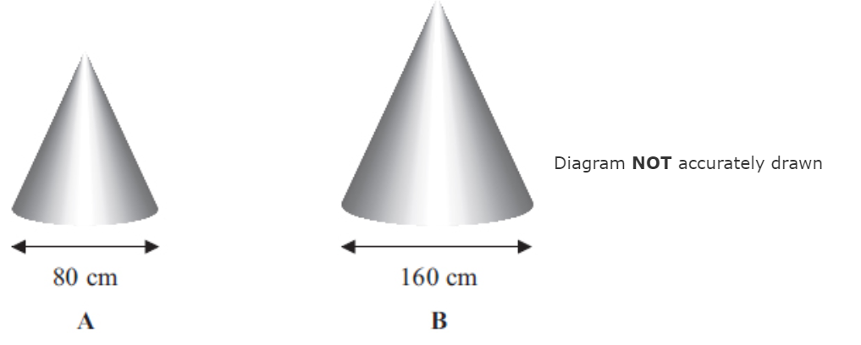  Diagram **NOT** accurately drawn

The two solid cones are mathematically similar.  
The base of cone **A** is a circle with diameter 80 cm.  
The base of cone **B** is a circle with diameter 160 cm.

Ali uses 80 m*l* of paint to paint cone **A**.  
Ali is going to paint cone **B**.

(a) Work out how much paint, in m*l*, he will need.

..……………………………… m*l*

**(2)**

The volume of cone **A** is 171 700 cm3.

(b) Work out the volume of cone **B**.

………………………………… cm3

**(3)**

**(Total for Question 16 is 5 marks)**

**__________________________­­­­­________________________________________________**

**17.**

**

*AB* is parallel to *DC*

*DC* = 2*AB*

*M* is the midpoint of *BC*

* =* 2**b**

* =* 4**a**

(*a*)Find **in terms of **a** and **b**.

Give your answer in its simplest form.

......................................................

**(2)**

*N* is the point such that *DCN* is a straight line and *DC* : *CN* = 2 : 1

(*b*)Show that *AMN* is a straight line.

**(2)**

**(Total for Question 17 is 4 marks)**

**___________________________________________________________________________**

**18.** In the diagram, *DAPS* and *CBQR* are straight lines.   
*AB* is parallel to *QP* and *DC* is parallel to *RS*.   
*AD* = 11 cm, *BC* = 5 cm, *PS* = 27.5 cm and *RS* = 42.5 cm.

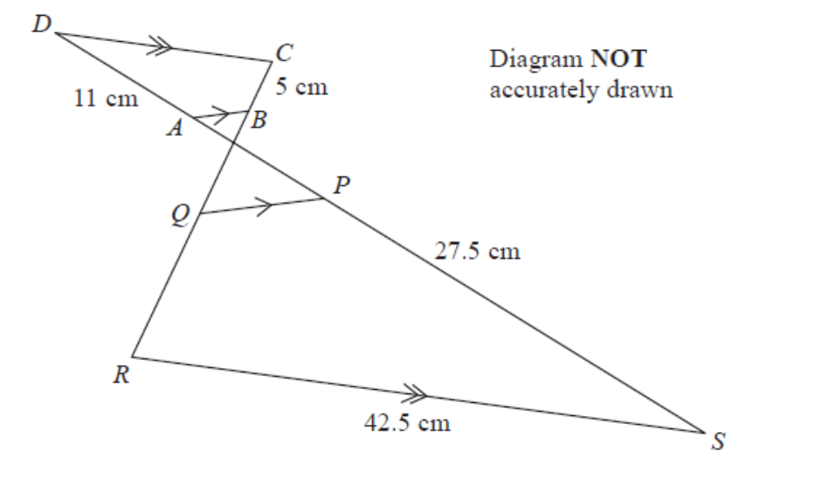

Quadrilateral *ABCD* is similar to quadrilateral *PQRS*.

(a)   Work out the length of *RQ*.

........................................................... cm

**(2)**

(b)   Work out the length of *CD*.

........................................................... cm

**(2)**

**(Total for Question 18 is 4 marks)**

**___________________________________________________________________________**

**19.** The diagram shows a solid hemisphere.

Surface area of a sphere = 4*π r* 2

Volume of a sphere = *π r* 3



The hemisphere has a **total** surface area of *π* cm2

The hemisphere has a volume of *kπ* cm3

Find the value of *k*.

.......................................................

**(Total for Question 19 is 4 marks)**

**___________________________________________________________________________**

**20.** *ABC* is a triangle.

**

*AC* = 8.4 m

Angle *ACB* = 40°

The area of the triangle = 100 m2.

Work out the length of *AB*.

Give your answer correct to 3 significant figures.

You must show all your working.

............................................. m

**(Total for Question 20 is 5 marks)**

**___________________________________________________________________________**

**TOTAL FOR PAPER IS 80 MARKS**

**BLANK PAGE**