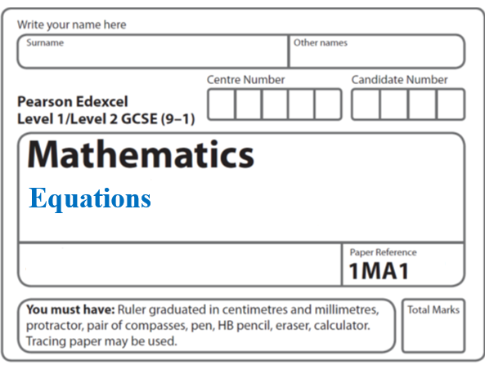**Instructions**

**Simultaneous equations**

* Use **black** ink or ball-point pen.
  + **Fill in the boxes** at the top of this page with your name,  
    centre number and candidate number.
* Answer **all** questions.
* Answer the questions in the spaces provided  
  *– there may be more space than you need.*
* You must **show all your working.**
* Diagrams are **NOT** accurately drawn, unless otherwise indicated.
* If your calculator does not have a *π* button, take the value of *π* to be3.142

unless the question instructs otherwise.

**Information**

* The total mark for this paper is **42**. There are **10** questions.
* Questions have been arranged in an ascending order of mean difficulty, as found by all students in the June 2017–November 2019 examinations.
* The marks for **each** question are shown in brackets  
  *– use this as a guide as to how much time to spend on each question.*

**Advice**

* Read each question carefully before you start to answer it.
* Keep an eye on the time.
* Try to answer every question.
* Check your answers if you have time at the end.

**1** Solve the simultaneous equations

3*x* + *y* = –4

3*x* – 4*y* = 6

*x* = .......................................................

*y* = .......................................................

**(Total for Question 1 is 3 marks)**

**___________________________________________________________________________**

**2** Solve the simultaneous equations

3*x* – 2*y* = –5

2*x* – 4*y* = 2

*x* = .......................................................

*y* = .......................................................

**(Total for Question 2 is 3 marks)**

**___________________________________________________________________________**

**3** Solve the simultaneous equations

5*x* + *y* = 21

*x* − 3*y* = 9

*x* = ......................................................

*y* = ......................................................

**(Total for Question 3 is 3 marks)**

**___________________________________________________________________________**

**4** Solve the simultaneous equations

2*x* + 3*y* = 6

7*x* – 2*y* = 1

*x* = .......................................................

*y* = .......................................................

**(Total for Question 4 is 4 marks)**

**___________________________________________________________________________**

**5** Solve the simultaneous equations

4*x* + 6*y* = 5

7*x* + 5*y* = –10.5

*x* = .......................................................

*y* = .......................................................

**(Total for Question 5 is 4 marks)**

**___________________________________________________________________________**

**6** Solve algebraically the simultaneous equations

*x*2 + *y*2 = 25

*y* – 3*x* = 13

..............................................................................

**(Total for Question 6 is 5 marks)**

**___________________________________________________________________________**

**7** Solve algebraically the simultaneous equations

*x*2 − 4*y*2 = 9

3*x* + 4*y* = 7

.....................................................................................................................................................

**(Total for Question 7 is 5 marks)**

**___________________________________________________________________________**

**8** Solve algebraically

*x*2 + *y*2 = 18

*x* − 2*y* = −3

.......................................................................................................................................

**(Total for Question 8 is 5 marks)**

**___________________________________________________________________________**

**9** Solve algebraically the simultaneous equations

2*x*2 − *y*2 = 17

*x* + 2*y* = 1

.............................................................................................................................................

**(Total for Question 9 is 5 marks)**

**___________________________________________________________________________**

**10** Solve algebraically the simultaneous equations

*y* = 2*x*2 – 3*x* – 10

2*x* – *y* = –2

..............................................................................................................

**(Total for Question 10 is 5 marks)**

**___________________________________________________________________________**

**TOTAL MARKS FOR PAPER: 42**