**GCSE Mathematics**

**Practice Tests: Set 14**

**Paper 2F/3F (Calculator)**

**Time: 1 hour 30 minutes**

You should have: Ruler graduated in centimetres and millimetres, protractor, pair of compasses, pen, HB pencil, eraser, calculator. Tracing paper may be used.

**Instructions**



* Use **black** ink or ball-point pen.
* **Fill in the boxes** at the top of this page with your name,  
  centre number and candidate number.
* Answer **all** questions.
* Answer the questions in the spaces provided

– *there may be more space than you need*.

* **Calculators may be used.**
* Diagrams are NOT accurately drawn, unless otherwise indicated.
* You must **show all your working out.**

**Information**

* The total mark for this paper is 80
* The marks for **each** question are shown in brackets  
  – *use this as a guide as to how much time to spend on each question*.

**Advice**

* Read each question carefully before you start to answer it.
* Keep an eye on the time.
* Try to answer every question.
* Check your answers if you have time at the end.

**Answer ALL questions.**

**Write your answers in the spaces provided.**

**You must write down all the stages in your working.**

**1** Solve 9*y* = 36

*y* = .......................................................

**(Total for Question 1 is 1 mark)**

**___________________________________________________________________________**

**2** Expand 4(3*g* + 1)

.......................................................

**(Total for Question 2 is 1 mark)**

**___________________________________________________________________________**

**3** Change 6500 grams into kilograms.

.......................................................kilograms

**(Total for Question 3 is 1 mark)**

**___________________________________________________________________________**

**4**Write these decimals in order of size.

Start with the smallest decimal.

|  |  |  |  |  |
| --- | --- | --- | --- | --- |
| 0.9 | 0.035 | 0.003 | 0.539 | 0.5 |

......................................................................................................................................................

**(Total for Question 4 is 1 mark)**

**___________________________________________________________________________**

**5**Factorise 25*f* – 10

.......................................................

**(Total for Question 5 is 1 mark)**

**___________________________________________________________________________**

**6**Work out 23% of 450 millilitres.

.......................................................millilitres

**(Total for Question 5 is 2 marks)**

**___________________________________________________________________________**

**7**Here are the first five terms of a number sequence.

|  |  |  |  |  |
| --- | --- | --- | --- | --- |
| 3 | 7 | 11 | 15 | 19 |

(*a*)Write down the next term of the sequence.

.......................................................

**(1)**

(*b*)Explain how you worked out your answer.

......................................................................................................................................................

**(1)**

(*c*)Find the first number greater than 70 that is in the sequence.

.......................................................

**(2)**

Ada says,

“96 is a number in the sequence”

(*d*)Is Ada correct?

You must give a reason for your answer.

......................................................................................................................................................

......................................................................................................................................................

**(Total for Question 7 is 5 marks)**

**___________________________________________________________________________**

**8**Lucas is going on a country walk.

Lucas works out how long each part of his walk will take.

This information is shown in the following table.

|  |  |
| --- | --- |
|  | **Time taken** |
| Walk from home to Village A | 20 minutes |
| Walk from Village A to Village B | 35 minutes |
| Stop for lunch in Village B | 1 hour 15 minutes |
| Walk from Village B to home | 30 minutes |

Lucas leaves home at 11 10

At what time will Lucas get home?

.......................................................

**(Total for Question 8 is 3 marks)**

**___________________________________________________________________________**

**9**Here is a list of ingredients needed to make apple crumble for 6 people.

|  |
| --- |
| **AppleCrumble** |
| Ingredients for 6 people |
| 12 apples |
| 150 g butter |
| 195 g flour |
| 90 g oats |
| 120 g sugar |

Nadiya wants to make apple crumble for 14 people.

(*a*) Work out the amount of butter she needs.

.......................................................g

**(2)**

Alison makes apple crumble for a group of people.

She uses 630 g of oats.

(*b*)Work out the number of people in the group.

.......................................................

**(2)**

**(Total for Question 9 is 4 marks)**

**___________________________________________________________________________**

**10** Matt buys a notebook and some pencils.

The notebook costs £2.35

Each pencil costs £0.74

Matt has a total of £20 to spend on the notebook and the pencils.

He buys the greatest number of pencils that he can.

Work out how many pencils he buys.

.......................................................

**(Total for Question 10 is 3 marks)**

**___________________________________________________________________________**

**11** There are 280 counters in a bag.

 of the counters are red.

 of the counters are yellow.

The rest of the counters are green.

Work out the number of green counters in the bag.

.......................................................

**(3)**

**(Total for Question 11 is 9 marks)**

**___________________________________________________________________________**

**12** Pavel asked 60 people at an airport where they came from.

All of the 60 people came from Europe or Africa or Asia.

9 people came from Africa.

14 females came from Europe.

3 males came from Africa.

16 of the 29 males came from Asia.

Using this information, complete the two-way table.

|  |  |  |  |  |
| --- | --- | --- | --- | --- |
|  | **Europe** | **Africa** | **Asia** | **Total** |
| **Male** |  |  |  |  |
| **Female** |  |  |  |  |
| **Total** |  |  |  |  |

**(Total for Question 12 is 4 marks)**

**___________________________________________________________________________**

**13** At a cake sale, Michael sells some lemon cakes and some chocolate cakes.

the number of lemon cakes he sells : the number of chocolate cakes he sells = 2 : 7

Michael sells a total of 162 cakes.

Work out the number of lemon cakes Michael sells.

.......................................................

**(Total for Question 13 is 2 marks)**

**___________________________________________________________________________**

**14**Below is a conversion graph to change between metres and feet.

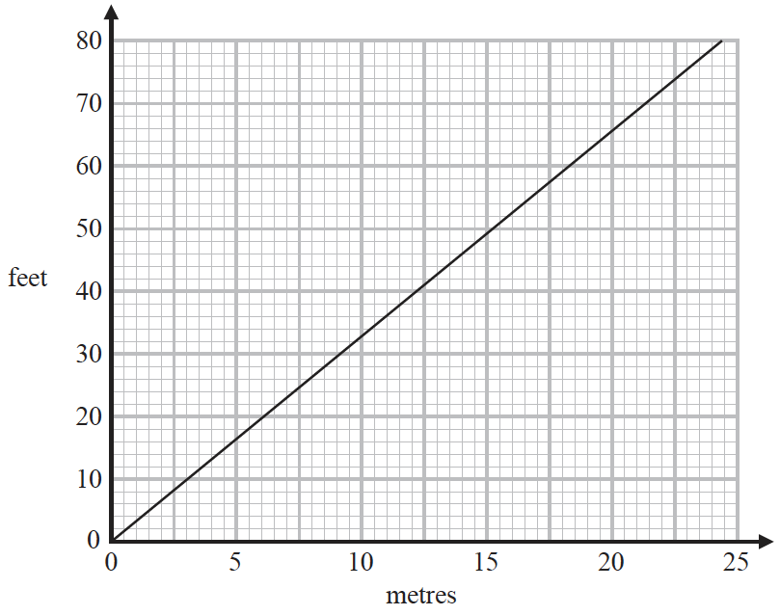

(*a*)Use the graph to change

(i)10 metres to feet,

.......................................................feet

(ii)50 feet to metres.

.......................................................metres

**(2)**

Joss lives 820 metres above sea level.

Nicky lives 2850 feet above sea level.

(*b*)Which is the greater, 820 metres or 2850 feet?

You must show how you get your answer.

**(2)**

**(Total for Question 14 is 4 marks)**

**___________________________________________________________________________**

**15** Himari’s annual salary is 3 130 000 Japanese Yen (JPY).

She gets a salary increase of 4%

(*a*)Work out Himari’s salary after this increase.

.......................................................JPY

**(3)**

Kaito bought a car.

The value of the car when Kaito bought it was 750 000 JPY.

At the end of each year, the value of his car had depreciated by 15%

(*b*) Work out the value of Kaito’s car at the end of 3 years.

Give your answer correct to the nearest JPY.

....................................................... JPY

**(3)**

**(Total for Question 15 is 6 marks)**

**___________________________________________________________________________**

**16**Hugo records the number of pairs of trainers sold in each of four shoe shops last Saturday.

He is going to draw a pie chart for his results.

The incomplete table shows two of Hugo’s results and the sizes of three of the angles in

his pie chart.

|  |  |  |
| --- | --- | --- |
| **Name of shop** | **Number of pairs of trainers** | **Angle in pie chart** |
| ABC Shoes | ............................................ | 30° |
| Kilian Stuart Sports | 18 | 45° |
| One Stop Shoes | 48 | ............................................° |
| Superfast Trainers | ............................................ | 165° |

Complete the table.

**(Total for Question 16 is 4 marks)**

**___________________________________________________________________________**

**17**The table shows information about the lengths of time, in minutes, 120 customers spent

in a supermarket.

|  |  |
| --- | --- |
| **Lengthoftime(*L* minutes)** | **Frequency** |
| 20 < *L* ≤ 30 | 6 |
| 30 < *L* ≤ 40 | 26 |
| 40 < *L* ≤ 50 | 31 |
| 50 < *L* ≤ 60 | 40 |
| 60 < *L* ≤ 70 | 17 |

(*a*)Write down the modal class.

.......................................................

**(1)**

(*b*)Work out an estimate for the mean length of time spent by the 120 customers in the

supermarket.

.......................................................minutes

**(4)**

**(Total for Question 17 is 5 marks)**

**___________________________________________________________________________**

**18**The diagram shows the plan of Sophia’s gym floor.



Sophia is going to paint all the gym floor.

Each tin of paint she is going to use covers an area of 20 m2

There is a special offer on the paint that Sophia is going to buy.

|  |
| --- |
| **Special Offer** |
| 1 tin for £13 |
| 4 tins for £40 |

Work out the least amount of money that Sophia has to pay in order to buy all the paint she needs.

Show your working clearly.

£ .......................................................

**(Total for Question 18 is 5 marks)**

**___________________________________________________________________________**

**19** Toy cars are made in a factory.

The toy cars are made for 15 hours each day.

5 toy cars are made every 12 seconds.

For the toy cars made each day, the probability of a toy car being faulty is 0.002

Work out an estimate of the number of faulty toy cars that are made each day.

.......................................................

**(Total for Question 19 is 4 marks)**

**___________________________________________________________________________**

**20**The diagram shows a right-angled triangle.

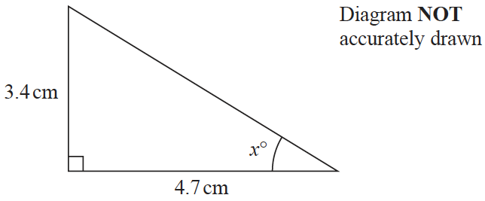

Calculate the value of *x*.

Give your answer correct to one decimal place.

*x* = .......................................................

**(Total for Question 20 is 3 marks)**

**___________________________________________________________________________**

**21** Gavin bought 3 pairs of jeans in the USA.

He paid a **total** of $72

Gavin sold the 3 pairs of jeans in England.

He sold each pair of jeans for £34.50

£1 = $1.34

Work out Gavin’s percentage profit.

Give your answer correct to the nearest whole number.

.......................................................%

**(Total for Question 21 is 4 marks)**

**___________________________________________________________________________**

**22** *p* = −6

*m* = −2

Work out the value of 2*p*2 + 3*m*

.......................................................

**(Total for Question 22 is 4 marks)**

**___________________________________________________________________________**

**23**

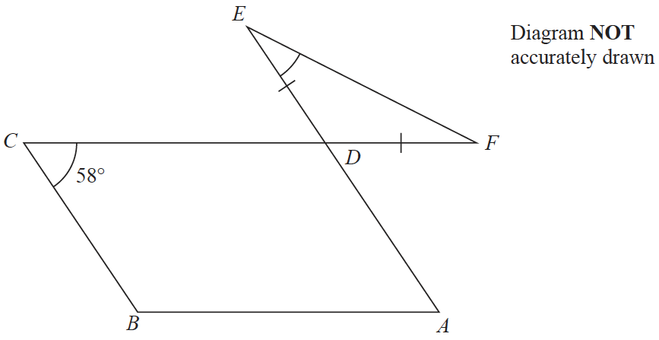

The diagram shows a parallelogram *ABCD* and an isosceles triangle *DEF* in which *DE* = *DF*

*CDF* and *ADE* are straight lines.

Angle *BCD* = 58°

Work out the size of angle *DEF*.

Give a reason for each stage of your working.

.......................................................°

**(Total for Question 23 is 5 marks)**

**___________________________________________________________________________**

**24** Here is a list of six numbers written in order of size.

|  |  |  |  |  |  |
| --- | --- | --- | --- | --- | --- |
| 4 | 7 | *x* | 10 | *y* | *y* |

The numbers have

a median of 9

a mean of 11

Find the value of *x* and the value of *y*.

*x* = .......................................................

*y* = .......................................................

**(Total for Question 24 is 4 marks)**

**___________________________________________________________________________**

**25** In a sale, normal prices are reduced by 20%

A designer handbag costs £1080 in the sale.

Work out the normal price of the bag.

£.......................................................

**(Total for Question 25 is 3 marks)**

**TOTAL FOR PAPER IS 80 MARKS**