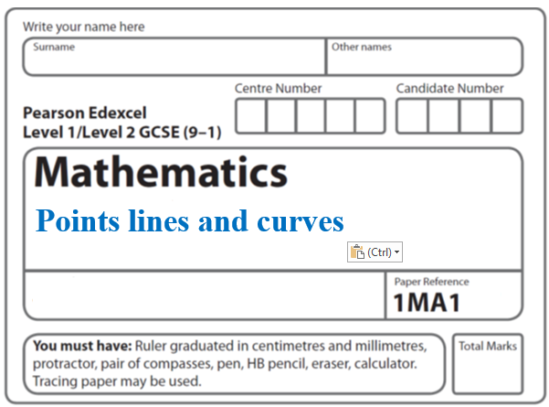**Instructions**

**Coordinate geometry_Circles**

* Use **black** ink or ball-point pen.
  + **Fill in the boxes** at the top of this page with your name,  
    centre number and candidate number.
* Answer **all** questions.
* Answer the questions in the spaces provided  
  *– there may be more space than you need.*
* You must **show all your working.**
* Diagrams are **NOT** accurately drawn, unless otherwise indicated.
* If your calculator does not have a *π* button, take the value of *π* to be3.142

unless the question instructs otherwise.

**Information**

* The total mark for this paper is **34**. There are **9** questions.
* Questions have been arranged in an ascending order of mean difficulty, as found by all students in the June 2017–November 2019 examinations.
* The marks for **each** question are shown in brackets  
  *– use this as a guide as to how much time to spend on each question.*

**Advice**

* Read each question carefully before you start to answer it.
* Keep an eye on the time.
* Try to answer every question.
* Check your answers if you have time at the end.

**1** (*a*)On the grid, draw the graph of *x*2 + *y*2 = 12.25

**

(**2**)

(*b*)Hence find estimates for the solutions of the simultaneous equations

*x*2 + *y*2 = 12.25

2*x* + *y* = 1

............................................................................................................

(**3**)

(**Total for Question 1 is 5 marks)**

**___________________________________________________________________________**

**2** The equation of a circle is *x*2 + *y*2 = 42.25

Find the radius of the circle.

..............................................................

**(Total for Question 2 is 1 mark)**

**___________________________________________________________________________**

**3** The equation of a curve is *y* = *ax*

*A* is the point where the curve intersects the *y*-axis.

(*a*)State the coordinates of *A*.

( .......................... , ..........................)

**(1)**

The equation of circle **C** is *x*2 + *y*2 = 16

The circle **C** is translated by the vector  to give circle **B**.

(*b*)Draw a sketch of circle **B**.

Label with coordinates

the centre of circle **B**

and any points of intersection with the *x*-axis.

**(3)**

**(Total for Question 3 is 4 marks)**

**4** The diagram shows a circle, centre *O*.

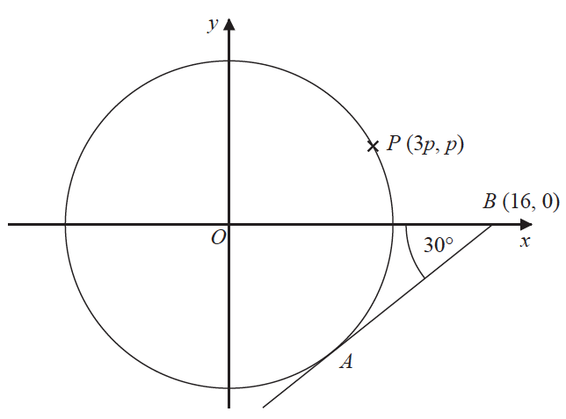

*AB* is the tangent to the circle at the point *A*.

Angle *OBA* = 30°

Point *B* has coordinates (16, 0)

Point *P* has coordinates (3*p*, *p*)

Find the value of *p*.

Give your answer correct to 1 decimal place.

You must show all your working.

*p* = .......................................................

**(Total for Question 4 is 4 marks)**

**___________________________________________________________________________**

**5** Here is a circle, centre *O*, and the tangent to the circle at the point *P*(4, 3) on the circle.



Find an equation of the tangent at the point *P*.

................................................................................

**(Total for Question 5 is 3 marks)**

**___________________________________________________________________________**

**6** Prove algebraically that the straight line with equation *x* − 2*y* = 10 is a tangent to the

circle with equation *x*2 + *y*2 = 20

**(Total for Question 6 is 5 marks)**

**___________________________________________________________________________**

**7**

**

The diagram shows the circle with equation *x*2 + *y*2 = 100

The unit of length on both axes is one centimetre.

The circle intersects the positive *y*-axis at the point *A*.

The point *C* on the circle has coordinates (6, −8)

The straight lines *AB* and *CB* are tangents to the circle.

Find the area of quadrilateral *ABCO*.

....................................................... cm2

**(Total for Question 7 is 4 marks)**

**___________________________________________________________________________**

**8** The line *l* is a tangent to the circle *x*2 + *y*2 = 40 at the point *A*.

*A* is the point (2, 6).

The line *l* crosses the *x*-axis at the point *P*.

Work out the area of triangle *OAP*.

.......................................................

**(Total for Question 8 is 5 marks)**

**___________________________________________________________________________**

**9 L** is the circle with equation *x*2 + *y*2 = 4

*P*  is a point on **L**.

Find an equation of the tangent to **L** at the point *P*.

......................................................

**(Total for Question 9 is 3 marks)**

**TOTAL FOR PAPER IS 34 MARKS**