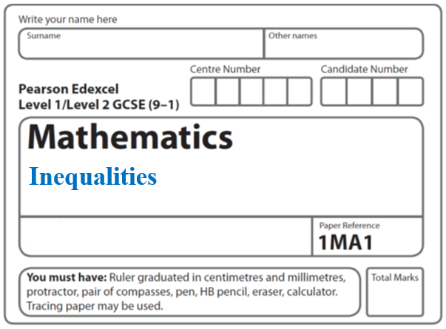

**Instructions**

* Use **black** ink or ball-point pen.
  + **Fill in the boxes** at the top of this page with your name,  
    centre number and candidate number.
* Answer **all** questions.
* Answer the questions in the spaces provided  
  *– there may be more space than you need.*
* You must **show all your working.**
* Diagrams are **NOT** accurately drawn, unless otherwise indicated.
* If your calculator does not have a *π* button, take the value of *π* to be3.142

unless the question instructs otherwise.

**Information**

* The total mark for this paper is **36**. There are **9** questions.
* Questions have been arranged in an ascending order of mean difficulty, as found by all students in the June 2017–November 2019 examinations.
* The marks for **each** question are shown in brackets  
  *– use this as a guide as to how much time to spend on each question.*

**Advice**

* Read each question carefully before you start to answer it.
* Keep an eye on the time.
* Try to answer every question.
* Check your answers if you have time at the end.

**1** (*a*)Solve 14*n* > 11*n* + 6

.......................................................

**(2)**

(*b*)On the number line below, show the set of values of *x* for which –2 < *x* + 3 ⩽ 4



**(3)**

**(Total for Question 1 is 5 marks)**

**___________________________________________________________________________**

**2** A number, *n*, is rounded to 2 decimal places.

The result is 4.76.

Using inequalities, write down the error interval for *n*.

............................................................................................................

**(Total for Question 2 is 2 marks)**

**___________________________________________________________________________**

**3**



Write down the three inequalities that define the shaded region.

.......................................................

.......................................................

.......................................................

**(Total for Question 3 is 4 marks)**

**___________________________________________________________________________**

**4** Solve 2*x*2 + 3*x* – 2 > 0

......................................................................................................

**(Total for Question 4 is 3 marks)**

**___________________________________________________________________________**

**5** Solve 2*x*2 – 5*x* – 12 > 0

.......................................................

**(Total for Question 5 is 3 marks) ___________________________________________________________________________**

**6** Solve the inequality 2*x*2 + *x* – 3 < 0

Represent the solution set on the number line.



**(Total for Question 6 is 4 marks)**

**___________________________________________________________________________**

**7** *n* is an integer such that 3*n* + 2 ⩽ 14 and  > 1

Find all the possible values of *n*.

.......................................................

(**Total for Question 7 is 5 marks**)

**___________________________________________________________________________**

**8** Solve 22 <  < 32

Show all your working.

.............................................................................................................

**(Total for Question 8 is 5 marks)**

**___________________________________________________________________________**

**9** Here is a rectangle and a right-angled triangle.



All measurements are in centimetres.

The area of the rectangle is greater than the area of the triangle.

Find the set of possible values of *x*.

.......................................................

**(Total for Question 9 is 5 marks)**

**TOTAL MARKS FOR PAPER: 36**