*Maths Emporium*

*Hannah’s Sweets*

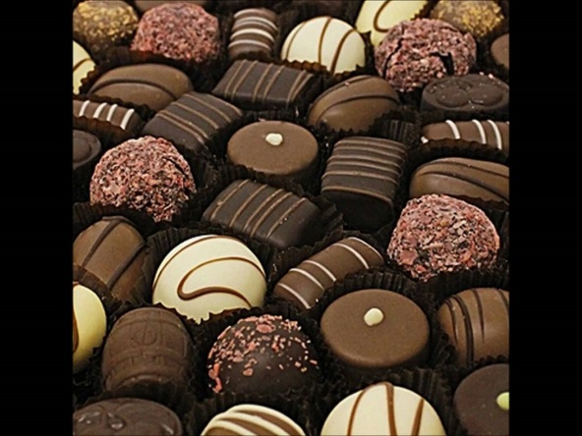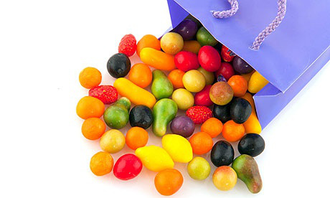

**Introduction**

The question about Hannah’s sweets is probably the most famous GCSE maths question ever and now Hannah can’t stop eating sweets. Help her out before she loses all her teeth.

**Information**

The marks for individual questions are shown in round brackets: e.g. **(2)**.

There are 11 questions in this booklet. The total mark is **45**.

**Calculators may be used in all questions.**

**Advice**

Show all stages in any calculations.

Work steadily through the paper. Do not spend too long on one recipe.

If you cannot answer a question, leave it and attempt the next one.

Return at the end to those you have left out.

**1.** Hannah chooses chocolates from a box of two different types.

The probability that she chooses a crème tangerine is 0.7

Hannah chooses two chocolates.

(a) Complete the probability tree diagram.

**First choice Second choice**

crème tangerine

0.7

crème tangerine

0.7

…… montelimar

crème tangerine

……

……..

montelimar

…….. montelimar

(b) Work out the probability that she chooses two different types of chocolate.

...........................................................

**(3)**

**(Total 5 marks)**

**___________________________________________________________________________**

**3.** Hannah chooses chocolates from a box of two different types.

The probability that she will choose a coconut fudge is 0.2

When she chooses a Savoy truffle, the probability of having all her teeth taken out is 0.7

When she chooses a coconut fudge, the probability of **not** having all her teeth taken out is 0.95

(a) Complete the probability tree diagram for this information.

teeth taken out

……

coconut fudge

……

…… teeth **not** taken out

teeth taken out

……

……..

Savoy truffle

…….. teeth **not** taken out

(b) Work out the probability that, Hannah chooses a coconut fudge and has all her teeth taken out.

...........................................................

**(2)**

**(Total 5 marks)**

**___________________________________________________________________________**

**4.** There are 8 chocolates in a box of Good News chocolates.

6 of the chocolates are cool cherry creams.

2 of the chocolates are pineapple hearts.

Hannah takes at random a chocolate from the Good news box.

She keeps the chocolate.

Then Hannah’s sister Lee takes at random a chocolate from the Good News box.

(a) Complete the probability tree diagram.

**Hannah Lee**

 cool cherry cream

…….. pineapple heart

(b) Work out the probability that both Hannah and Lee both choose a cool cherry cream.

...........................................................

**(2)**

(c) Work out the probability that at least one cool cherry cream is chosen.

...........................................................

**(3)**

**(Total 5 marks)**

**___________________________________________________________________________**

**5.** Hannah has a box of chocolates of many different types. She chooses a chocolate from the box.

The probability that she chooses a coconut fudge is 0.4

The probability that she chooses a coffee dessert is 0.3

(a) Complete the probability tree diagram.

coconut fudge

coconut fudge

0.4

…… coffee dessert

coconut fudge

……

0.3

coffee dessert

….. coffee dessert

(b) Work out the probability that Hannah chooses both a coconut fudge and a coffee dessert.

……………………………………..

**(2)**

**(Total 4 marks)**

**___________________________________________________________________________**

**6.** There are ten chocolates in a box.

4 of the pens are ginger slings.

6 of the pens are pineapple hearts.

Hannah takes at random a chocolate from the box and scoffs it.

She then takes at random another chocolate from the box and scoffs it.

Work out the probability that Hannah has scoffed one chocolate of each type.

……………………………………

**(Total 4 marks)**

**___________________________________________________________________________**

**7.** There are 11 montelimars and 8 Savoy truffles in a box of chocolates.

Hannah is going to pick at random two chocolates from the box.

Work out the probability that Hannah will pick two montelimars or two Savoy truffles.

……………………………………

**(Total 4 marks)**

**___________________________________________________________________________**

**8.** Hannah has 10 sweets in a bag.

7 of the sweets are orange.

3 of sweets are yellow.

Hannah takes at random two sweets from the bag.

(a) Complete the probability tree diagram.

**(2)**

**1st choice**

**2nd choice**



(b) Work out the probability that at least one of the sweets is yellow.

...........................................................

**(3)**

**(Total 5 marks)**

**___________________________________________________________________________**

**9.** There are *n* sweets in a bag.

6 of the sweets are orange.

The rest of the sweets are yellow.

Hannah takes at random a sweet from the bag.

She eats the sweet.

Hannah then takes at random another sweet from the bag.

She eats the sweet.

The probability that Hannah eats two orange sweets is .

(*a*) Show that *n*2 – *n* – 90 = 0

**(3)**

(*b*) Solve *n*2 – *n* – 90 = 0 to find the value of *n.*

..........................................

**(3)**

**(Total 6 marks)**

**___________________________________________________________________________**

**10.** Hannah buys packets of chocolates.

There are 8 crème tangerines in each packet of crème tangerines.

There are 6 montelimars in each packet of montelimars.

There are 5 ginger slings in each packet of ginger slings.

Hannah buys equal numbers of crème tangerines, montelimars and ginger slings.

How many packets of type of chocolate did Hannah buy?

................................. packets of crème tangerines

................................. packets of montelimars

................................. packets of ginger slings

**(Total 3 marks)**

**___________________________________________________________________________**

**11.** Hannah has an empty box.

She puts some crème tangerines and some nice apple tarts into the box.

The ratio of the number of crème tangerines to the number of nice apple tarts is 1 : 4

Hannah’s sister Holly takes at random 2 items from the box.

The probability that she takes 2 crème tangerines is .

How many crème tangerines did Hannah put into the box?

.......................................................

**(Total 4 marks)**

**___________________________________________________________________________**

