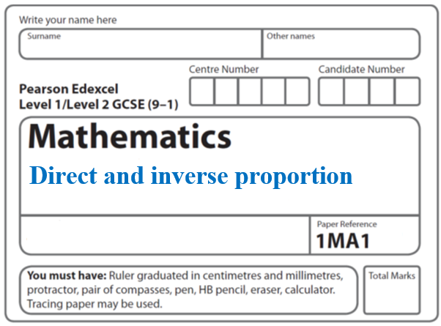**Instructions**

* Use **black** ink or ball-point pen.
  + **Fill in the boxes** at the top of this page with your name,  
    centre number and candidate number.
* Answer **all** questions.
* Answer the questions in the spaces provided  
  *– there may be more space than you need.*
* You must **show all your working.**
* Diagrams are **NOT** accurately drawn, unless otherwise indicated.
* If your calculator does not have a *π* button, take the value of *π* to be3.142

unless the question instructs otherwise.

**Information**

* The total mark for this paper is **34**. There are **12** questions.
* Questions have been arranged in an ascending order of mean difficulty, as found by all students in the June 2017–November 2019 examinations.
* The marks for **each** question are shown in brackets  
  *– use this as a guide as to how much time to spend on each question.*

**Advice**

* Read each question carefully before you start to answer it.
* Keep an eye on the time.
* Try to answer every question.
* Check your answers if you have time at the end.

**1**

**

The graphs of *y* against *x* represent four different types of proportionality.

Match each type of proportionality in the table to the correct graph.

|  |  |
| --- | --- |
| **Type of proportionality** | **Graph letter** |
| *y*  *x* |  |
| *y*  *x*2 |  |
| *y* |  |
| *y* |  |

(**Total for Question 1 is 2 marks**)

**___________________________________________________________________________**

**2** Here are four graphs.

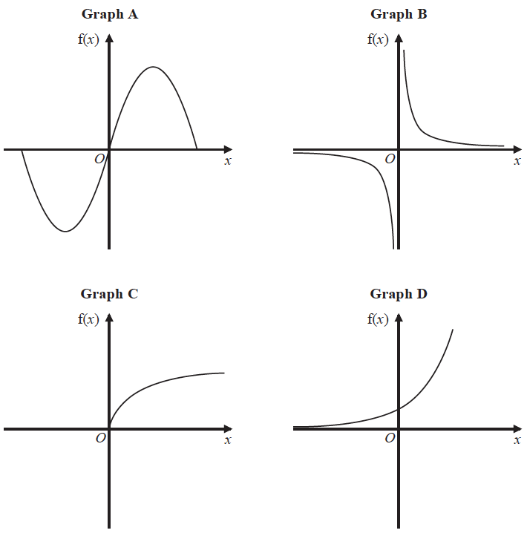

The graphs represent four different types of function f.

Match each description of the function in the table to the letter of its graph.

|  |  |
| --- | --- |
| **Description of function** | **Graph** |
| f(*x*) is inversely proportional to *x* |  |
| f(*x*) is a trigonometrical function |  |
| f(*x*) is an exponential function |  |
| f(*x*) is directly proportional to |  |

**(Total for Question 2 is 2 marks)**

**___________________________________________________________________________**

**3** *h* is inversely proportional to *p*

*p* is directly proportional to **

Given that *h* = 10 and *t* = 144 when *p* = 6

find a formula for *h* in terms of *t*

.................................................................................

**(Total for Question 3 is 4 marks)**

**___________________________________________________________________________**

**4** *y* is inversely proportional to *d* 2

When *d* = 10, *y* = 4

*d* is directly proportional to *x*2

When *x* = 2, *d* = 24

Find a formula for *y* in terms of *x*.

Give your answer in its simplest form.

.......................................................

(**Total for Question 4 is 5 marks**)

**___________________________________________________________________________**

**5** The table shows a set of values for *x* and *y*.

|  |  |  |  |  |
| --- | --- | --- | --- | --- |
| *x* | 1 | 2 | 3 | 4 |
| *y* | 9 |  | 1 |  |

*y* is inversely proportional to the square of *x*.

(*a*)Find an equation for *y* in terms of *x*.

.......................................................

**(2)**

(*b*)Find the positive value of *x* when *y* = 16

.......................................................

**(2)**

**(Total for Question 5 is 4 marks)**

**___________________________________________________________________________**

**6** *y* is inversely proportional to the square of *x*.

*y* = 8 when *x* = 2.5

Find the negative value of *x* when *y* = 

.......................................................

**(Total for Question 6 is 3 marks)**

**___________________________________________________________________________**

**7** *y* is inversely proportional to *x*3

*y* = 44 when *x* = *a*

Show that *y* = 5.5 when *x* = 2*a*

**(Total for Question 7 is 3 marks)**

**___________________________________________________________________________**

**8** *y* is directly proportional to 

*y* =  when *x* = 8

Find the value of *y* when *x* = 64

....................................................................

**(Total for Question 8 is 3 marks)**

**___________________________________________________________________________**

**9** *T* is inversely proportional to the cube of *u*.

When *u* = 5, *T* = 0.0096

Find the value of *u* when *T* = 0.15

.......................................................

**(Total for Question 9 is 3 marks)**

**___________________________________________________________________________**

**10** *P* is inversely proportional to the square root of *m*.

*P* = 10 when *m* = 

Work out the value of *m* when *P* = 2

.......................................................

**(Total for Question 10 is 3 marks)**

**___________________________________________________________________________**

**11** Here are five graphs.

Each graph shows either direct proportion or inverse proportion.



The table shows five equations.

|  |  |
| --- | --- |
| **Equation** | **Graph** |
| *y* = *kx*3 | ................................... |
| *y* = *k* | ................................... |
| *y* = *kx*2 | ................................... |
| *y* = | ................................... |
| *y* = *kx* | ................................... |

Match the letter of each graph to its equation.

**(Total for Question 11 is 3 marks)**

**___________________________________________________________________________**

**12** *y* is inversely proportional to the square of *x*.

*y* = 1 when *x* = 10

Find the value of *y* when *x* = 5

*y* = .......................................................

**(Total for Question 12 is 3 marks)**

**___________________________________________________________________________**

**TOTAL MARKS FOR PAPER: 34**