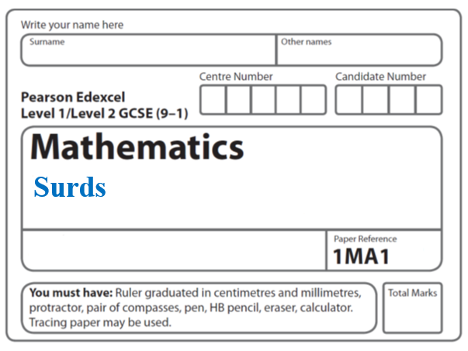

**Instructions**

* Use **black** ink or ball-point pen.
  + **Fill in the boxes** at the top of this page with your name,  
    centre number and candidate number.
* Answer **all** questions.
* Answer the questions in the spaces provided  
  *– there may be more space than you need.*
* You must **show all your working.**
* Diagrams are **NOT** accurately drawn, unless otherwise indicated.
* If your calculator does not have a *π* button, take the value of *π* to be3.142

unless the question instructs otherwise.

**Information**

* The total mark for this paper is **39**. There are **11** questions.
* Questions have been arranged in an ascending order of mean difficulty, as found by all students in the June 2017–November 2019 examinations.
* The marks for **each** question are shown in brackets  
  *– use this as a guide as to how much time to spend on each question.*

**Advice**

* Read each question carefully before you start to answer it.
* Keep an eye on the time.
* Try to answer every question.
* Check your answers if you have time at the end.

**1** (*a*)Express  in the form ** where *a* is an integer.

.......................................................

**(2)**

(*b*)Express  in the form ** where *b* and *c* are integers.

.......................................................

**(3)**

**(Total for Question 1 is 5 marks)**

**_____________________________________________________________________**

**2**  can be written in the form ** where *a* is an integer.

Find the value of *a*.

*a* = .......................................................

(**Total for Question 2 is 3 marks**)

**3** Martin did this question.

|  |
| --- |
| Rationalise the denominator of |

Here is how he answered the question.

|  |  |
| --- | --- |
|  | = |
|  | = |
|  | = |
|  | = |

Martin’s answer is wrong.

(*a*)Find Martin’s mistake.

..........................................................................................................................................

..........................................................................................................................................

(**1**)

Sian did this question.

|  |
| --- |
| Rationalise the denominator of |

Here is how she answered the question.

|  |  |
| --- | --- |
|  | = |
|  | = |
|  | = |

Sian’s answer is wrong.

(*b*)Find Sian’s mistake.

..........................................................................................................................................

..........................................................................................................................................

(**1**)

(**Total for Question 3 is 2 marks**)

**_____________________________________________________________________**

**4** (*a*)Rationalise the denominator of 

Give your answer in its simplest form.

.......................................................

**(2)**

(*b*)Show that  can be written in the form ** where *a* and *b* are integers.

**(3)**

**(Total for Question 4 is 5 marks)**

**_____________________________________________________________________**

**5** Show that  can be written in the form *a*(*b* + ) where *a* and *b* are integers.

**(Total for Question 5 is 3 marks)**

**_____________________________________________________________________**

**6** Show that  can be written in the form *a* + *b* where *a* and *b* are integers.

**(Total for Question 6 is 3 marks)**

**7** Show that  can be written 

**(Total for Question 7 is 3 marks)**

**_____________________________________________________________________**

**8** Simplify fully 

You must show your working.

.........................................

**(Total for Question 8 is 3 marks)**

**_____________________________________________________________________**

**9** Show that  can be written as 

**(Total for Question 9 is 3 marks)**

**_____________________________________________________________________**

**10**  can be written in the form **

Find the value of *a* and the value of *b*.

*a* = .......................................................

*b* = .......................................................

**(Total for Question 10 is 5 marks)**

**_____________________________________________________________________**

**11** Show that  can be written in the form *a* + *b*√2, where *a* and *b* are integers.

**(Total for Question 11 is 4 marks)**

**_____________________________________________________________________**

**TOTAL MARKS FOR PAPER: 39**