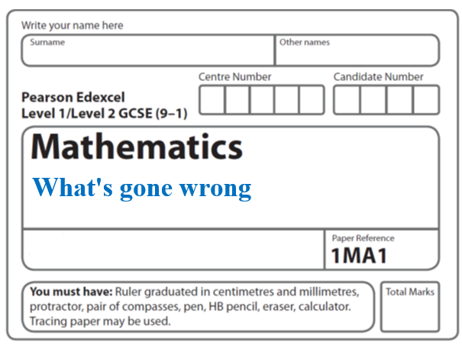**Instructions**

* Use **black** ink or ball-point pen.
  + **Fill in the boxes** at the top of this page with your name,  
    centre number and candidate number.
* Answer **all** questions.
* Answer the questions in the spaces provided  
  *– there may be more space than you need.*
* You must **show all your working.**
* Diagrams are **NOT** accurately drawn, unless otherwise indicated.
* If your calculator does not have a *π* button, take the value of *π* to be3.142

unless the question instructs otherwise.

**Information**

* The total mark for this paper is **19**. There are **11** questions.
* Questions have been arranged in an ascending order of mean difficulty, as found by all students in the June 2017–November 2019 examinations.
* The marks for **each** question are shown in brackets  
  *– use this as a guide as to how much time to spend on each question.*

**Advice**

* Read each question carefully before you start to answer it.
* Keep an eye on the time.
* Try to answer every question.
* Check your answers if you have time at the end.

**1** When a biased 6-sided dice is thrown once, the probability that it will land on 4 is .65

The biased dice is thrown twice.

Amir draws this probability tree diagram.

The diagram is **not** correct.



Write down **two** things that are wrong with the probability tree diagram.

1 .......................................................................................................................................

..........................................................................................................................................

2..................................................................................................................................................................................................................................................................................

(**Total for Question 1 is 2 marks**)

**_____________________________________________________________________**

**2** Patrick has to work out the exact value of 

Patrick says,

“ of 64 is 16 so  = 16 ”

Explain what is wrong with what Patrick says.

..........................................................................................................................................

..........................................................................................................................................

..........................................................................................................................................

**(Total for Question 2 is 1 mark)**

**_____________________________________________________________________**

**3** *ABC* is a right-angled triangle.

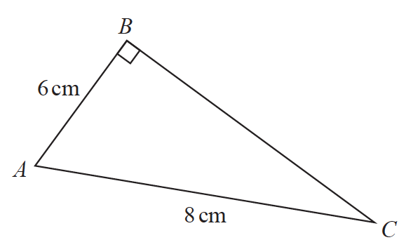

Here is Sarah’s method to find the length of *BC*.

*BC* 2 = *AB* 2 + *AC* 2

= 62 + 82

= 100

*BC* = 10

(*a*)What mistake has Sarah made in her method?

..........................................................................................................................................

..........................................................................................................................................

..........................................................................................................................................

**(1)**

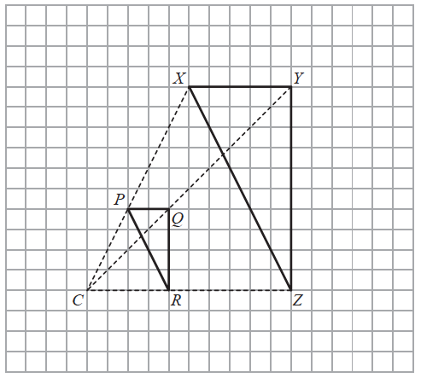

Roy is going to enlarge triangle *PQR* with centre *C* and scale factor 1

He draws triangle *XYZ*.

(*b*)Explain why Roy’s diagram is **not** correct.

..........................................................................................................................................

..........................................................................................................................................

..........................................................................................................................................

**(1)**

**(Total for Question 3 is 2 marks)**

**_____________________________________________________________________**

**4** The table shows some information about the weights of 50 potatoes.

|  |  |
| --- | --- |
| **Weight (*w* grams)** | **Frequency** |
| 10 < *w* ⩽ 20 | 6 |
| 20 < *w* ⩽ 30 | 21 |
| 30 < *w* ⩽ 40 | 13 |
| 40 < *w* ⩽ 50 | 7 |
| 50 < *w* ⩽ 60 | 3 |

Iveta drew this frequency polygon for the information in the table.

The frequency polygon is **not** fully correct.

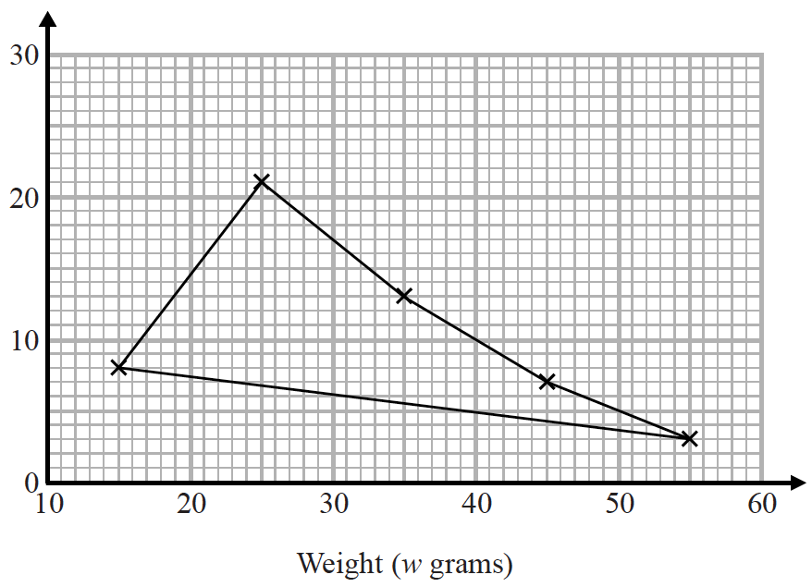

Write down **two** things that are wrong with the frequency polygon.

1........................................................................................................................................

..........................................................................................................................................

2........................................................................................................................................

..........................................................................................................................................

**(Total for Question 4 is 2 marks)**

**_____________________________________________________________________**

**5** There are 30 students in Mr Lear’s class.

16 of the students are boys.

Two students from the class are chosen at random.

Mr Lear draws this probability tree diagram for this information.



(*a*)Write down **one** thing that is wrong with the probabilities in the probability tree diagram.

..........................................................................................................................................

..........................................................................................................................................

**(1)**

Owen and Wasim play for the school football team.

The probability that Owen will score a goal in the next match is 0.4.

The probability that Wasim will score a goal in the next match is 0.25.

Mr Slater says,

“The probability that both boys will score a goal in the next match is 0.4 + 0.25”

(*b*)Is Mr Slater right?

Give a reason for your answer.

..........................................................................................................................................

..........................................................................................................................................

**(1)**

**(Total for Question 5 is 2 marks)**

**_____________________________________________________________________**

**6** Sean has information about the height, in cm, and the weight, in kg, of each of ten rugby players.

He is asked to draw a scatter graph and a line of best fit for this information.

Here is his answer.



Sean has plotted the points accurately.

Write down two things that are wrong with his answer.

1........................................................................................................................................

..........................................................................................................................................

2........................................................................................................................................

..........................................................................................................................................

**(Total for Question 6 is 2 marks)**

**_____________________________________________________________________**

**7** Sean has drawn a time series graph to show the numbers, in thousands, of visitors to a

fun park.

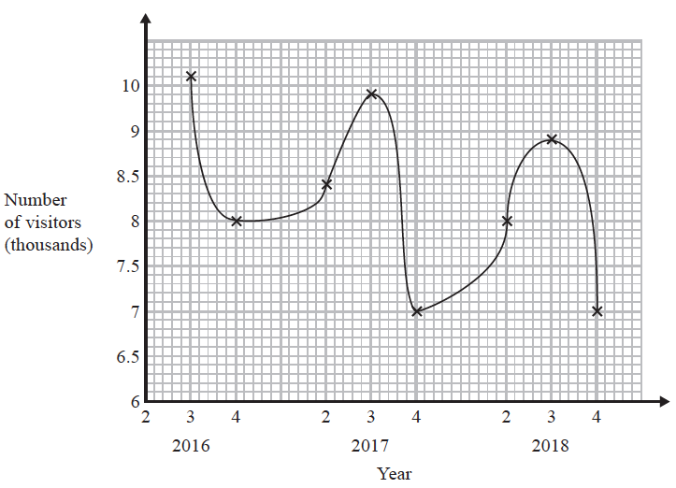

Write down two things that are wrong or could be misleading with this graph.

1 .......................................................................................................................................

..........................................................................................................................................

..........................................................................................................................................

2 .......................................................................................................................................

..........................................................................................................................................

..........................................................................................................................................

**(Total for Question 7 is 2 marks)**

**_____________________________________________________________________**

**8** Brogan needs to draw the graph of *y* = *x*2 + 1

Here is her graph.



Write down one thing that is wrong with Brogan’s graph.

..........................................................................................................................................

..........................................................................................................................................

**(Total for Question 8 is 1 mark)**

**_____________________________________________________________________**

**9** *T* =  + 5

Here is Spencer’s method to make *q* the subject of the formula.

2 × *T* = *q* + 5

*q* = 2*T* – 5

What mistake did Spencer make in the first line of his method?

..........................................................................................................................................

..........................................................................................................................................

..........................................................................................................................................

**(Total for Question 9 is 1 mark)**

**_____________________________________________________________________**

**10** Martin did this question.

|  |
| --- |
| Rationalise the denominator of |

Here is how he answered the question.

|  |  |
| --- | --- |
|  | = |
|  | = |
|  | = |
|  | = |

Martin’s answer is wrong.

(*a*)Find Martin’s mistake.

..........................................................................................................................................

..........................................................................................................................................

(**1**)

Sian did this question.



Here is how she answered the question.

|  |  |
| --- | --- |
|  | = |
|  | = |
|  | = |

Sian’s answer is wrong.

(*b*)Find Sian’s mistake.

..........................................................................................................................................

..........................................................................................................................................

(**1**)

(**Total for Question 10 is 2 marks**)

**_____________________________________________________________________**

**11** The table shows some information about the dress sizes of 25 women.

|  |  |
| --- | --- |
| **Dress size** | **Number of women** |
| 8 | 2 |
| 10 | 9 |
| 12 | 8 |
| 14 | 6 |

(*a*)Find the median dress size.

.......................................................

**(1)**

3 of the 25 women have a shoe size of 7

Zoe says that if you choose at random one of the 25 women, the probability that she has

either a shoe size of 7 or a dress size of 14 is  because



(*b*)Is Zoe correct?

You must give a reason for your answer.

..........................................................................................................................................

..........................................................................................................................................

**(1)**

**(Total for Question 11 is 2 marks)**

**_____________________________________________________________________**

**TOTAL MARKS FOR PAPER: 19**