**Statistical diagrams: Frequency trees and Tree diagrams**

**Instructions**

* Use **black** ink or ball-point pen.
  + **Fill in the boxes** at the top of this page with your name,  
    centre number and candidate number.
* Answer **all** questions.
* Answer the questions in the spaces provided  
  *– there may be more space than you need.*
* You must **show all your working.**
* Diagrams are **NOT** accurately drawn, unless otherwise indicated.
* If your calculator does not have a *π* button, take the value of *π* to be3.142

unless the question instructs otherwise.

**Information**

* The total mark for this paper is **43**. There are **10** questions.
* Questions have been arranged in an ascending order of mean difficulty, as found by all students in the June 2017–November 2019 examinations.
* The marks for **each** question are shown in brackets  
  *– use this as a guide as to how much time to spend on each question.*

**Advice**

1. Read each question carefully before you start to answer it.
2. Keep an eye on the time.
3. Try to answer every question.
4. Check your answers if you have time at the end.

**1** Each worker in a factory is either left-handed or right-handed.

22 of the 45 workers are male.

16 of the 34 right-handed workers are female.

Complete the frequency tree for this information.



(**Total for Question 1 is 3 marks**)

**2** 200 people live in a village.

23 people do **not** have a garden.

10 males do **not** have a garden.

95 people are male.

(*a*)Use this information to complete the frequency tree.



**(3)**

One of the people who does **not** have a garden is chosen at random.

(*b*)Write down the probability that this person is female.

......................................................

**(2)**

**(Total for Question 2 is 5 marks)**

**___________________________________________________________________________**

**3** 120 people were at a hockey match.

Each person was asked if they wanted to stand or to sit to watch the match.

75 of the people were female

29 of the males wanted to stand

30 of the people wanted to sit

(*a*)Use this information to complete the frequency tree.

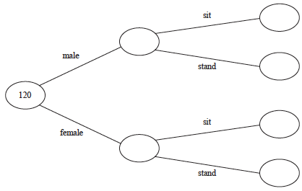

**(3)**

One of the 120 people is chosen at random.

(*b*)Write down the probability that this person is a male who wanted to stand.

.......................................................

**(1)**

**(Total for Question 3 is 4 marks)**

**___________________________________________________________________________**

**4** 80 people are asked if they like coffee.

48 of these people are women.

61 of the 80 people like coffee.

8 of the men do **not** like coffee.

(*a*)Use this information to complete the frequency tree.



**(3)**

One of the people who like coffee is chosen at random.

(*b*)Find the probability that this person is a woman.

......................................................

**(2)**

**(Total for Question 4 is 5 marks)**

**___________________________________________________________________________**

**5** Amina has two bags.

In the first bag there are 3 red balls and 7 green balls.

In the second bag there are 5 red balls and 4 green balls.

Amina takes at random a ball from the first bag.

She then takes at random a ball from the second bag.

(*a*)Complete the probability tree diagram.



**(2)**

(*b*)Work out the probability that Amina takes two red balls.

......................................................

**(2)**

**(Total for Question 5 is 4 marks)**

**6** There are 60 children in Year 6

Each of these children has either a school lunch or a packed lunch.

32 of the children are boys.

 of the boys have a school lunch.

 of the girls have a packed lunch.

Use this information to complete the frequency tree.



**(Total for Question 6 is 4 marks)**

**___________________________________________________________________________**

**7** 60 people each took a driving test one day.

21 of these people were women.

18 of the 60 people failed their test.

27 of the men passed their test.

(a)Use this information to complete the frequency tree.



**(3)**

One of the men is chosen at random.

(b)Work out the probability that this man failed his test.

.........................................

**(2)**

**(Total for Question 7 is 5 marks)**

**___________________________________________________________________________**

**8** The diagram shows a fair 4-sided spinner.



Hasmeet is going to spin the spinner twice.

(*a*) Complete the probability tree diagram.



**(2)**

(*b*) Work out the probability that the spinner will land on A on the first spin and will land

on B on the second spin.

.......................................................

**(2)**

**(Total for Question 8 is 4 marks)**

**___________________________________________________________________________**

**9** Graham has a fair red 6-sided dice and a fair blue 8-sided dice.

The red dice can land on 1, 2, 3, 4, 5 or 6

The blue dice can land on 1, 2, 3, 4, 5, 6, 7 or 8

Graham is going to roll both dice.

(a) Complete the probability tree diagram.

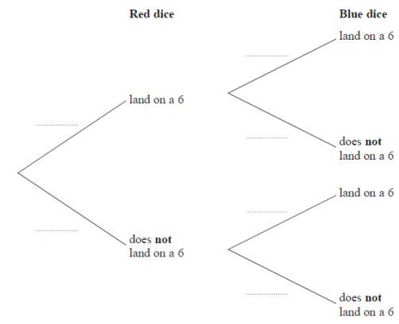

**(2)**

(b) Work out the probability that neither dice will land on a 6

.........................................

**(2)**

**(Total for Question 9 is 4 marks)**

**___________________________________________________________________________**

**10** Sameena has a round pencil case and a square pencil case.

There are 4 blue pens and 3 red pens in the round pencil case.

There are 3 blue pens and 5 red pens in the square pencil case.

Sameena takes at random one pen out of each pencil case.

(a)Complete the probability tree diagram.

 **(2)**

(b)Work out the probability that the pens Sameena takes are both red.

.......................................................

**(2)**

**(Total for Question 10 is 4 marks)**

**___________________________________________________________________________**

**TOTAL MARKS FOR PAPER: 43**