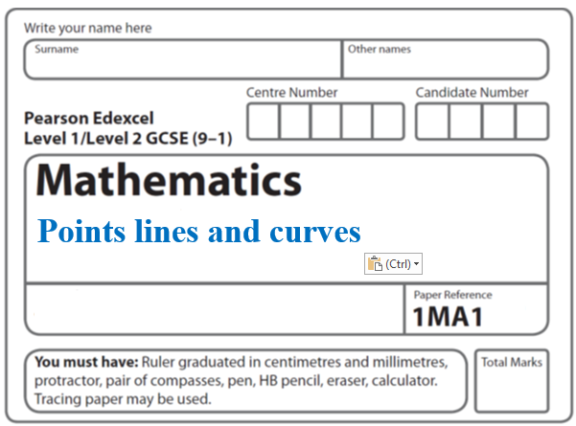**Instructions**

**Quadratic graphs**

* Use **black** ink or ball-point pen.
  + **Fill in the boxes** at the top of this page with your name,  
    centre number and candidate number.
* Answer **all** questions.
* Answer the questions in the spaces provided  
  *– there may be more space than you need.*
* You must **show all your working.**
* Diagrams are **NOT** accurately drawn, unless otherwise indicated.
* If your calculator does not have a *π* button, take the value of *π* to be3.142

unless the question instructs otherwise.

**Information**

* The total mark for this paper is **35**. There are **8** questions.
* Questions have been arranged in an ascending order of mean difficulty, as found by all students in the June 2017–November 2019 examinations.
* The marks for **each** question are shown in brackets  
  *– use this as a guide as to how much time to spend on each question.*

**Advice**

* Read each question carefully before you start to answer it.
* Keep an eye on the time.
* Try to answer every question.
* Check your answers if you have time at the end.

**1** (*a*)Complete the table of values for *y* = *x*2 – *x* – 6

|  |  |  |  |  |  |  |  |
| --- | --- | --- | --- | --- | --- | --- | --- |
| *x* | –3 | –2 | –1 | 0 | 1 | 2 | 3 |
| *y* | 6 |  |  | – 6 |  |  |  |

(**2**)

(*b*)On the grid, draw the graph of *y* = *x*2 – *x* – 6 for values of *x* from –3 to 3

(**2**)



(*c*)Use your graph to find estimates of the solutions to the equation *x*2 – *x* – 6 = –2

.................................................................................

(**2**)

(**Total for Question 1 is 6 marks)**

**___________________________________________________________________________**

**2** The graph of *y* = f(*x*) is drawn on the grid.



(*a*)Write down the coordinates of the turning point of the graph.

( .......................... , ..........................)

**(1)**

(*b*)Write down estimates for the roots of f(*x*) = 0

.................................................................................

**(1)**

(*c*)Use the graph to find an estimate for f(1.5)

.......................................................

**(1)**

**(Total for Question 2 is 3 marks)**

**___________________________________________________________________________**

**3** (*a*)Complete this table of values for *y* = *x*2 + *x* – 4

|  |  |  |  |  |  |  |  |
| --- | --- | --- | --- | --- | --- | --- | --- |
| ***x*** | –3 | –2 | –1 | 0 | 1 | 2 | 3 |
| ***y*** |  | –2 | –4 |  | –2 |  |  |

**(2)**

(*b*)On the grid, draw the graph of *y* = *x*2 + *x* – 4 for values of *x* from –3 to 3



**(2)**

(*c*)Use the graph to estimate a solution to *x*2 + *x* – 4 = 0

.......................................................

**(1)**

**(Total for Question 3 is 5 marks)**

**___________________________________________________________________________**

**4** The diagram shows part of the graph of *y* = *x*2 – 2*x* + 3

**

(*a*)By drawing a suitable straight line, use your graph to find estimates for the solutions

of *x*2 – 3*x* – 1 = 0

............................................................................................................

**(2)**

*P* is the point on the graph of *y* = *x*2 – 2*x* + 3 where *x* = 2

(*b*)Calculate an estimate for the gradient of the graph at the point *P*.

......................................................

**(3)**

**(Total for Question 4 is 5 marks)**

**___________________________________________________________________________**

**5** Here is the graph of *y* = *x*2 – 2*x* – 4

**

(a) Write down estimates for the roots of *x*2 – 2*x* – 4 = 0

.......................................................

**(2)**

(b) Write down the coordinates of the turning point of *y* = *x*2 – 2*x* – 4

(............................ , ............................)

**(1)**

**(Total for Question 4 is 3 marks)**

**___________________________________________________________________________**

**6** (a) Complete the table of values for *y* = *x*3 – 3*x* + 1

|  |  |  |  |  |  |
| --- | --- | --- | --- | --- | --- |
| *x* | –2 | -1 | 0 | 1 | 2 |
| *y* |  |  |  |  |  |

**(2)**

(b) On the grid below, draw the graph of *y* = *x*3 – 3*x* + 1 for values of *x* from –2 to 2



**(2)**

**(Total for Question 6 is 4 marks)**

**___________________________________________________________________________**

**7** Sketch the graph of

*y* = 2*x*2 – 8*x* – 5

showing the coordinates of the turning point and the exact coordinates of any intercepts

with the coordinate axes.

**(Total for Question 7 is 5 marks)**

**___________________________________________________________________________**

**8** Here is the graph of *y* = *x*2 – 3

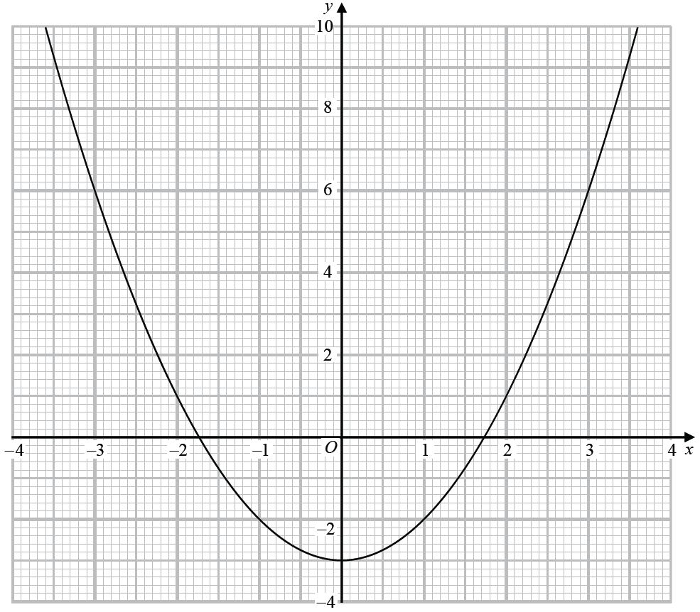

Use the graph to find estimates for the solutions to the equation *x*2 – 2*x* – 2 = 0

You must show how you get your solutions.

.............................................................................................................

**(Total for Question 8 is 4 marks)**

**___________________________________________________________________________**

**TOTAL MARKS FOR PAPER: 35**