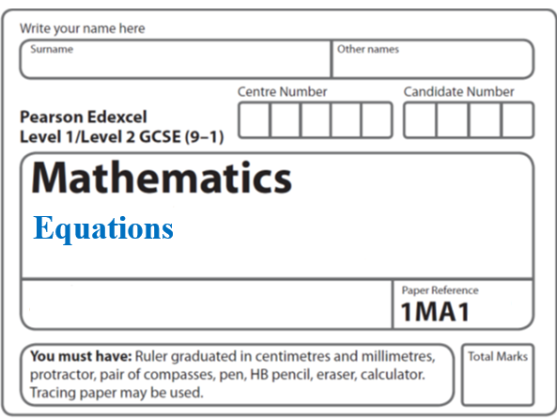**Instructions**

**Mean**

* Use **black** ink or ball-point pen.
  + **Fill in the boxes** at the top of this page with your name,  
    centre number and candidate number.
* Answer **all** questions.
* Answer the questions in the spaces provided  
  *– there may be more space than you need.*
* You must **show all your working.**
* Diagrams are **NOT** accurately drawn, unless otherwise indicated.
* If your calculator does not have a *π* button, take the value of *π* to be3.142

unless the question instructs otherwise.

**Information**

* The total mark for this paper is **32**. There are **9** questions.
* Questions have been arranged in an ascending order of mean difficulty, as found by all students in the June 2017–November 2019 examinations.
* The marks for **each** question are shown in brackets  
  *– use this as a guide as to how much time to spend on each question.*

**Advice**

* Read each question carefully before you start to answer it.
* Keep an eye on the time.
* Try to answer every question.
* Check your answers if you have time at the end.

**1** Fran asks each of 40 students how many books they bought last year.

The chart below shows information about the number of books bought by each of the 40 students.



(*a*)Work out the percentage of these students who bought 20 or more books.

.......................................................%

**(2)**

(*b*)Show that an estimate for the mean number of books bought is 9.5

You must show all your working.

**(4)**

**(Total for Question 1 is 6 marks)**

**__________________________________________________________________________**

**2** There are 10 boys and 20 girls in a class.

The class has a test.

The mean mark for all the class is 60.

The mean mark for the girls is 54.

Work out the mean mark for the boys.

.......................................................

**(Total for Question 2 is 3 marks)**

**___________________________________________________________________________**

**3** The table gives information about the times taken, in seconds, by 18 students to run a race.

|  |  |
| --- | --- |
| **Time (*t* seconds)** | **Frequency** |
| 5 < *t* ⩽ 10 | 1 |
| 10 < *t* ⩽ 15 | 2 |
| 15 < *t* ⩽ 20 | 7 |
| 20 < *t* ⩽ 25 | 8 |

Work out an estimate for the mean time.

Give your answer correct to 3 significant figures.

....................................................... seconds

**(Total for Question 3 is 3 marks)**

**___________________________________________________________________________**

**4** 4 red bricks have a mean weight of 5 kg.

5 blue bricks have a mean weight of 9 kg.

1 green brick has a weight of 6 kg.

Donna says,

“The mean weight of the 10 bricks is less than 7 kg.”

Is Donna correct?

You must show how you get your answer.

**(Total for Question 4 is 3 marks)**

**___________________________________________________________________________**

**5** Mark has 18 bags of counters and 12 boxes of counters.

The mean number of counters in all 30 bags and boxes is 14

The mean number of counters in the 18 bags is 10

Mark says

“The mean number of counters per box is 4”

Is Mark right?

You must show how you get your answer.

**(Total for Question 5 is 3 marks)**

**___________________________________________________________________________**

**6** 20 men, 10 women and 10 children are in a competition.

The mean score for the women is 15.6.

The mean score for the children is 9.2.

Kevin says that the mean score for all 40 people is 11.2.

(*a*) Work out the mean score for the men.

.......................................................

**(3)**

Kevin was wrong.

The mean score for all 40 people was actually 11.15.

(*b*) How does this affect the mean score for the men?

......................................................................................................................................................

......................................................................................................................................................

**(1)**

**(Total for Question 6 is 4 marks)**

**___________________________________________________________________________**

**7** In a class there are 11 boys and 19 girls.

The mean weight of all 30 children is 32.85 kg.

The mean weight of the 11 boys is 31.9 kg.

Work out the mean weight of the 19 girls.

.......................................................kg

**(Total for Question 7 is 3 marks)**

**___________________________________________________________________________**

**8** Hasmeet walks once round a circle with diameter 80 metres.



There are 8 points equally spaced on the circumference of the circle.

(*a*) Find the distance Hasmeet walks between one point and the next point.

......................................................m

**(2)**

Four of the points are moved, as shown in the diagram below.



Hasmeet walks once round the circle again.

(*b*) Has the mean distance that Hasmeet walks between one point and the next point changed?

You must give a reason for your answer.

......................................................................................................................................................

......................................................................................................................................................

**(1)**

**(Total for Question 8 is 3 marks)**

**___________________________________________________________________________**

**9** The table shows information about the weekly earnings of 20 people who work in a shop.

|  |  |
| --- | --- |
| **Weekly earnings (£*x*)** | **Frequency** |
| 150 < *x* ⩽ 250 | 1 |
| 250 < *x* ⩽ 350 | 11 |
| 350 < *x* ⩽ 450 | 5 |
| 450 < *x* ⩽ 550 | 0 |
| 550 < *x* ⩽ 650 | 3 |

(*a*)Work out an estimate for the mean of the weekly earnings.

£.....................................

**(3)**

Nadiya says,

“The mean may **not** be the best average to use to represent this information.”

(*b*)Do you agree with Nadiya?

You must justify your answer.

......................................................................................................................................................

......................................................................................................................................................

**(1)**

**(Total for Question 9 is 4 marks)**

**___________________________________________________________________________**

**TOTAL MARKS FOR PAPER: 32**