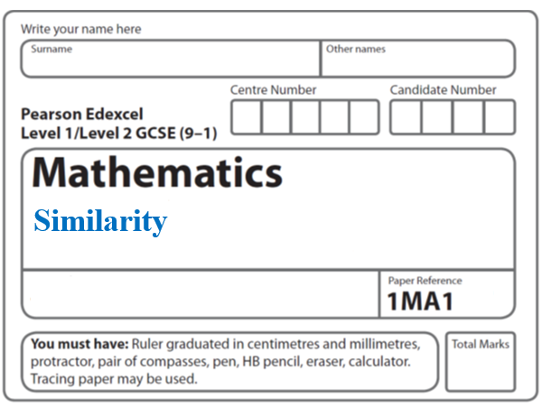**Instructions**

* Use **black** ink or ball-point pen.
  + **Fill in the boxes** at the top of this page with your name,  
    centre number and candidate number.
* Answer **all** questions.
* Answer the questions in the spaces provided  
  *– there may be more space than you need.*
* You must **show all your working.**
* Diagrams are **NOT** accurately drawn, unless otherwise indicated.
* If your calculator does not have a *π* button, take the value of *π* to be3.142

unless the question instructs otherwise.

**Information**

* The total mark for this paper is **27**. There are **8** questions.
* Questions have been arranged in an ascending order of mean difficulty, as found by all students in the June 2017–November 2019 examinations.
* The marks for **each** question are shown in brackets  
  *– use this as a guide as to how much time to spend on each question.*

**Advice**

* Read each question carefully before you start to answer it.
* Keep an eye on the time.
* Try to answer every question.
* Check your answers if you have time at the end.

**1**

**

*ABC* and *EDC* are straight lines.

*EA* is parallel to *DB.*

*EC* = 8.1 cm.

*DC* = 5.4 cm.

*DB* = 2.6 cm.

(*a*)Work out the length of *AE.*

...................................................... cm

**(2)**

*AC* = 6.15 cm.

(*b*)Work out the length of *AB.*

...................................................... cm

**(2)**

**(Total for Question 1 is 4 marks)**

**___________________________________________________________________________**

**2** Here are two similar solid shapes.



surface area of shape **A** : surface area of shape **B** = 3 : 4

The volume of shape **B** is 10 cm3

Work out the volume of shape **A**.

Give your answer correct to 3 significant figures.

....................................................... cm3

(**Total for Question 2 is 3 marks**)

**___________________________________________________________________________**

**3** Here are two pots.



Pot **A** and pot **B** are mathematically similar.

The area of the base of pot **B** is 160 cm2.

Work out the area of the base of pot **A**.

....................................................... cm2

**(Total for Question 3 is 2 marks)**

**4** The two triangles in the diagram are similar.

**

There are two possible values of *x*.

Work out each of these values.

State any assumptions you make in your working.

**(Total for Question 4 is 5 marks)**

**___________________________________________________________________________**

**5 A** and **B** are two similar cylindrical containers.

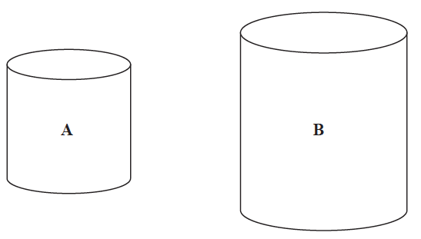

the surface area of container **A** : the surface area of container **B** = 4 : 9

Tyler fills container **A** with water.

She then pours all the water into container **B**.

Tyler repeats this and stops when container **B** is full of water.

Work out the number of times that Tyler fills container **A** with water.

You must show all your working.

.......................................................

**(Total for Question 5 is 4 marks)**

**___________________________________________________________________________**

**6** Three solid shapes **A**, **B** and **C** are similar.

The surface area of shape **A** is 4 cm2

The surface area of shape **B** is 25 cm2

The ratio of the volume of shape **B** to the volume of shape **C** is 27 : 64

Work out the ratio of the height of shape **A** to the height of shape **C**.

Give your answer in its simplest form.

......................................................

**(Total for Question 6 is 4 marks)**

**___________________________________________________________________________**

**7** Cone **A** and cone **B** are mathematically similar.

The ratio of the volume of cone **A** to the volume of cone **B** is 27 : 8

The surface area of cone **A** is 297 cm2

Show that the surface area of cone **B** is 132 cm2

**(Total for Question 7 is 3 marks)**

**___________________________________________________________________________**

**8** A factory makes ice cream tubs in two sizes, small and large.



The tubs are similar in shape.

The height of the small tub is 5 cm.

The volume of the small tub is 150 cm3.

The volume of the large tub is 500 cm3.

Work out the height of the large tub.

Give your answer correct to 3 significant figures.

.......................................................cm

**(Total for Question 8 is 2 marks)**

**___________________________________________________________________________**

**TOTAL MARKS FOR PAPER: 27**