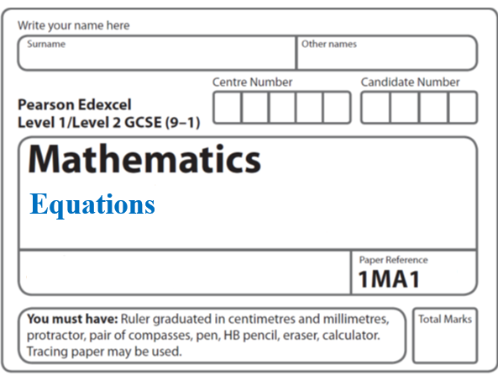**Instructions**

**Iteration**

* Use **black** ink or ball-point pen.
  + **Fill in the boxes** at the top of this page with your name,  
    centre number and candidate number.
* Answer **all** questions.
* Answer the questions in the spaces provided  
  *– there may be more space than you need.*
* You must **show all your working.**
* Diagrams are **NOT** accurately drawn, unless otherwise indicated.
* If your calculator does not have a *π* button, take the value of *π* to be3.142

unless the question instructs otherwise.

**Information**

* The total mark for this paper is **39**. There are **6** questions.
* Questions have been arranged in an ascending order of mean difficulty, as found by all students in the June 2017–November 2019 examinations.
* The marks for **each** question are shown in brackets  
  *– use this as a guide as to how much time to spend on each question.*

**Advice**

* Read each question carefully before you start to answer it.
* Keep an eye on the time.
* Try to answer every question.
* Check your answers if you have time at the end.

**1** (*a*)Show that the equation *x*3 + *x* = 7 has a solution between 1 and 2.

(**2**)

(*b*)Show that the equation *x*3 + *x* = 7 can be rearranged to give *x* = 

(**1**)

(*c*)Starting with *x*0 = 2,

use the iteration formula *xn* + 1 = three times to find an estimate for a

solution of *x*3 + *x* = 7

.......................................................

(**3**)

(**Total for Question 1 is 6 marks**)

**___________________________________________________________________________**

**2** Using 

with *x*0 = −2.5

(*a*)find the values of *x*1, *x*2 and *x*3

*x*1 = .......................................................

*x*2 = .......................................................

*x*3 = .......................................................

**(3)**

(*b*)Explain the relationship between the values of *x*1, *x*2 and *x*3 and the equation *x*3 + 2*x*2 + 4 = 0

......................................................................................................................................................

......................................................................................................................................................

......................................................................................................................................................

......................................................................................................................................................

**(2)**

**(Total for Question 2 is 5 marks)**

**___________________________________________________________________________**

**3** (*a*)Show that the equation *x*3 + 7*x* – 5 = 0 has a solution between *x* = 0 and *x* = 1

**(2)**

(*b*)Show that the equation *x*3 + 7*x* – 5 = 0 can be arranged to give *x* = 

**(2)**

(*c*)Starting with *x*0 = 1, use the iteration formula *xn*+1 =  three times to find

an estimate for the solution of *x*3 + 7*x* – 5 = 0

.......................................................

**(3)**

(*d*)By substituting your answer to part (*c*)into *x*3 + 7*x* – 5,

comment on the accuracy of your estimate for the solution to *x*3 + 7*x* – 5 = 0

......................................................................................................................................................

......................................................................................................................................................

**(2)**

**(Total for Question 3 is 9 marks)**

**___________________________________________________________________________**

**4** (a)Show that the equation *x*3 + 5*x* – 4 = 0 has a solution between *x* = 0 and *x* = 1

**(2)**

(b)Show that the equation *x*3 + 5*x* – 4 = 0 can be arranged to give **

**(2)**

(c)Starting with *x*0 = 0, use the iteration formula *xn* + 1 =  ** twice,

to find an estimate for the solution of *x*3 + 5*x* – 4 = 0

.......................................................

**(3)**

**(Total for Question 4 is 7 marks)**

**___________________________________________________________________________**

**5** (*a*) Show that the equation *x*3 − 3*x*2 + 3 = 0 has a solution between *x* = 2 and *x* = 3

**(2)**

(*b*) Show that the equation *x*3 − 3*x*2 + 3 = 0 can be rearranged to give **

**(1)**

(*c*)Starting with , use the iteration formula ** to find the value of .

Give your answer correct to 3 decimal places.

.......................................................

**(3)**

**(Total for Question 5 is 6 marks)**

**___________________________________________________________________________**

**6** (*a*)Show that the equation 3*x*2 – *x*3 + 3 = 0 can be rearranged to give

*x* = 3 + 

**(2)**

(*b*)Using

*x*n+1 = 3 +  with *x*0 = 3.2,

find the values of *x*1, *x*2 and *x*3

..................................................................................

**(3)**

(*c*)Explain what the values of *x*1, *x*2 and *x*3 represent.

......................................................................................................................................................

......................................................................................................................................................

**(1)**

**(Total for Question 6 is 6 marks)**

**___________________________________________________________________________**

**TOTAL MARKS FOR PAPER: 39**