**GCSE Mathematics**

**Practice Tests: Set 12**

**Paper 2F/3F (Calculator)**

**Time: 1 hour 30 minutes**

You should have: Ruler graduated in centimetres and millimetres, protractor, pair of compasses, pen, HB pencil, eraser, calculator. Tracing paper may be used.

**Instructions**

* Use **black** ink or ball-point pen.
* **Fill in the boxes** at the top of this page with your name,  
  centre number and candidate number.
* Answer **all** questions.
* Answer the questions in the spaces provided



– *there may be more space than you need*.

* **Calculators may be used.**
* Diagrams are NOT accurately drawn, unless otherwise indicated.
* You must **show all your working out.**

**Information**

* The total mark for this paper is 80
* The marks for **each** question are shown in brackets  
  – *use this as a guide as to how much time to spend on each question*.

**Advice**

* Read each question carefully before you start to answer it.
* Keep an eye on the time.
* Try to answer every question.
* Check your answers if you have time at the end.

**Answer ALL questions.**

**Write your answers in the spaces provided.**

**You must write down all the stages in your working.**

**1** Cara has a bottle of juice.

There is 1 litre of juice in the bottle.

Cara makes some drinks.

She uses exactly 30 millilitres of this juice to make each drink.

Cara makes as many drinks as possible.

How many drinks does Cara make?

.......................................................

**(Total for Question 1is 3 marks)**

**___________________________________________________________________________**

**2** (*a*)Write the ratio 32 : 80 in its simplest form.

.......................................................

**(2)**

There are only red counters and blue counters in a bag.

In the bag

the number of red counters : the number of blue counters = 5 : 7

(*b*)What fraction of the counters in the bag are red?

.......................................................

**(1)**

**(Total for Question 2 is 3 marks)**

**___________________________________________________________________________**

**3** Kamal sells 240 ice creams for a total of £640

 of the ice creams he sells are large.

The cost of each large ice cream he sells is £3.80

All the other ice creams he sells are small.

He sells each small ice cream for the same cost.

Work out the cost of each small ice cream.

£.......................................................

**(Total for Question 3 is 4 marks)**

**___________________________________________________________________________**

**4** Sam takes an English exam.

There are two papers in the exam.

Each paper has a maximum mark of 80

To pass the exam, Sam needs to get at least 60% of the total marks.

Sam gets 55% of the 80 marks in paper 1

Work out the least number of marks that Sam must get in paper 2 to pass the

English exam.

.......................................................

**(Total for Question 4 is 4 marks)**

**___________________________________________________________________________**

**5**

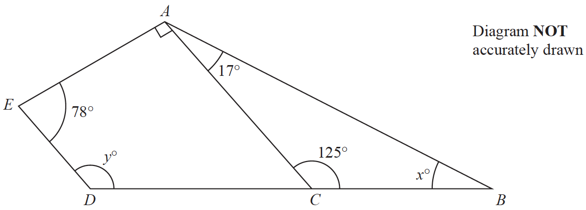

*ABDE* is a quadrilateral.

*ABC* is a triangle.

*DCB* is a straight line.

(*a*)(i) Work out the value of *x*.

*x* = .......................................................

**(1)**

(ii) Give a reason for your answer.

......................................................................................................................................................

**(1)**

(*b*)Work out the value of *y*.

Give a reason for each stage of your working.

*y* = .......................................................

**(3)**

**(Total for Question 5 is 5 marks)**

**___________________________________________________________________________**

**6** The diagram shows a shape.

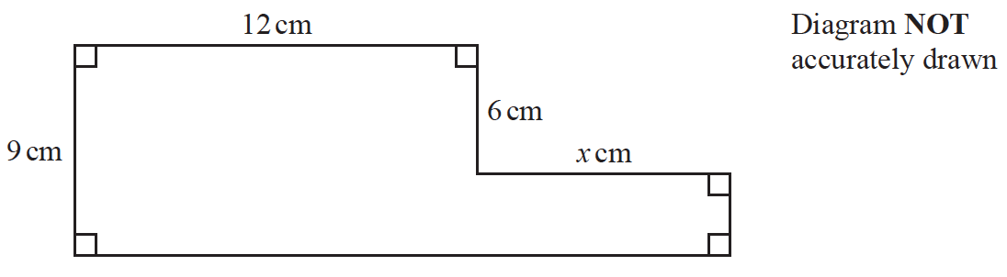

The shape has area 129 cm2

Work out the value of *x*.

*x* = .......................................................

**(Total for Question 6 is 4 marks)**

**___________________________________________________________________________**

**7** Here is a sequence of patterns made from square tiles.



(*a*)In the space below, draw Pattern number 4

**(1)**

(*b*)Complete the table.

|  |  |  |  |  |  |
| --- | --- | --- | --- | --- | --- |
| **Pattern number** | 1 | 2 | 3 | 4 | 5 |
| **Number of tiles** | 4 | 6 | 8 |  |  |

**(1)**

(*c*)Work out the number of tiles in Pattern number 30

.......................................................

**(2)**

Liz says that in Pattern number *n*, the number of tiles is 2*n*.

(*d*)Is Liz correct?

You must give a reason for your answer.

......................................................................................................................................................

......................................................................................................................................................

**(1)**

**(Total for Question 7 is 5 marks)**

**___________________________________________________________________________**

**8** The table shows information about the weights, in kilograms, of 40 babies.

|  |  |
| --- | --- |
| **Weight (*w* kg)** | **Frequency** |
| 2 < *w* ⩽ 3 | 12 |
| 3 < *w* ⩽ 4 | 16 |
| 4 < *w* ⩽ 5 | 9 |
| 5 < *w* ⩽ 6 | 2 |
| 6 < *w* ⩽ 7 | 1 |

(*a*)Write down the modal class.

.......................................................

**(1)**

(*b*)Work out an estimate for the mean weight of the 40 babies.

....................................................... kg

**(4)**

One of the 40 babies is going to be chosen at random.

(*c*)Find the probability that this baby has a weight of more than 5 kg.

.......................................................

**(2)**

**(Total for Question 8 is 7 marks)**

**___________________________________________________________________________**

**9** The scale drawing shows the positions of a ship, *S*, and a port, *P*.



(*a*)Find the bearing of *S* from *P*.

.......................................................°

**(1)**

The ship *S* now sails directly towards port *P*.

The ship sails at an average speed of 24 km/h.

(*b*)Work out how long it takes the ship to get to *P*.

Give your answer correct to the nearest hour.

....................................................... hours

**(4)**

**(Total for Question 9 is 5 marks)**

**___________________________________________________________________________**

**10** Kwo asked 40 people where they went on holiday last year.

He is going to draw a pie chart for his results.

16 of the 40 people said they went to Egypt.

(*a*)Work out the size of the angle in the pie chart for Egypt.

.......................................................°

**(2)**

Tiffany asked some people what type of holiday they each like the best.

She used her results to draw this pie chart.

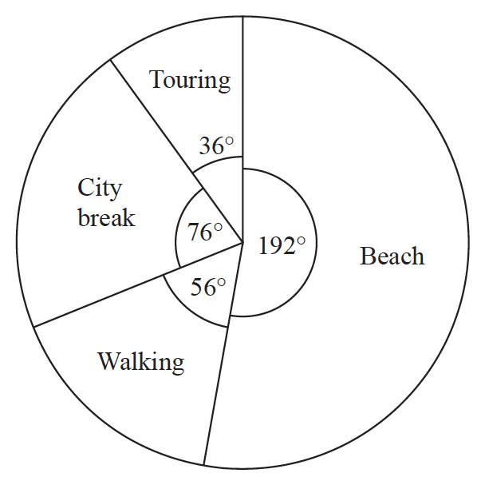

48 of the people that Tiffany asked said they like beach holidays the best.

(*b*)Work out how many of the people Tiffany asked said they like walking holidays

the best.

.......................................................

**(2)**

**(Total for Question 10 is 4 marks)**

**___________________________________________________________________________**

**11** Greg bought 36 oranges.

He paid 50p for each orange.

Greg sold  of the oranges for 60p each.

He sold  of the oranges for 40p each.

He sold the remainder of the oranges for 25p each.

Work out Greg’s percentage loss.

......................................................%

**(Total for Question 11 is 5 marks)**

**___________________________________________________________________________**

**12** (*a*)Find the highest common factor (HCF) of 28 and 70

.......................................................

**(2)**

(*b*)Find the lowest common multiple (LCM) of 28 and 105

.......................................................

**(2)**

**(Total for Question 12 is 4 marks)**

**___________________________________________________________________________**

**13** 120 children go on an activity holiday.

The ratio of the number of girls to the number of boys is 3 : 5

On Sunday, all the children either go sailing or go climbing.

 of the boys go climbing.

Twice as many girls go sailing as go climbing.

Work out how many children go sailing on Sunday.

.......................................................

**(Total for Question 13 is 6 marks)**

**___________________________________________________________________________**

**14** (*a*)Write 7.8 × 10−4 as an ordinary number.

..................................................................................

**(1)**

(*b*)Work out 

Give your answer in standard form.

..................................................................................

**(2)**

**(Total for Question 14 is 3 marks)**

**___________________________________________________________________________**

**15** Brendon, Asha and Julie share some money in the ratios 3 : 2 : 6

The **total** amount of money that Asha and Julie receive is £36

Work out the amount of money that Brendon receives.

£......................................................

**(Total for Question 15 is 3 marks)**

**___________________________________________________________________________**

**16** The diagram shows a box in the shape of a cuboid.



The box is put on a table.

The face of the box in contact with the table has length 1.2 metres and width *x* metres.

The force exerted by the box on the table is 27 newtons.

The pressure on the table due to the box is 30 newtons/m2

|  |
| --- |
|  |

Work out the value of *x*.

*x* = .......................................................

**(Total for Question 16 is 3 marks)**

**___________________________________________________________________________**

**17** The point *A* has coordinates (5, −4)

The point *B* has coordinates (13, 1)

(*a*)Work out the coordinates of the midpoint of *AB*.

(............................ , ............................)

**(2)**

Line **L** has equation *y* = 2 − 3*x*

(*b*)Write down the gradient of line **L**.

.......................................................

**(1)**

Line **L** has equation *y* = 2 − 3*x*

(*c*)Does the point with coordinates (100, −302) lie on line **L**?

You must give a reason for your answer.

......................................................................................................................................................

......................................................................................................................................................

......................................................................................................................................................

**(1)**

**(Total for Question 17 is 4 marks)**

**___________________________________________________________________________**

**18** Here is a right-angled triangle.

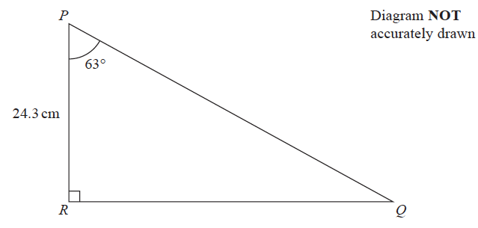

Calculate the length of *PQ*.

Give your answer correct to 3 significant figures.

....................................................... cm

**(Total for Question 18 is 3 marks)**

**___________________________________________________________________________**

**19** The diagram shows a regular hexagon, *ABCDEF*, and an isosceles triangle, *GHJ*.

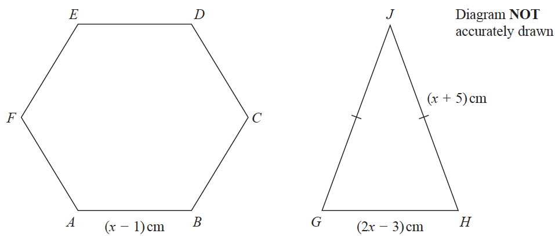

The perimeter of the hexagon is equal to the perimeter of the triangle.

Find the length of each side of the hexagon.

Show clear algebraic working.

...................................................... cm

**(Total for Question 19 is 5 marks)**

**TOTAL FOR PAPER IS 80 MARKS**