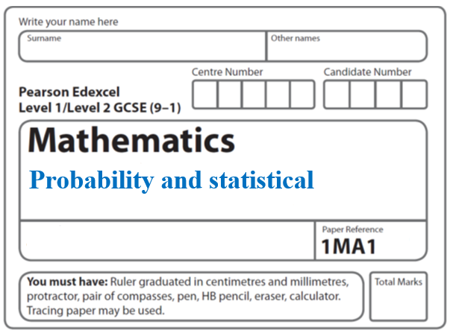**Instructions**

**Probability**

* Use **black** ink or ball-point pen.
  + **Fill in the boxes** at the top of this page with your name,  
    centre number and candidate number.
* Answer **all** questions.
* Answer the questions in the spaces provided  
  *– there may be more space than you need.*
* You must **show all your working.**
* Diagrams are **NOT** accurately drawn, unless otherwise indicated.
* If your calculator does not have a *π* button, take the value of *π* to be3.142

unless the question instructs otherwise.

**Information**

* The total mark for this paper is 6**7**. There are **18** questions.
* Questions have been arranged in an ascending order of mean difficulty, as found by all students in the June 2017–November 2019 examinations.
* The marks for **each** question are shown in brackets  
  *– use this as a guide as to how much time to spend on each question.*

**Advice**

* Read each question carefully before you start to answer it.
* Keep an eye on the time.
* Try to answer every question.
* Check your answers if you have time at the end.

**1** There are only blue cubes, red cubes and yellow cubes in a box.

The table shows the probability of taking at random a blue cube from the box.

|  |  |  |  |
| --- | --- | --- | --- |
| **Colour** | blue | red | yellow |
| **Probability** | 0.2 |  |  |

The number of red cubes in the box is the same as the number of yellow cubes in the box.

(*a*)Complete the table.

**(2)**

There are 12 blue cubes in the box.

(*b*)Work out the total number of cubes in the box.

.......................................................

**(2)**

**(Total for Question 1 is 4 marks)**

**___________________________________________________________________________**

**2** There are only blue counters, yellow counters, green counters and red counters in a bag.

A counter is taken at random from the bag.

The table shows the probabilities of getting a blue counter or a yellow counter or a green counter.

|  |  |  |  |  |
| --- | --- | --- | --- | --- |
| **Colour** | blue | yellow | green | red |
| **Probability** | 0.2 | 0.35 | 0.4 |  |

(*a*)Work out the probability of getting a red counter.

......................................................

**(1)**

(*b*)What is the least possible number of counters in the bag?

You must give a reason for your answer.

............................................................................................................................................................................................................................................................................................................

**(2)**

**(Total for Question 2 is 3 marks)**

**___________________________________________________________________________**

**3** The table shows the probabilities that a biased dice will land on 2, on 3, on 4, on 5 and on 6

|  |  |  |  |  |  |  |
| --- | --- | --- | --- | --- | --- | --- |
| **Number on dice** | **1** | **2** | **3** | **4** | **5** | **6** |
| **Probability** |  | 0.17 | 0.18 | 0.09 | 0.15 | 0.1 |

Neymar rolls the biased dice 200 times.

Work out an estimate for the total number of times the dice will land on 1 or on 3.

......................................................

**(Total for Question 3 is 3 marks)**

**___________________________________________________________________________**

**4** There are some counters in a bag.

The counters are red or white or blue or yellow.

Bob is going to take at random a counter from the bag.

The table shows each of the probabilities that the counter will be blue or will be yellow.

|  |  |  |  |  |
| --- | --- | --- | --- | --- |
| **Colour** | red | white | blue | yellow |
| **Probability** |  |  | 0.45 | 0.25 |

There are 18 blue counters in the bag.

The probability that the counter Bob takes will be red is twice the probability that the

counter will be white.

(*a*)Work out the number of red counters in the bag.

.......................................................

(**4**)

A marble is going to be taken at random from a box of marbles.

The probability that the marble will be silver is 0.5.

There must be an even number of marbles in the box.

(*b*)Explain why.

......................................................................................................................................................

......................................................................................................................................................

(**1**)

(**Total for Question 4 is 5 marks**)

**___________________________________________________________________________**

**5** The table shows some information about the dress sizes of 25 women.

|  |  |
| --- | --- |
| **Dress size** | **Number of women** |
| 8 | 2 |
| 10 | 9 |
| 12 | 8 |
| 14 | 6 |

(*a*)Find the median dress size.

.......................................................

**(1)**

3 of the 25 women have a shoe size of 7

Zoe says that if you choose at random one of the 25 women, the probability that she has

either a shoe size of 7 or a dress size of 14 is  because



(*b*)Is Zoe correct?

You must give a reason for your answer.

......................................................................................................................................................

......................................................................................................................................................

**(1)**

**(Total for Question 5 is 2 marks)**

**___________________________________________________________________________**

**6** There are 9 counters in a bag.

7 of the counters are green.

2 of the counters are blue.

Ria takes at random two counters from the bag.

Work out the probability that Ria takes one counter of each colour.

You must show your working.

.......................................................

**(Total for Question 6 is 4 marks)**

**___________________________________________________________________________**

**7** There are only red counters, blue counters and purple counters in a bag.

The ratio of the number of red counters to the number of blue counters is 3 : 17

Sam takes at random a counter from the bag.

The probability that the counter is purple is 0.2

Work out the probability that Sam takes a red counter.

.......................................................

(**Total for Question 7 is 3 marks**)

**___________________________________________________________________________**

**8** There are only blue cubes, yellow cubes and green cubes in a bag.

There are

twice as many blue cubes as yellow cubes

and four times as many green cubes as blue cubes.

Hannah takes at random a cube from the bag.

Work out the probability that Hannah takes a yellow cube.

......................................................

**(Total for Question 8 is 3 marks)**

**___________________________________________________________________________**

**9** When a drawing pin is dropped it can land point down or point up.

Lucy, Mel and Tom each dropped the drawing pin a number of times.

The table shows the number of times the drawing pin landed point down and the number

of times the drawing pin landed point up for each person.

|  |  |  |  |
| --- | --- | --- | --- |
|  | **Lucy** | **Mel.** | **Tom** |
| **point down** | 31 | 53 | 16 |
| **point up** | 14 | 27 | 9 |

Rachael is going to drop the drawing pin once.

(*a*)Whose results will give the best estimate for the probability that the drawing pin will

land point up?

Give a reason for your answer. ......................................................................................................................................................

......................................................................................................................................................

**(1)**

Stuart is going to drop the drawing pin twice.

(*b*)Use all the results in the table to work out an estimate for the probability that the

drawing pin will land point up the first time and point down the second time.

.......................................................

**(2)**

**(Total for Question 9 is 3 marks)**

**___________________________________________________________________________**

**10** There are only red counters and blue counters in a bag.

Joe takes at random a counter from the bag.

The probability that the counter is red is 0.65

Joe puts the counter back into the bag.

Mary takes at random a counter from the bag.

She puts the counter back into the bag.

(*a*)What is the probability that Joe and Mary take counters of different colours?

..............................................................

**(2)**

There are 78 red counters in the bag.

(*b*)How many blue counters are there in the bag?

..............................................................

**(2)**

**(Total for Question 10 is 4 marks)**

**___________________________________________________________________________**

**11** There are only *r* red counters and *g* green counters in a bag.

A counter is taken at random from the bag.

The probability that the counter is green is 

The counter is put back in the bag.

2 more red counters and 3 more green counters are put in the bag.

A counter is taken at random from the bag.

The probability that the counter is green is 

Find the number of red counters and the number of green counters that were in the bag originally.

ed counters.......................................................

green counters.......................................................

**(Total for Question 11 is 5 marks)**

**___________________________________________________________________________**

**12** There are 12 counters in a bag.

There is an equal number of red counters, blue counters and yellow counters in the bag.

There are no other counters in the bag.

3 counters are taken at random from the bag.

(*a*) Work out the probability of taking 3 red counters.

......................................................

**(2)**

The 3 counters are put back into the bag.

Some more counters are now put into the bag.

There is still an equal number of red counters, blue counters and yellow counters in the bag.

There are no counters of any other colour in the bag.

3 counters are taken at random from the bag.

(*b*) It is now less likely or equally likely or more likely that the 3 counters will be red?

You must show how you get your answer.

**(2)**

**(Total for Question 12 is 4 marks)**

**___________________________________________________________________________**

**13** Marek has 9 cards.

There is a number on each card.

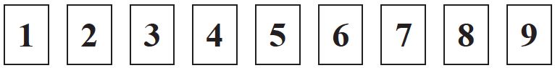

Marek takes at random two of the cards.

He works out the product of the numbers on the two cards.

Work out the probability that the product is an even number.

.......................................................

**(Total for Question 13 is 3 marks)**

**___________________________________________________________________________**

**14** When a biased coin is thrown 4 times, the probability of getting 4 heads is 

Work out the probability of getting 4 tails when the coin is thrown 4 times.

.......................................................

**(Total for Question 14 is 2 marks)**

**___________________________________________________________________________**

**15** There are only green pens and blue pens in a box.

There are three more blue pens than green pens in the box.

There are more than 12 pens in the box.

Simon is going to take at random two pens from the box.

The probability that Simon will take two pens of the same colour is 

Work out the number of green pens in the box.

......................................................

**(Total for Question 15 is 6 marks)**

**16** There are

6 black counters and 4 white counters in bag **A**

7 black counters and 3 white counters in bag **B**

5 black counters and 5 white counters in bag **C3**

Bernie takes at random a counter from bag **A** and puts the counter in bag **B**.

He then takes at random a counter from bag **B** and puts the counter in bag **C**.

Find the probability that there are now more black counters than white counters in bag **C**.

.........................................

**(Total for Question 16 is 3 marks)**

**___________________________________________________________________________**

**17** There are some red counters and some white counters in a bag.

At the start, 7 of the counters are red, the rest of the counters are white.

Alfie takes at random a counter from the bag.

He does not put the counter back in the bag.

Alfie then takes at random another counter from the bag.

The probability that the first counter Alfie takes is white **and** the second counter Alfie

takes is red is .

Work out the number of white counters in the bag at the start.

.......................................................

**(Total for Question 17 is 5 marks)**

**___________________________________________________________________________**

**___________________________________________________________________________**

**18** There are 9 counters in a bag.

There is an even number on 3 of the counters.

There is an odd number on 6 of the counters.

Three counters are going to be taken at random from the bag.

The numbers on the counters will be added together to give the total.

Find the probability that the total is an odd number.

.......................................................

**(Total for Question 18 is 5 marks)**

**___________________________________________________________________________**

**TOTAL MARKS FOR PAPER: 67**