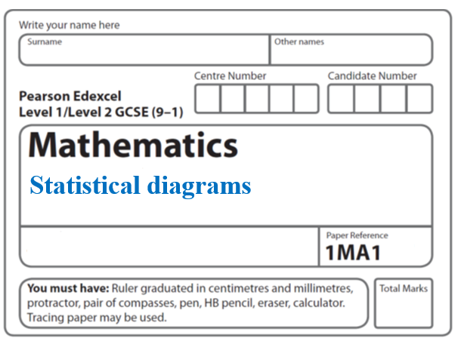**Instructions**

**Box plots**

* Use **black** ink or ball-point pen.
  + **Fill in the boxes** at the top of this page with your name,  
    centre number and candidate number.
* Answer **all** questions.
* Answer the questions in the spaces provided  
  *– there may be more space than you need.*
* You must **show all your working.**
* Diagrams are **NOT** accurately drawn, unless otherwise indicated.
* If your calculator does not have a *π* button, take the value of *π* to be3.142

unless the question instructs otherwise.

**Information**

* The total mark for this paper is **43**. There are **10** questions.
* Questions have been arranged in an ascending order of mean difficulty, as found by all students in the June 2017–November 2019 examinations.
* The marks for **each** question are shown in brackets  
  *– use this as a guide as to how much time to spend on each question.*

**Advice**

* Read each question carefully before you start to answer it.
* Keep an eye on the time.
* Try to answer every question.

Check your answers if you have time at the end.

**1** The box plot shows information about the distribution of the amounts of money spent by

some male students on their holidays.



(*a*)Work out the interquartile range for the amounts of money spent by these male students.

£.......................................................

**(2)**

The table below shows information about the distribution of the amounts of money spent

by some female students on their holidays.

|  |  |  |  |  |  |
| --- | --- | --- | --- | --- | --- |
|  | Smallest | Lower quartile | Median | Upper quartile | Largest |
| Money spent (£) | 60 | 180 | 300 | 350 | 650 |

(*b*)On the grid above, draw a box plot for the information in the table.

**(2)**

Chris says,

“The box plots show that the female students spent more money than the male students.”

(*c*)Is Chris correct?

Give a reason for your answer.

..........................................................................................................................................

..........................................................................................................................................

..........................................................................................................................................

..........................................................................................................................................

**(1)**

**(Total for Question 1 is 5 marks)**

**_____________________________________________________________________**

**2** The table gives some information about the heights of 80 girls.

|  |  |
| --- | --- |
| Least height | 133 cm |
| Greatest height | 170 cm |
| Lower quartile | 145 cm |
| Upper quartile | 157 cm |
| Median | 151 cm |

(*a*)Draw a box plot to represent this information.



(**3**)

(*b*)Work out an estimate for the number of these girls with a height between 133 cm and 157 cm.

.......................................................

(**2**)

(**Total for Question 2 is 5 marks**)

**_____________________________________________________________________**

**3** Megan grows potatoes.

The box plot below shows information about the weights of Megan’s potatoes.

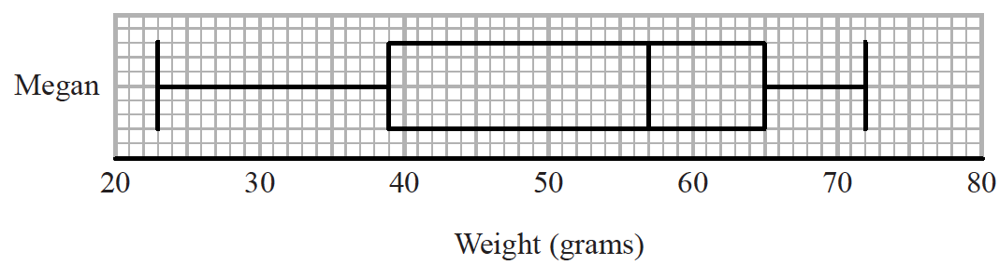

Megan says that half of her potatoes weigh less than 50 grams each.

(*a*)Is Megan correct?

Give a reason for your answer.

..........................................................................................................................................

..........................................................................................................................................

..........................................................................................................................................

**(1)**

Amy also grows potatoes.

The box plot below shows information about the weights of Amy’s potatoes.

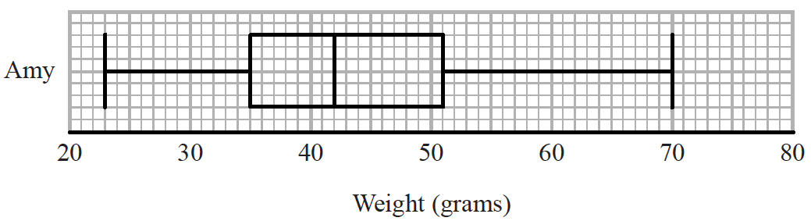

(*b*)Compare the distribution of the weights of Megan’s potatoes with the distribution of the weights of Amy’s potatoes.

..........................................................................................................................................

..........................................................................................................................................

..........................................................................................................................................

..........................................................................................................................................

..........................................................................................................................................

**(2)**

**(Total for Question 3 is 3 marks)**

**_____________________________________________________________________**

**4** The table shows information about the heights, in cm, of a group of Year 11 girls.

|  |  |
| --- | --- |
|  | **height (cm)** |
| least height | 154 |
| median | 165 |
| lower quartile | 161 |
| interquartile range | 7 |
| range | 20 |

(*a*)Draw a box plot for this information.



**(3)**

The box plot below shows information about the heights, in cm, of a group of Year 7 girls.



(*b*)Compare the distribution of heights of the Year 7 girls with the distribution of heights of the Year 11 girls.

..........................................................................................................................................

..........................................................................................................................................

..........................................................................................................................................

..........................................................................................................................................

**(2)**

**(Total for Question 4 is 5 marks)**

**_____________________________________________________________________**

**5** The stem and leaf diagram shows information about the heights, in cm, of 23 sunflowers.

|  |  |  |  |  |  |  |  |  |  |
| --- | --- | --- | --- | --- | --- | --- | --- | --- | --- |
| 17 | 3 | 4 | 9 |  |  |  |  |  |  |
| 18 | 6 | 8 | 8 |  |  |  |  |  |  |
|  |
| 19 | 0 | 0 | 1 | 4 | 6 | 7 | 8 |  | Key: 17|3 represents 173 cm |
| 20 | 1 | 4 | 7 | 7 | 9 | 9 |  |  |  |
|  |
| 21 | 4 | 8 | 8 | 9 |  |  |  |  |  |

On the grid, draw a box plot for this information.

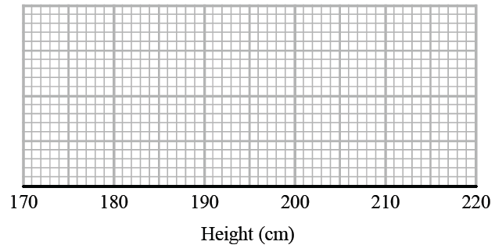

**(Total for Question 5 is 3 marks)**

**_________________________________________________________________________**

**6** The times that 48 trains left a station on Monday were recorded.

The cumulative frequency graph gives information about the numbers of minutes the

trains were delayed, correct to the nearest minute.



The shortest delay was 0 minutes.

The longest delay was 42 minutes.

(*a*)On the grid below, draw a box plot for the information about the delays on Monday.



**(3)**

48 trains left the station on Tuesday.

The box plot below gives information about the delays on Tuesday.



(*b*)Compare the distribution of the delays on Monday with the distribution of the delays

on Tuesday.

..........................................................................................................................................

..........................................................................................................................................

..........................................................................................................................................

..........................................................................................................................................

**(2)**

Mary says,

“The longest delay on Tuesday was 33 minutes.

This means that there must be some delays of between 25 minutes and 30 minutes.”

(*c*)Is Mary right?

You must give a reason for your answer.

..........................................................................................................................................

..........................................................................................................................................

**(1)**

**(Total for Question 6 is 6 marks)**

**7** Joan measured the heights of students in four different classes.

She drew a cumulative frequency graph and a box plot for each class.

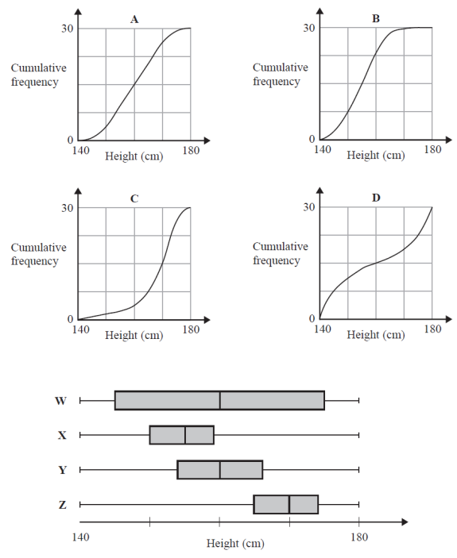Match each cumulative frequency graph to its box plot.

|  |  |
| --- | --- |
| **Cumulative frequency graph** | **Box plot** |
| **A** |  |
| **B** |  |
| **C** |  |
| **D** |  |

**(Total for Question 7 is 2 marks)**

**_____________________________________________________________________**

**8** Tom grows tomatoes.

The box plot below shows the distribution of the weights of 15 of Tom’s tomatoes.



(a)Work out the interquartile range.

....................................................... g

**(1)**

Jack also grows tomatoes.

Here are the weights, in grams, of 15 of Jack’s tomatoes.

|  |  |  |  |  |  |  |  |  |  |  |  |  |  |  |
| --- | --- | --- | --- | --- | --- | --- | --- | --- | --- | --- | --- | --- | --- | --- |
| 153 | 155 | 158 | 164 | 166 | 167 | 170 | 170 | 173 | 174 | 175 | 175 | 177 | 179 | 186 |

(b)On the grid below, draw a box plot for this information.



**(3)**

(c)Compare the distribution of the weights of Tom’s tomatoes with the distribution of

the weights of Jack’s tomatoes.

..........................................................................................................................................

..........................................................................................................................................

..........................................................................................................................................

..........................................................................................................................................

**(2)**

**(Total for Question 8 is 6 marks)**

**_____________________________________________________________________**

**9** The table shows some information about the weights, in kg, of some boxes.

|  |  |  |  |  |
| --- | --- | --- | --- | --- |
| Minimum | Lower Quartile | Median | Upper Quartile | Range |
| 12 | 20 | 32 | 40 | 55 |

Ben uses this information to draw the box plot below.

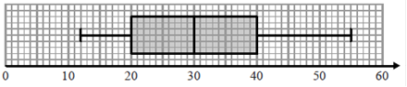

Weight (kg)

Write down two things wrong with this box plot.

1........................................................................................................................................

2........................................................................................................................................

**(Total for Question 9 is 2 marks)**

**_____________________________________________________________________**

**10** The stem and leaf diagram shows the ages, in years, of 25 people.

|  |  |  |  |  |  |  |  |  |  |  |  |  |  |  |  |  |  |  |
| --- | --- | --- | --- | --- | --- | --- | --- | --- | --- | --- | --- | --- | --- | --- | --- | --- | --- | --- |
| 1 | 7 | 7 | 8 | 9 |  |  |  |  |  |  |  | Key: 1 | 7 represents 17 years | | | | | | |
| 2 | 1 | 2 | 4 | 4 | 5 | 5 | 6 | 7 | 8 | 9 | 9 |  |  |  |  |  |  |  |
| 3 | 0 | 1 | 2 | 2 | 3 | 4 | 5 | 6 |  |  |  |  |  |  |  |  |  |  |
| 4 | 0 | 1 |  |  |  |  |  |  |  |  |  |  |  |  |  |  |  |  |

(*a*) (i) On the grid, draw a box plot for this information.



**(3)**

One of these people is chosen at random.

(ii) What is the probability that this person is 30 years of age or older?

.......................................................

**(2)**

The grouped frequency table gives information about the ages of a different group of people.

|  |  |
| --- | --- |
| **Age (*a* years)** | **Frequency** |
| 0 < *a* ⩽ 20 | 7 |
| 20 < *a* ⩽ 30 | 12 |
| 30 < *a* ⩽ 40 | 5 |
| 40 < *a* ⩽ 50 | 1 |

Anne drew this cumulative frequency table for this information.

|  |  |
| --- | --- |
| **Age (*a* years)** | **Cumulative frequency** |
| 0 < *a* ⩽ 20 | 7 |
| 20 < *a* ⩽ 30 | 19 |
| 30 < *a* ⩽ 40 | 24 |
| 40 < *a* ⩽ 50 | 25 |

The cumulative frequency table is **not** correct.

(*b*) Write down one thing that is wrong with the table.

..........................................................................................................................................

**(1)**

**(Total for Question 10 is 6 marks)**

**_____________________________________________________________________**

**TOTAL MARKS FOR PAPER: 43**