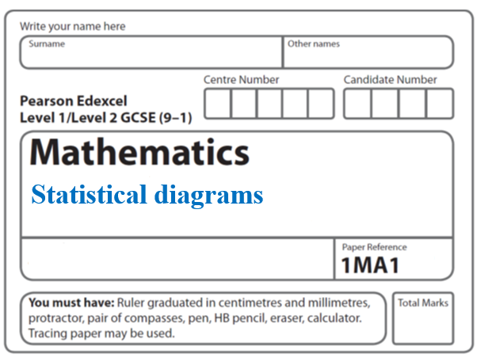**Instructions**

**Histograms**

* Use **black** ink or ball-point pen.
  + **Fill in the boxes** at the top of this page with your name,  
    centre number and candidate number.
* Answer **all** questions.
* Answer the questions in the spaces provided  
  *– there may be more space than you need.*
* You must **show all your working.**
* Diagrams are **NOT** accurately drawn, unless otherwise indicated.
* If your calculator does not have a *π* button, take the value of *π* to be3.142

unless the question instructs otherwise.

**Information**

* The total mark for this paper is **27**. There are **8** questions.
* Questions have been arranged in an ascending order of mean difficulty, as found by all students in the June 2017–November 2019 examinations.
* The marks for **each** question are shown in brackets  
  *– use this as a guide as to how much time to spend on each question.*

**Advice**

* Read each question carefully before you start to answer it.
* Keep an eye on the time.
* Try to answer every question.

Check your answers if you have time at the end.

**1** The histogram shows information about the times taken by some students to finish a puzzle.



(*a*)Complete the frequency table for this information.

|  |  |
| --- | --- |
| **Time taken** (***t* minutes**) | **Frequency** |
| 0 < *t* ⩽ 5 | 4 |
| 5 < *t* ⩽ 15 |  |
| 15 < *t* ⩽ 25 |  |
| 25 < *t* ⩽ 30 |  |
| 30 < *t* ⩽ 50 |  |

(**2**)

(*b*)Find an estimate for the lower quartile of the times taken to finish the puzzle.

................................. minutes

(**2**)

(**Total for Question 1 is 4 marks**)

**_____________________________________________________________________**

**2** The histogram shows some information about the ages of the 134 members of a sports club.



20% of the members of the sports club who are over 50 years of age are female.

Work out an estimate for the number of female members who are over 50 years of age.

......................................................

**(Total for Question 2 is 3 marks)**

**_____________________________________________________________________**

**3** The histogram gives information about the distribution of the weights of some onions

grown by a farmer.

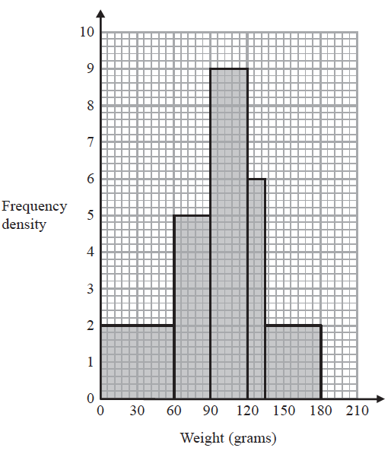

Onions less than 60 grams in weight are used for pickling.

Onions greater than 120 grams in weight are sold at the market.

The rest of the onions are sent to a food processing factory.

A pie chart is drawn using the information opposite to show what the farmer does with the onions he grows.

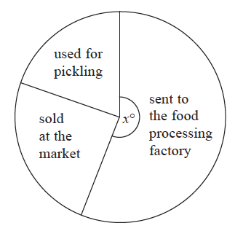

The angle of the sector for the onions sent to the food processing factory is *x*°.

Work out the value of *x*.

*x* = .......................................................

**(Total for Question 3 is 4 marks)**

**_____________________________________________________________________**

**4** The table shows information about the distances 570 students travelled to a university

open day.

|  |  |
| --- | --- |
| **Distance (*d* miles)** | **Frequency** |
| 0 < *d* ⩽ 20 | 120 |
| 20 < *d* ⩽ 50 | 90 |
| 50 < *d* ⩽ 80 | 120 |
| 80 < *d* ⩽ 150 | 140 |
| 150 < *d* ⩽ 200 | 100 |

(*a*)Draw a histogram for the information in the table.



**(3)**

(*b*)Estimate the median distance.

....................................................... miles

**(2)**

**(Total for Question 4 is 5 marks)**

**_____________________________________________________________________**

**5** The histogram shows information about the ages of the members of a football

supporters club.



There are 20 members aged between 25 and 30

One member of the club is chosen at random.

What is the probability that this member is more than 30 years old?

..................................................................................

**(Total for Question 5 is 3 marks)**

**_____________________________________________________________________**

**6** The histogram gives information about the weights of some fish.

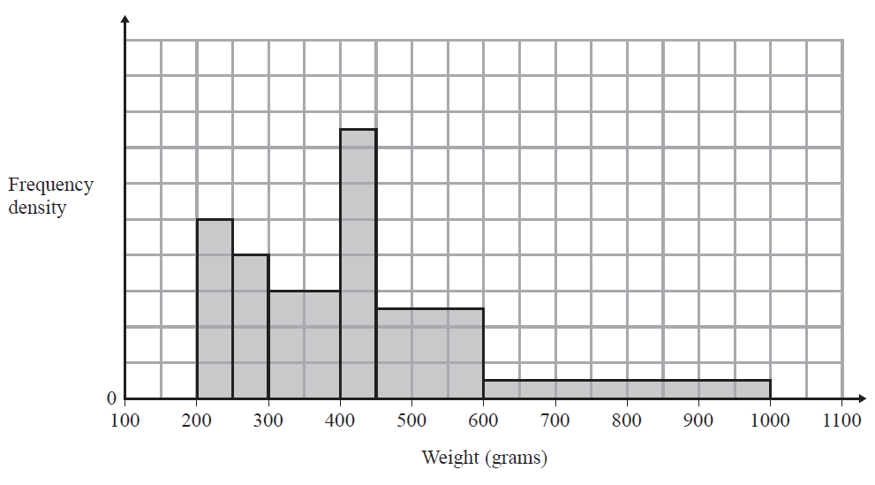

The number of fish with a weight between 400 g and 450 g is 7 more than the number of fish with a weight between 250 g and 300 g.

(a) Calculate the total number of fish represented by the histogram.

.......................................................

**(3)**

(b) (i) Use the histogram to find an estimate for the median weight.

....................................................... g

(ii) Give a reason why your answer to part (b)(i) is only an estimate.

..........................................................................................................................................

..........................................................................................................................................

**(3)**

**(Total for Question 6 is 6 marks) _____________________________________________________________________**

**7** The table shows information about the times a group of students took to do a park run.

|  |  |
| --- | --- |
| **Time taken (*t* minutes)** | **Frequency** |
| 0 < *t* ⩽ 25 | 20 |
| 25 < *t* ⩽ 45 | 35 |
| 45 < *t* ⩽ 60 | 45 |
| 60 < *t* ⩽ 75 | 87 |
| 75 < *t* ⩽ 85 | 10 |
| 85 < *t* ⩽ 95 | 8 |

Draw a histogram for this information.



**(Total for Question 7 is 3 marks)**

**_____________________________________________________________________**

**8** The histogram gives information about the heights, in metres, of the trees in a park.

The histogram is incomplete.

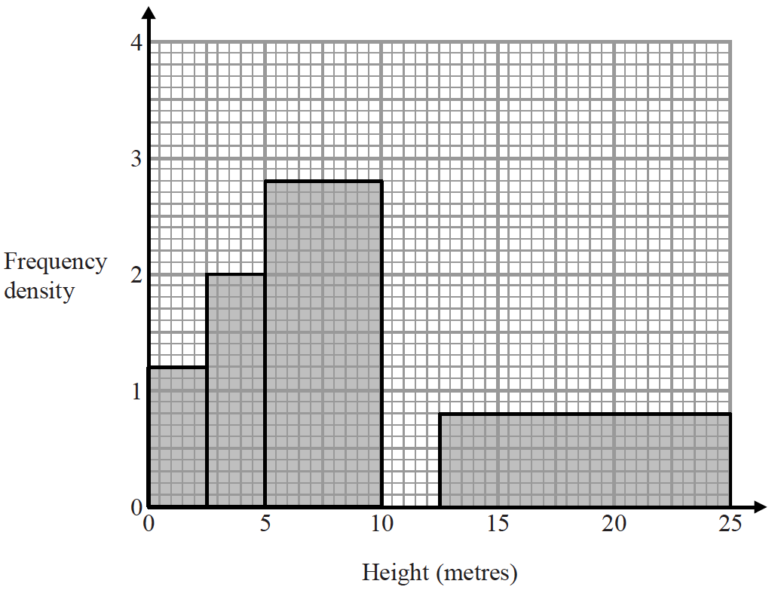

20% of the trees in the park have a height between 10 metres and 12.5 metres.

None of the trees in the park have a height greater than 25 metres.

Complete the histogram.

**(Total for Question 8 is 3 marks)**

**TOTAL MARKS FOR PAPER: 27**