**Similarity and Congruence**

**Instructions**

* Use **black** ink or ball-point pen.
  + **Fill in the boxes** at the top of this page with your name,  
    centre number and candidate number.
* Answer **all** questions.
* Answer the questions in the spaces provided  
  *– there may be more space than you need.*
* You must **show all your working.**
* Diagrams are **NOT** accurately drawn, unless otherwise indicated.
* If your calculator does not have a *π* button, take the value of *π* to be3.142

unless the question instructs otherwise.

**Information**

* The total mark for this paper is **20**. There are **7** questions.
* Questions have been arranged in an ascending order of mean difficulty, as found by all students in the June 2017–November 2019 examinations.
* The marks for **each** question are shown in brackets  
  *– use this as a guide as to how much time to spend on each question.*

**Advice**

1. Read each question carefully before you start to answer it.
2. Keep an eye on the time.
3. Try to answer every question.
4. Check your answers if you have time at the end.

**1** The diagram shows five shapes on a centimetre grid.



(*a*)Write down the name of shape **E**.

.......................................................

**(1)**

Two of the shapes are congruent.

(*b*)Write down the letters of these two shapes.

............................ and ............................

**(1)**

**(Total for Question 1 is 2 marks)**

**___________________________________________________________________________**

**2** *ABC* and *PQR* are similar right-angled triangles.

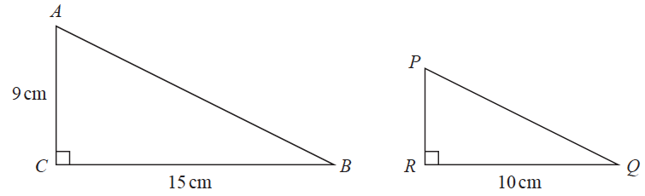

angle *ABC* = angle *PQR*

(*a*)Work out the length of *PR*.

....................................................... cm

**(2)**

Triangle *EGH* is congruent to triangle *KGF*.

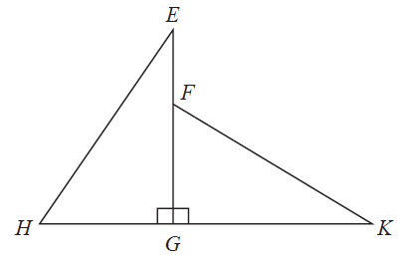

*HK* = 10 cm.

*HG* = 4 cm.

(*b*)Work out the length of *EF*.

....................................................... cm

**(2)**

**(Total for Question 2 is 4 marks)**

**___________________________________________________________________________**

**3** Here are two squares, **A** and **B**.

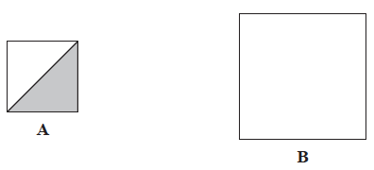

The length of the side of square **A** is 50% of the length of the side of square **B**.

Express the area of the shaded region of square **A** as a percentage of the area of square **B**.

....................................................... %

**(Total for Question 4 is 3 marks)**

**___________________________________________________________________________**

**4**



Show that these two triangles are mathematically similar.

**(Total for Question 7 is 2 marks)**

**___________________________________________________________________________**

**5** Here are two rectangles.



Jim says,

“The two rectangles are similar because 8 + 4 = 12 and 6 + 4 = 10”

Is Jim correct?

Explain your answer.

......................................................................................................................................................

......................................................................................................................................................

**(Total for Question 5 is 1 mark)**

**___________________________________________________________________________**

**6** Triangle *ABC* and triangle *DEF* are similar.

**

(*a*)Work out the length of *DF*.

....................................................... cm

(**2**)

(*b*)Work out the length of *CB*.

....................................................... cm

(**2**)

**(Total for Question 3 is 4 marks)**

**___________________________________________________________________________**

**7**

**

*ABC* and *EDC* are straight lines.

*EA* is parallel to *DB.*

*EC* = 8.1 cm.

*DC* = 5.4 cm.

*DB* = 2.6 cm.

(*a*)Work out the length of *AE.*

...................................................... cm

**(2)**

*AC* = 6.15 cm.

(*b*)Work out the length of *AB.*

...................................................... cm

**(2)**

**(Total for Question 6 is 4 marks)**

**___________________________________________________________________________**

**TOTAL MARKS FOR PAPER: 20**