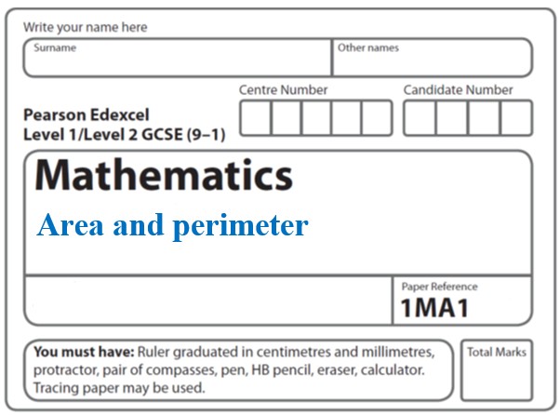

**Area and Perimeter: Arcs Sectors Circles**

**Instructions**

* Use **black** ink or ball-point pen.
  + **Fill in the boxes** at the top of this page with your name,  
    centre number and candidate number.
* Answer **all** questions.
* Answer the questions in the spaces provided  
  *– there may be more space than you need.*
* You must **show all your working.**
* Diagrams are **NOT** accurately drawn, unless otherwise indicated.
* If your calculator does not have a *π* button, take the value of *π* to be3.142

unless the question instructs otherwise.

**Information**

* The total mark for this paper is **71**. There are **16** questions.
* Questions have been arranged in an ascending order of mean difficulty, as found by all students in the June 2017–November 2019 examinations.
* The marks for **each** question are shown in brackets  
  *– use this as a guide as to how much time to spend on each question.*

**Advice**

* Read each question carefully before you start to answer it.
* Keep an eye on the time.
* Try to answer every question.
* Check your answers if you have time at the end.

**1** The diagram shows a shape made from a trapezium *ABCD* and a semicircle with diameter *DC*.



*DC* = 8 cm.

The shape has area 64 cm2

The height of the trapezium is 5 cm.

Work out the length of *AB*.

Give your answer correct to 1 decimal place.

....................................................... cm

**(Total for Question 1 is 5 marks)**

**___________________________________________________________________________**

**2** The diagram shows a cycle track.



The track has two straight sides each of length 40 m.

Each end of the track is a semicircle of radius 27 m.

The diameter of each wheel of Ian’s bike is 590 mm.

Ian is going to ride his bike around the track once.

Calculate how many complete revolutions each wheel of his bike will make.

.......................................................

**(Total for Question 2 is 5 marks)**

**___________________________________________________________________________**

**3** *OAB* is a sector of a circle with centre *O* and radius 7 cm.

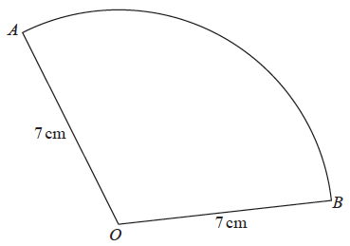

The area of the sector is 40 cm2

Calculate the perimeter of the sector.

Give your answer correct to 3 significant figures.

................................................ cm

**(Total for Question 3 is 4 marks)**

**___________________________________________________________________________**

**4**

**

*ONQ* is a sector of a circle with centre *O* and radius 11 cm.

*A* is the point on *ON* and *B* is the point on *OQ* such that *AOB*

is an equilateral triangle of side 7 cm.

Calculate the area of the shaded region as a percentage of the area of the sector *ONQ.*

Give your answer correct to 1 decimal place.

......................................................%

**(Total for Question 4 is 5 marks)**

**___________________________________________________________________________**

**5** A square, with sides of length *x* cm, is inside a circle.

Each vertex of the square is on the circumference of the circle.

The area of the circle is 49 cm2.

Work out the value of *x*.

Give your answer correct to 3 significant figures.

.......................................................

**(Total for Question 5 is 4 marks)**

**___________________________________________________________________________**

**6** The circumference of circle **B** is 90% of the circumference of circle **A**.

(*a*)Find the ratio of the area of circle **A** to the area of circle **B**.

.......................................................

**(2)**

Square **E** hassidesoflength*e* cm.

Square **F** has sides of length *f* cm.

The area of square **E** is 44% greater than the area of square **F**.

(*b*)Work out the ratio *e* : *f*

.......................................................

**(2)**

**(Total for Question 6 is 4 marks)**

**___________________________________________________________________________**

**7** The diagram shows a circle and an equilateral triangle.

One side of the equilateral triangle is a diameter of the circle.

The circle has a circumference of 44 cm.

Work out the area of the triangle.

Give your answer correct to 3 significant figures.

.......................................................cm2

**(Total for Question 7 is 3 marks)**

**___________________________________________________________________________**

**8** The diagram shows 3 identical circles inside a rectangle.

Each circle touches the other two circles and the sides of the rectangle, as shown in

the diagram.



The radius of each circle is 24 mm.

Work out the area of the rectangle.

Give your answer correct to 3 significant figures.

...................................................... mm2

**(Total for Question 8 is 4 marks)**

**___________________________________________________________________________**

**9** The diagram shows a square *ABCD* with sides of length 20 cm.

It also shows a semicircle and an arc of a circle.

**

*AB* is the diameter of the semicircle.

*AC* is an arc of a circle with centre *B*.

Show that 

**(Total for Question 9 is 4 marks)**

**___________________________________________________________________________**

**10** Here is a shaded shape *ABCD*.



The shape is made from a triangle and a sector of a circle, centre *O* and radius 6 cm.

*OCD* is a straight line.

*AD* = 14 cm

Angle *AOD* = 140°

Angle *OAD* = 24°

Calculate the perimeter of the shape.

Give your answer correct to 3 significant figures.

.......................................................cm

**(Total for Question 10 is 5 marks)**

**11** The diagram shows a logo made from three circles.



Each circle has centre *O*.

Daisy says that exactly  of the logo is shaded.

Is Daisy correct?

You must show all your working.

**(Total for Question 11 is 4 marks)**

**___________________________________________________________________________**

**12** The region **R**, shown shaded in the diagram, is the region between two circles with the

same centre.



The outer circle has radius (2*n* + 6)

The inner circle has radius (*n* – 1)

All measurements are in centimetres.

The area of **R** is greater than the area of a circle of radius (*n* + 13) cm.

*n* is an integer.

Find the least possible value of *n*.

You must show all of your working.

.......................................................

**(Total for Question 12 is 5 marks)**

**___________________________________________________________________________**

**13**

**

*AB* is a chord of a circle centre *O*.

The radius of the circle is 30 cm.

Angle *AOB* = 80°

Work out what percentage of the area of the circle is shaded.

.......................................................%

**(Total for Question 13 is 5 marks)**

**___________________________________________________________________________**

**14** The diagram shows a sector of a circle of radius 9 cm.



The sector has a perimeter of 25 cm.

Work out the value of *x*.

Give your answer correct to 1 decimal place.

.......................................................

**(Total for Question 14 is 4 marks)**

**___________________________________________________________________________**

**15**



*OAC* is a sector of a circle, centre *O*, radius 10 m.

*BA* is the tangent to the circle at point *A*.

*BC* is the tangent to the circle at point *C*.

Angle *AOC* = 120°

Calculate the area of the shaded region.

Give your answer correct to 3 significant figures.

......................................................m2

**(Total for Question 15 is 5 marks)**

**16** Here are two solid prisms, prism **A** and prism **B**.



prism **A** prism **B**

The cross section of prism **A** is a sector, with angle 45°, of a circle of radius 10 cm.

The prism has a depth of 10 cm and a mass of 40*π* grams.

The cross section of prism **B** is a sector, with angle 60°, of a circle of radius 10 cm.

The prism has a depth of 5 cm and a mass of 50*π* grams.

Express the difference in the densities of the two prisms as a percentage of the density of prism **A**.

....................................................... %

**(Total for Question 16 is 5 marks)**

**___________________________________________________________________________**

**TOTAL MARKS FOR PAPER: 71**