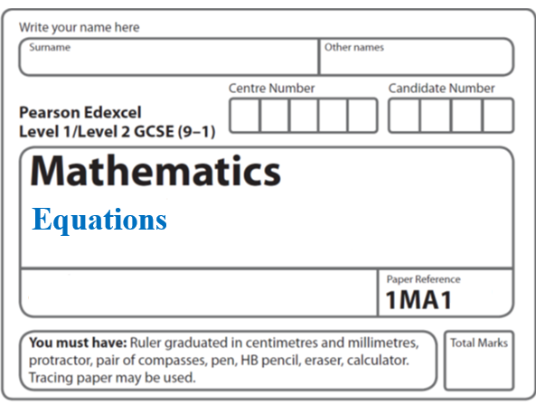**Instructions**

**Median and Quartiles**

* Use **black** ink or ball-point pen.
  + **Fill in the boxes** at the top of this page with your name,  
    centre number and candidate number.
* Answer **all** questions.
* Answer the questions in the spaces provided  
  *– there may be more space than you need.*
* You must **show all your working.**
* Diagrams are **NOT** accurately drawn, unless otherwise indicated.
* If your calculator does not have a *π* button, take the value of *π* to be3.142

unless the question instructs otherwise.

**Information**

* The total mark for this paper is **70**. There are **16** questions.
* Questions have been arranged in an ascending order of mean difficulty, as found by all students in the June 2017–November 2019 examinations.
* The marks for **each** question are shown in brackets  
  *– use this as a guide as to how much time to spend on each question.*

**Advice**

* Read each question carefully before you start to answer it.
* Keep an eye on the time.
* Try to answer every question.
* Check your answers if you have time at the end.

**1** A bus company recorded the ages, in years, of the people on coach A and the people

on coach B.

Here are the ages of the 23 people on coach A.

|  |  |  |  |  |  |  |  |  |  |  |  |
| --- | --- | --- | --- | --- | --- | --- | --- | --- | --- | --- | --- |
| 41 | 42 | 44 | 48 | 52 | 53 | 53 | 53 | 56 | 57 | 57 | 59 |
| 60 | 61 | 63 | 64 | 64 | 66 | 67 | 69 | 74 | 77 | 79 |  |

(*a*)Complete the table below to show information about the ages of the people on coach A.

|  |  |
| --- | --- |
| Median |  |
| Lower quartile |  |
| Upper quartile |  |
| Least age | 41 |
| Greatest age | 79 |

**(2)**

Here is some information about the ages of the people on coach B.

|  |  |
| --- | --- |
| Median | 70 |
| Lower quartile | 54 |
| Upper quartile | 73 |
| Least age | 42 |
| Greatest age | 85 |

Richard says that the people on coach A are younger than the people on coach B.

(*b*)Is Richard correct?

You must give a reason for your answer.

......................................................................................................................................................

......................................................................................................................................................

......................................................................................................................................................

**(1)**

Richard says that the people on coach A vary more in age than the people on coach B.

(c)Is Richard correct?

You must give a reason for your answer.

......................................................................................................................................................

......................................................................................................................................................

......................................................................................................................................................

**(1)**

**(Total for Question 1 is 4 marks)**

**___________________________________________________________________________**

**2** The box plot shows information about the distribution of the amounts of money spent by

some male students on their holidays.



(*a*)Work out the interquartile range for the amounts of money spent by these male students.

£.......................................................

**(2)**

The table below shows information about the distribution of the amounts of money spent

by some female students on their holidays.

|  |  |  |  |  |  |
| --- | --- | --- | --- | --- | --- |
|  | Smallest | Lower quartile | Median | Upper quartile | Largest |
| Money spent (£) | 60 | 180 | 300 | 350 | 650 |

(*b*)On the grid above, draw a box plot for the information in the table.

**(2)**

Chris says,

“The box plots show that the female students spent more money than the male students.”

(*c*)Is Chris correct?

Give a reason for your answer.

......................................................................................................................................................

......................................................................................................................................................

......................................................................................................................................................

......................................................................................................................................................

**(1)**

**(Total for Question 2 is 5 marks)**

**___________________________________________________________________________**

**3** The table gives some information about the heights of 80 girls.

|  |  |
| --- | --- |
| Least height | 133 cm |
| Greatest height | 170 cm |
| Lower quartile | 145 cm |
| Upper quartile | 157 cm |
| Median | 151 cm |

(*a*)Draw a box plot to represent this information.



(**3**)

(*b*)Work out an estimate for the number of these girls with a height between 133 cm and

157 cm.

.......................................................

(**2**)

(**Total for Question 3 is 5 marks**)

**____________________________________________________________________________**

**4** The table gives information about the times taken, in seconds, by 18 students to run a race.

|  |  |
| --- | --- |
| **Time (*t* seconds)** | **Frequency** |
| 5 < *t* ⩽ 10 | 1 |
| 10 < *t* ⩽ 15 | 2 |
| 15 < *t* ⩽ 20 | 7 |
| 20 < *t* ⩽ 25 | 8 |

Work out an estimate for the mean time.

Give your answer correct to 3 significant figures.

....................................................... seconds

**(Total for Question 4 is 3 marks)**

**___________________________________________________________________________**

**5** The table shows information about the heights of 80 plants.

|  |  |
| --- | --- |
| **Height (*h* cm)** | **Frequency** |
| 10 < *h* ⩽ 20 | 7 |
| 20 < *h* ⩽ 30 | 13 |
| 30 < *h* ⩽ 40 | 14 |
| 40 < *h* ⩽ 50 | 12 |
| 50 < *h* ⩽ 60 | 16 |
| 60 < *h* ⩽ 70 | 18 |

(*a*)Find the class interval that contains the median.

..................................................................................

**(1)**

(*b*)On the grid, draw a frequency polygon for the information in the table.

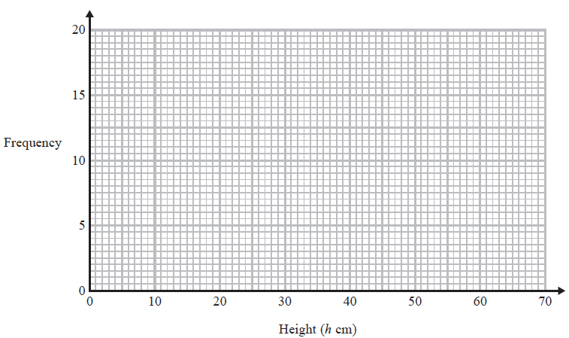

**(2)**

**(Total for Question 5 is 3 marks)**

**___________________________________________________________________________**

**6** The table shows information about the heights, in cm, of a group of Year 11 girls.

|  |  |
| --- | --- |
|  | **height (cm)** |
| least height | 154 |
| median | 165 |
| lower quartile | 161 |
| interquartile range | 7 |
| range | 20 |

(*a*)Draw a box plot for this information.



**(3)**

The box plot below shows information about the heights, in cm, of a group of Year 7 girls.



(*b*)Compare the distribution of heights of the Year 7 girls with the distribution of heights

of the Year 11 girls.

......................................................................................................................................................

......................................................................................................................................................

......................................................................................................................................................

......................................................................................................................................................

**(2)**

**(Total for Question 6 is 5 marks)**

**___________________________________________________________________________**

**7** The cumulative frequency graph shows information about the weights of 60 potatoes.



(*a*)Use the graph to find an estimate for the median weight.

....................................................... g

**(1)**

Jamil says,

“80 – 40 = 40 so the range of the weights is 40 g.”

(*b*)Is Jamil correct?

You must give a reason for your answer.

......................................................................................................................................................

......................................................................................................................................................

**(1)**

(*c*)Show that less than 25% of the potatoes have a weight greater than 65 g.

**(2)**

**(Total for Question 7 is 4 marks)**

**___________________________________________________________________________**

**8** The table shows information about the heights of 80 children.

|  |  |
| --- | --- |
| **Height (*h* cm)** | **Frequency** |
| 130 < *h* ⩽ 140 | 4 |
| 140 < *h* ⩽ 150 | 11 |
| 150 < *h* ⩽ 160 | 24 |
| 160 < *h* ⩽ 170 | 22 |
| 170 < *h* ⩽ 180 | 19 |

(*a*)Find the class interval that contains the median.

............................................................................

**(1)**

(*b*)Draw a frequency polygon for the information in the table.



**(2)**

**(Total for Question 8 is 3 marks)**

**___________________________________________________________________________**

**9** The cumulative frequency table shows information about the times, in minutes, taken by

40 people to complete a puzzle.

|  |  |
| --- | --- |
| **Time (*m* minutes)** | **Cumulative frequency** |
| 20 < *m* ⩽ 40 | 5 |
| 20 < *m* ⩽ 60 | 25 |
| 20 < *m* ⩽ 80 | 35 |
| 20 < *m* ⩽ 100 | 38 |
| 20 < *m* ⩽ 120 | 40 |

(*a*)On the grid below, draw a cumulative frequency graph for this information.

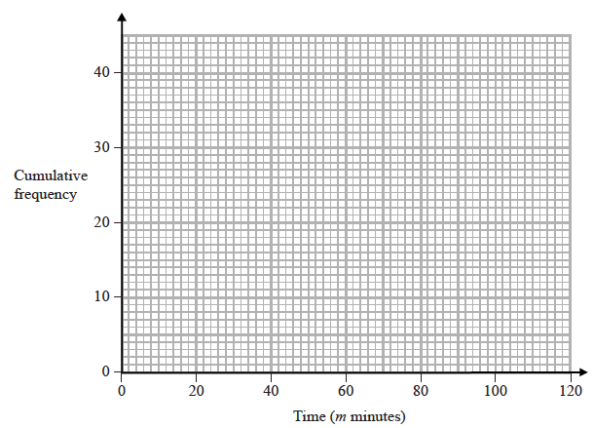

**(2)**

(*b*)Use your graph to find an estimate for the interquartile range.

....................................................... minutes

**(2)**

One of the 40 people is chosen at random.

(*c*)Use your graph to find an estimate for the probability that this person took between

50 minutes and 90 minutes to complete the puzzle.

.......................................................

**(2)**

**(Total for Question 10 is 6 marks)**

**___________________________________________________________________________**

**10** The table shows information about the distances 570 students travelled to a university

open day.

|  |  |
| --- | --- |
| **Distance (*d* miles)** | **Frequency** |
| 0 < *d* ⩽ 20 | 120 |
| 20 < *d* ⩽ 50 | 90 |
| 50 < *d* ⩽ 80 | 120 |
| 80 < *d* ⩽ 150 | 140 |
| 150 < *d* ⩽ 200 | 100 |

(*a*)Draw a histogram for the information in the table.



**(3)**

(*b*)Estimate the median distance.

....................................................... miles

**(2)**

**(Total for Question 11 is 5 marks)**

**____________________________________________________________________________**

**11** Tom grows tomatoes.

The box plot below shows the distribution of the weights of 15 of Tom’s tomatoes.

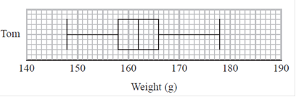

(a)Work out the interquartile range.

....................................................... g

**(1)**

Jack also grows tomatoes.

Here are the weights, in grams, of 15 of Jack’s tomatoes.

|  |  |  |  |  |  |  |  |  |  |  |  |  |  |  |
| --- | --- | --- | --- | --- | --- | --- | --- | --- | --- | --- | --- | --- | --- | --- |
| 153 | 155 | 158 | 164 | 166 | 167 | 170 | 170 | 173 | 174 | 175 | 175 | 177 | 179 | 186 |

(b)On the grid below, draw a box plot for this information.

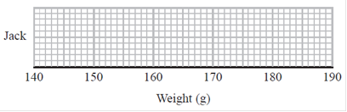

**(3)**

(c)Compare the distribution of the weights of Tom’s tomatoes with the distribution of

the weights of Jack’s tomatoes.

......................................................................................................................................................

......................................................................................................................................................

......................................................................................................................................................

......................................................................................................................................................

**(2)**

**(Total for Question 11 is 6 marks)**

**____________________________________________________________________________**

**12** The table shows some information about the weights, in kg, of some boxes.

|  |  |  |  |  |
| --- | --- | --- | --- | --- |
| Minimum | Lower Quartile | Median | Upper Quartile | Range |
| 12 | 20 | 32 | 40 | 55 |

Ben uses this information to draw the box plot below.

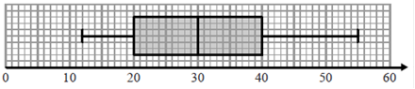

Weight (kg)

Write down two things wrong with this box plot.

1....................................................................................................................................................

2....................................................................................................................................................

**(Total for Question 12 is 2 marks)**

**___________________________________________________________________________**

**13** The histogram gives information about the weights of some fish.

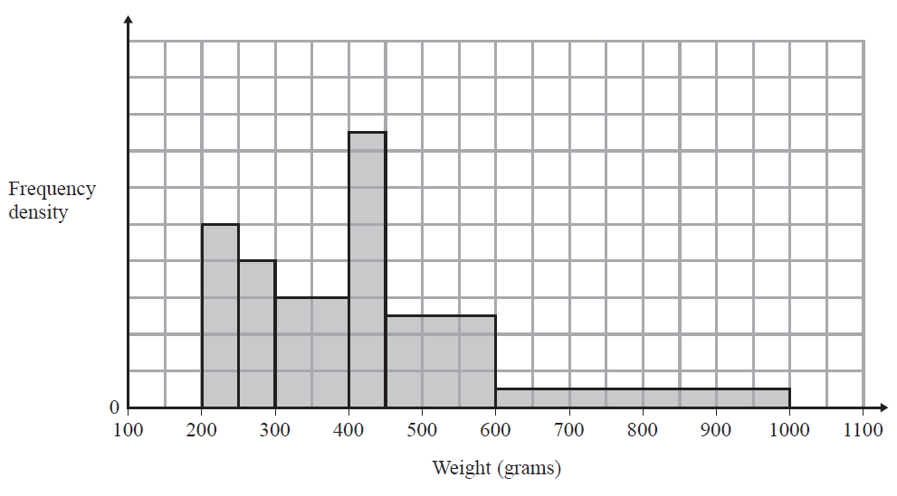

The number of fish with a weight between 400 g and 450 g is 7 more than the number of fish with a weight between 250 g and 300 g.

(a) Calculate the total number of fish represented by the histogram.

.......................................................

**(3)**

(b) (i) Use the histogram to find an estimate for the median weight.

....................................................... g

(ii) Give a reason why your answer to part (b)(i) is only an estimate.

......................................................................................................................................................

......................................................................................................................................................

**(3)**

**(Total for Question 13 is 6 marks) ___________________________________________________________________________**

**14** Francesco carried out a survey about the ages of the people in his office.

The table shows information about his results.

|  |  |
| --- | --- |
| **Age (*a* years)** | **Cumulative frequency** |
| 20 < *a* ⩽ 30 | 10 |
| 20 < *a* ⩽ 40 | 26 |
| 20 < *a* ⩽ 50 | 58 |
| 20 < *a* ⩽ 60 | 66 |
| 20 < *a* ⩽ 70 | 70 |

(*a*) On the grid opposite, draw a cumulative frequency graph for this information.

**(2)**



(*b*) Use your graph to find an estimate for the median age.

.......................................................years

**(1)**

Francesco says,

“More than 60% of the people in the office are between 35 and 55 years old.”

(*c*)Use your graph to determine if Francesco is correct.

......................................................................................................................................................

**(3)**

**(Total for Question 14 is 6 marks)**

**___________________________________________________________________________**

**15** The incomplete table and the incomplete box plot give information about the number of lorries using a bridge each day last January.

|  |  |
| --- | --- |
|  | **Number of lorries** |
| Least number |  |
| Lower quartile |  |
| Median |  |
| Upper quartile | 280 |
| Greatest number | 405 |



(a) (i) Use the information in the table to complete the box plot.

(ii) Use the information in the box plot to complete the table.

**(2)**

The box plot below gives information about the number of lorries using the bridge each day last February.



(b) Compare the distribution of the number of lorries using the bridge last January and the distribution of the number of lorries using the bridge last February.

................................................................................................................................................

................................................................................................................................................

................................................................................................................................................

................................................................................................................................................

**(2)**

**(Total for Question 15 is 4 marks)**

**____________________________________________________________________________**

**16** The table gives information about the times that 100 people took to travel to work.

|  |  |
| --- | --- |
| **Time (*t* minutes)** | **Frequency** |
| 0 < *t* ≤ 10 | 10 |
| 10 < *t* ≤ 20 | 26 |
| 20 < *t* ≤ 30 | 23 |
| 30 < *t* ≤ 40 | 19 |
| 40 < *t* ≤ 50 | 14 |
| 50 < *t* ≤ 60 | 8 |

(a) Find the class interval that contains the median.

.......................................................

**(1)**

(b) Draw a frequency polygon for the information in the table.

 **(2)**

**(Total for Question 16 is 3 marks)**

**TOTAL MARKS FOR PAPER: 70**