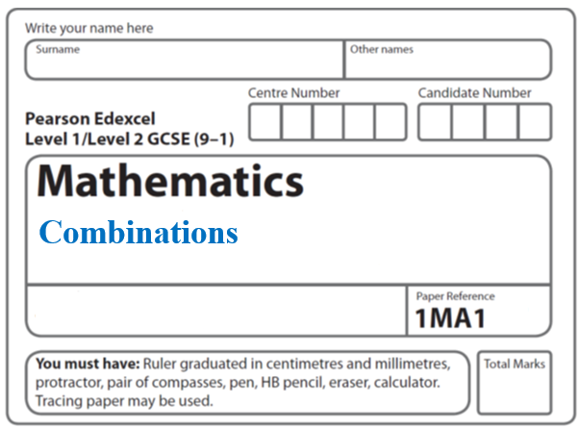**Instructions**

* Use **black** ink or ball-point pen.
  + **Fill in the boxes** at the top of this page with your name,  
    centre number and candidate number.
* Answer **all** questions.
* Answer the questions in the spaces provided  
  *– there may be more space than you need.*
* You must **show all your working.**
* Diagrams are **NOT** accurately drawn, unless otherwise indicated.
* If your calculator does not have a *π* button, take the value of *π* to be3.142

unless the question instructs otherwise.

**Information**

* The total mark for this paper is **14**. There are **5** questions.
* Questions have been arranged in an ascending order of mean difficulty, as found by all students in the June 2017–November 2019 examinations.
* The marks for **each** question are shown in brackets  
  *– use this as a guide as to how much time to spend on each question.*

**Advice**

* Read each question carefully before you start to answer it.
* Keep an eye on the time.
* Try to answer every question.
* Check your answers if you have time at the end.

**1** Sadia is going to buy a new car.

For the car, she can choose one body colour, one roof colour and one wheel type.

She can choose from

19 different body colours

25 different wheel types

The total number of ways Sadia can choose the body colour and the roof colour and the

wheel type is 3325

Work out the number of different roof colours that Sadia can choose from.

.......................................................

**(Total for Question 1 is 2 marks)**

**___________________________________________________________________________**

**2** In a restaurant there are

9 starter dishes

15 main dishes

8 dessert dishes

Janet is going to choose one of the following combinations for her meal.

a starter dish and a main dish

or a main dish and a dessert dish

or a starter dish, a main dish and a dessert dish

Show that there are 1335 different ways to choose the meal.

**(Total for Question 2 is 3 marks)**

**___________________________________________________________________________**

**3** Jeff is choosing a shrub and a rose tree for his garden.

At the garden centre there are 17 different types of shrubs and some rose trees.

Jeff says,

“There are 215 different ways to choose one shrub and one rose tree.”

Could Jeff be correct?

You must show how you get your answer.

**(Total for Question 3 is 2 marks)**

**___________________________________________________________________________**

**4** There are three dials on a combination lock.

Each dial can be set to one of the numbers 1, 2, 3, 4, 5

The three digit number 553 is one way the dials can be set, as shown in the diagram.

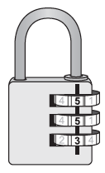

(*a*)Work out the number of different three digit numbers that can be set for the

combination lock.

.......................................................

**(2)**

(*b*)How many of the possible three digit numbers have three different digits?

.......................................................

**(2)**

**(Total for Question 4 is 4 marks)**

**___________________________________________________________________________**

**5** There are 95 girls and 87 boys in Year 13 at a school.

One girl is going to be chosen for the role of Head Girl.

A different girl is going to be chosen for the role of Deputy Head Girl.

One boy is going to be chosen for the role of Head Boy.

A different boy is going to be chosen for the role of Deputy Head Boy.

Work out how many different ways this can be done.

.......................................................

**(Total for Question 5 is 3 marks)**

**___________________________________________________________________________**

**TOTAL MARKS FOR PAPER: 14**