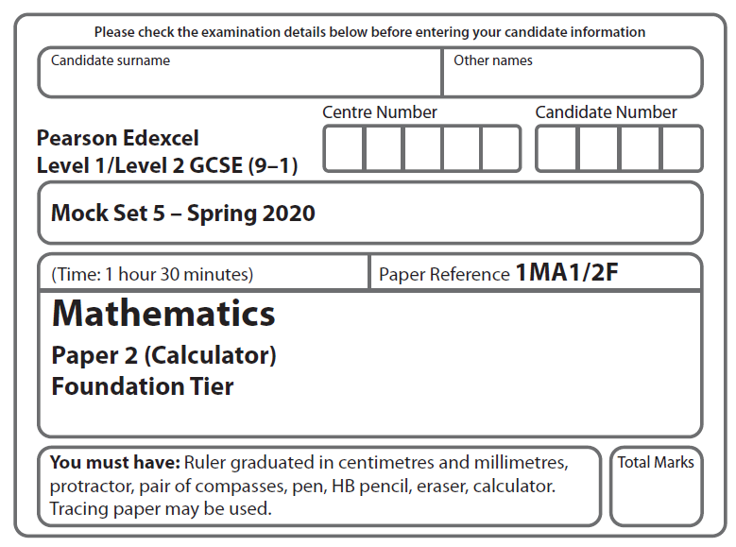

LPGS Autumn Mock Exam 2020

**Instructions**

* Use **black** ink or ball-point pen.
* 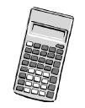**Fill in the boxes** at the top of this page with your name, centre number   
  and candidate number.
* Answer **all** questions.
* Answer the questions in the spaces provided.

*– there may be more space than you need.*

* You must **show all your working.**
* Diagrams are **NOT** accurately drawn, unless otherwise indicated.
* **Calculators may be used.**

**Information**

* The total mark for this paper is 80
* The marks for **each** question are shown in brackets

*– use this as a guide as to how much time to spend on each question.*

**Advice**

* Read each question carefully before you start to answer it.
* Try to answer every question.
* Check your answers if you have time at the end.

**S66510A**

**Answer ALL questions.**

**Write your answers in the spaces provided.**

**You must write down all the stages in your working.**

**1** Write the following numbers in order of size. Start with the smallest number.

0 – 1 3 5 – 4

…………………………………………………………………

**(Total for Question 1 is 1 mark)**

**2** Write the ratio 3 : 12 in its simplest form.

……………………

**(Total for Question 2 is 1 mark)**

**3** Write down all the factors of 8

………………………………………………………………………

**(Total for Question 3 is 1 mark)**

**4** Write as a percentage.

…………………..%

**(Total for Question 4 is 1 mark)**

**5** Change 250 millimetres to centimetres.

………………………. Centimetres

**(Total for Question 5 is 1 mark)**

**6**  Helen goes into a shop.

She wants to buy 2 shirts and a pair of shorts.

Each shirt costs £24.50

The pair of shorts costs £18.90

Helen only has £70 to spend.

Does Helen have enough money to buy the 2 shirts and the pair of shorts?

You must show how you get your answer.

**(Total for Question 6 is 3 marks)**

**7** The pictogram gives information about the number of cakes sold in a shop on Monday, on Tuesday, on Wednesday and on Thursday last week.

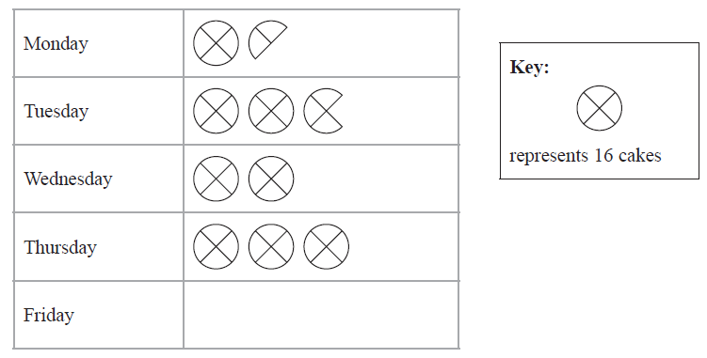

1. How many cakes were sold on Thursday?

…………………………

**(1)**

(b) Work out the total number of cakes sold on Monday, Tuesday and Wednesday.

………………………

**(2)**

On Friday 36 cakes were sold.

(c) Show this information on the pictogram.

**(1)**

**(Total for Question 7 is 4 marks)**

**8** Here is a timetable for the two trains **A** and **B.**

|  |  |  |
| --- | --- | --- |
|  | **A** | **B** |
| London | 13 20 | 13 40 |
| Stoke | 14 48 | 15 10 |

Which of these trains is expected to take the least time to travel from London to Stoke?

You must show how you get your answer.

**(Total for Question 8 is 2 marks)**

**9** Here is a rule for working out the area of a rhombus.

Multiply the lengths of the diagonals together

and then divide by 2

A rhombus has diagonals of length 6 cm and 8 cm.

(a) Use the rule to work out the area of this rhombus.

……………………………. cm2

**(1)**

A different rhombus has an area of 30 cm2

One of the diagonals of this rhombus has a length of 5 cm.

(b) Work out the length of the other diagonal.

……………………………. cm

**(2)**

**(Total for Question 9 is 3 marks)**

1. Here is a list of 8 numbers.

2 3 4 5 6 7 8 9

Aisha picks at random one of these numbers.

1. On the probability scale below, mark with a cross (**×**) the probability that

Aisha picks the number 1



0

1

**(1)**

1. On the probability scale below, mark with a cross (**×**) the probability that

Aisha picks a number greater than 5



0

1

**(1)**

**(Total for Question 10 is 2 marks)**

**11** Here is a centimetre grid.

|  |  |  |  |  |  |  |  |  |  |
| --- | --- | --- | --- | --- | --- | --- | --- | --- | --- |
|  |  |  |  |  |  |  |  |  |  |
|  |  |  |  |  |  |  |  |  |  |
|  |  |  |  |  |  |  |  |  |  |
|  |  |  |  |  |  |  |  |  |  |
|  |  |  |  |  |  |  |  |  |  |
|  |  |  |  |  |  |  |  |  |  |

On the grid, draw a rectangle with a perimeter of 20 cm.

**(Total for Question 11 is 2 marks)**

**12** Michelle cycles for 3 hours at an average speed of 27 km/h.

1. How many kilometres does Michelle cycle?

……………………….. km

**(2)**

Josh cycles 124 km in 4 hours.

1. What is his average speed?

…………………………….. km/h

**(2)**

The diagram shows a travel graph for two different cyclists, **A** and **B**.

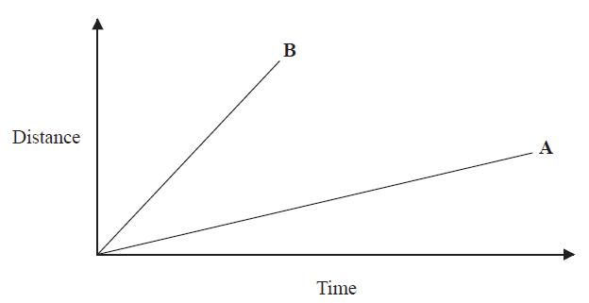

1. Which cyclist travelled at the greater average speed? You must give a reason for your answer.

…………………………………………………………………………………………………...

…………………………………………………………………………………………………...

…………………………………………………………………………………………………...

**(1)**

**(Total for Question 12 is 5 marks)**

1. Jamil buys 4 books and some pens.

Each book costs £5.95

Each pen costs £2.35

The total cost of the books and the pens is £37.90

Work out how many pens Jamil buys.

………………………….

**(Total for Question 13 is 3 marks)**

**14** (a) Write 16.45 correct to 1 decimal place.

……………………………..

**(1)**

(b) Write 4136 correct to 2 significant figures.

……………………………..

**(1)**

**(Total for Question 14 is 2 marks)**

**15** (a) Write one pair of brackets in this calculation so that the answer is correct.

5 + 2 × 7 – 4 = 11

**(1)**

1. Work out the value of 5*x* 3when *x* = 2

……………………………

**(1)**

**(Total for Question 15 is 2 marks)**

**16** Here is a list of ingredients for making 12 rock cakes.

**Rock Cakes**

Ingredients for 12 rock cakes

225 g flour

75 g sugar

100 g dried fruit

50 m*l* oil

75 m*l* milk

Nishat has

800 g flour

300 g sugar

She has plenty of all the other ingredients.

Nishat wants to make 42 rock cakes.

Does she have enough flour and enough sugar to make 42 rock cakes?

You must show how you get your answer.

**(Total for Question 16 is 3 marks)**

**17** The diagram shows triangle *ABD* and triangle *BCD*.

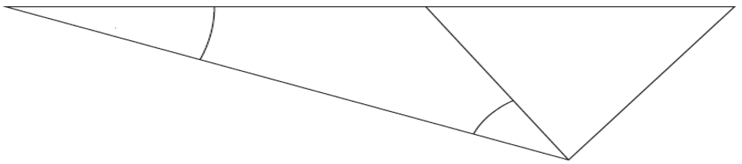

*A*

*B*

*C*

*D*

*x*

25°

*ABC* is a straight line.

*BCD* is an equilateral triangle.

Angle *DAB =* 25o

Work out the size of the angle marked *x*. Give a reason for each stage of your working.

…………………………… o

**(Total for Question 17 is 4 marks)**

**18** (a)On the grid below, draw the graph of *y =* 2 – 3*x* for values of *x* from – 3 to 3

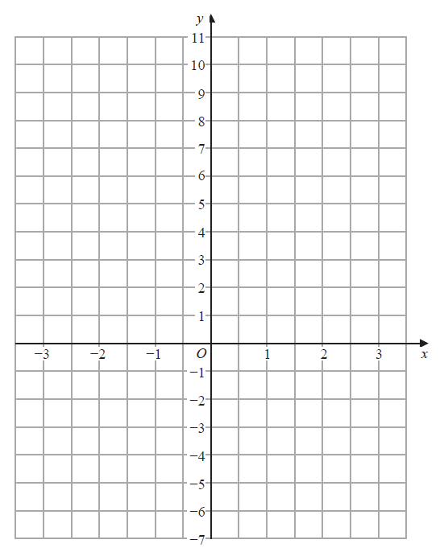

**(3)**

(b) Write down an equation of a line that is parallel to *y =* 2 – 3*x*

…………………………………………

**(1)**

**(Total for Question 18 is 4 marks)**

**19** Sian has a biased six-sided dice.

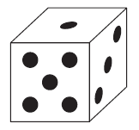

The table shows the probabilities that when Sian rolls the dice once it will land

on 1, on 2, on 3, on 4 and on 5

|  |  |  |  |  |  |  |
| --- | --- | --- | --- | --- | --- | --- |
| **Number on dice** | **1** | **2** | **3** | **4** | **5** | **6** |
| **Probability** | 20% | 18% | 11% | 27% | 13% |  |

Sian is going to roll the dice 50 times.

Work out an estimate for the number of times the dice will land either on 5 or on 6

………………………

**(Total for Question 19 is 3 marks)**

**20** Find the highest common factor (HCF) of 90 and 126

…………………………

**(Total for Question 20 is 3 marks)**

**21** (a) Simplify 2*a* 3 × *a* 4

…………………………………..

**(1)**

(b) Simplify 12*x* 5 *y* 2 ÷ 3*x* 2 *y*

…………………………………..

**(2)**

**(Total for Question 21 is 3 marks)**

**22** Joe went on holiday to Spain.

His flights cost a total of £320

Joe stayed in an apartment for 3 weeks.

The apartment cost 560 euros each week.

Joe hired a car for 15 days.

The car hire cost 20.16 euros each day.

The exchange rate was £1 = 1.12 euros.

1. Work out the total cost, in pounds, of the flights, the apartment and the car hire.

£……………………

**(4)**

(b) If there had been more than 1.12 euros to £1, how would this affect your answer

to part (a)?

…………………………………………………………………………………………………..

…………………………………………………………………………………………………..

…………………………………………………………………………………………………..

**(1)**

**(Total for Question 22 is 5 marks)**

**23**

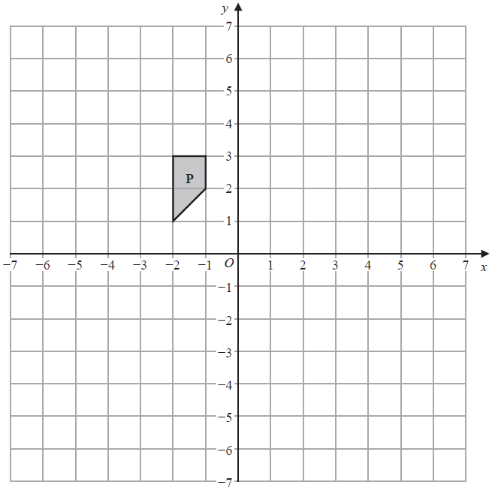

1. Translate shape **P** by the vector 

**(2)**

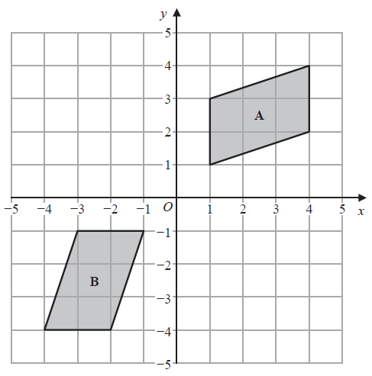

(b) Describe fully the single transformation that maps shape **A** onto shape **B**.

…………………………………………………………………………………………………...

…………………………………………………………………………………………………...

…………………………………………………………………………………………………...

**(2)**

**(Total for Question 23 is 4 marks)**

**24** The table gives information about the length of each of 90 sticks.

|  |  |
| --- | --- |
| **Length (*b* cm)** | **Frequency** |
| 0 < *b* ⩽ 8 | 5 |
| 8 < *b* ⩽ 16 | 20 |
| 16 < *b* ⩽ 24 | 45 |
| 24 < *b* ⩽ 32 | 20 |

Jenny drew the frequency polygon below for the information in the table. The frequency polygon is **not** correct.

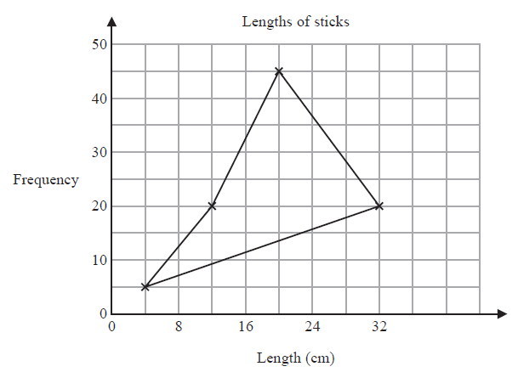

Write down **two** things that are wrong with the frequency polygon.

1 …………………………………………………………………………………………………...

…………………………………………………………………………………………………...

2 …………………………………………………………………………………………………...

…………………………………………………………………………………………………...

**(Total for Question 24 is 2 marks)**

**25**A rectangle has length 8 cm

The rectangle has area 20 cm2

The length of the rectangle is increased by 2 cm

The area of the rectangle is increased by 4 cm2

Noah says,

“The width of the rectangle decreases by less than 5%”

Is Noah correct?

You must show how you get your answer.

**(Total for Question 25 is 3 marks)**

**26**  *a* : *b* = 2 : 3

*b* : *c* = 5 : 6

Show that *a* : *c* = 5 : 9

**(Total for Question 26 is 2 marks)**

**27** *A*, *B* and *C* are points on a circle with diameter *AB*.

*ABC* is a right-angled triangle.

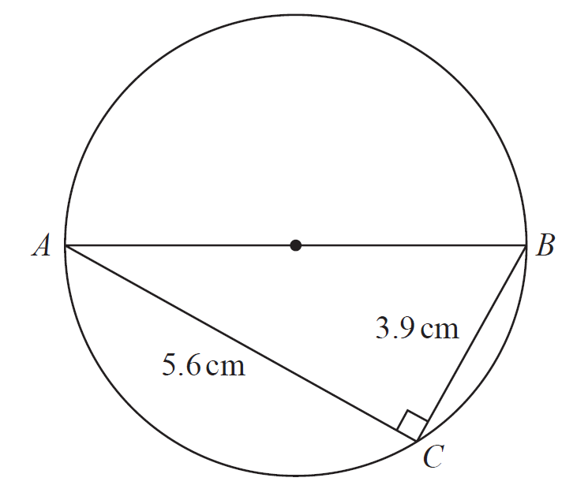

Calculate the area of the circle.

Give your answer correct to 3 significant figures.

……………………………….. cm2

**(Total for Question 27 is 4 marks)**

**28** Here are the first four terms of an arithmetic sequence.

– 6 – 2 2 6

1. Find an expression, in terms of *n*, for the *n*th term of this sequence.

…………………………….

**(2)**

1. Find the 10th term of this sequence.

………………………

**(1)**

**(Total for Question 28 is 3 marks)**

**29** (a) Factorise fully 6*m* 2 + 8*mp*

…………………………………….

**(2)**

(b) Expand and simplify (*x* – 7)(*x* + 4)

…………………………………………….

**(2)**

**(Total for Question 29 is 4 marks)**

**TOTAL FOR PAPER IS 80 MARKS**