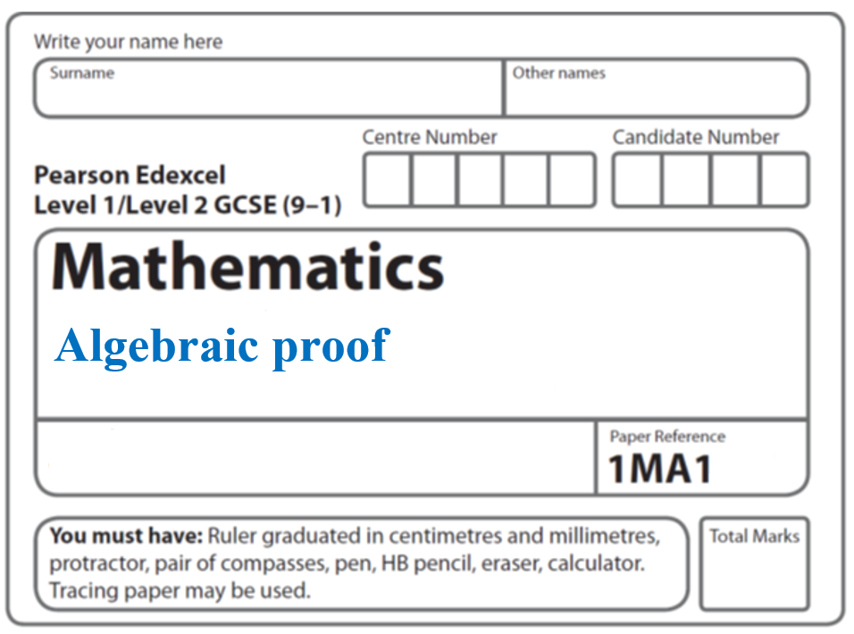

**Instructions**

* Use **black** ink or ball-point pen.
  + **Fill in the boxes** at the top of this page with your name,  
    centre number and candidate number.
* Answer **all** questions.
* Answer the questions in the spaces provided  
  *– there may be more space than you need.*
* You must **show all your working.**
* Diagrams are **NOT** accurately drawn, unless otherwise indicated.
* If your calculator does not have a *π* button, take the value of *π* to be3.142

unless the question instructs otherwise.

**Information**

* The total mark for this paper is **33**. There are **10** questions.
* Questions have been arranged in an ascending order of mean difficulty, as found by all students in the June 2017–November 2019 examinations.
* The marks for **each** question are shown in brackets  
  *– use this as a guide as to how much time to spend on each question.*

**Advice**

* Read each question carefully before you start to answer it.
* Keep an eye on the time.
* Try to answer every question.
* Check your answers if you have time at the end.

**1**



The area of square *ABCD* is 10 cm2.

Show that *x*2 + 6*x* = 1

**(Total for Question 1 is 3 marks)**

**___________________________________________________________________________**

**2** Prove that the square of an odd number is always 1 more than a multiple of 4.

(**Total for Question 2 is 4 marks**)

**___________________________________________________________________________**

**3** *n* is an integer greater than 1

Prove algebraically that *n*2 – 2 – (*n* – 2)2 is always an even number.

**(Total for Question 3 is 4 marks)**

**___________________________________________________________________________**

**4** Given that *n* can be any integer such that *n* > 1, prove that *n*2 – *n* is never an odd number.

**(Total for Question 4 is 2 marks)**

**___________________________________________________________________________**

**5** Prove algebraically that the sum of the squares of any two consecutive even numbers is

always a multiple of 4

**(Total for Question 5 is 3 marks)**

**___________________________________________________________________________**

**6** Prove algebraically that the difference between the squares of any two consecutive odd

numbers is always a multiple of 8

**(Total for Question 6 is 3 marks)**

**__________________________________________________________________________**

**7** *n* is an integer.

Prove algebraically that the sum of  and  is always a square number.

**(Total for Question 7 is 2 marks)**

**___________________________________________________________________________**

**8** Prove algebraically that the straight line with equation *x* − 2*y* = 10 is a tangent to the

circle with equation *x*2 + *y*2 = 20

**(Total for Question 8 is 5 marks)**

**___________________________________________________________________________**

**9** The ratio (*y* + *x*) : ( *y* – *x*) is equivalent to *k* : 1

Show that *y* =

**(Total for Question 9 is 3 marks)**

**___________________________________________________________________________**

**10** *a*, *b*, *c* are positive integers such that *a* > *b* > *c*.

*N* is the largest three digit number that has the digits *a*, *b* and *c*.

*K* is the smallest three digit number that has the digits *a*, *b* and *c*.

(a) Use algebra to show that the difference between *N* and *K* is always a multiple of 99.

**(3)**

(b) If *a* > *b* and *b* = *c* will the difference between *N* and *K* still be a multiple of 99?

Justify your answer.

......................................................................................................................................................

......................................................................................................................................................

**(1)**

**(Total for Question 10 is 4 marks) ___________________________________________________________________________**

**TOTAL MARKS FOR PAPER: 33**