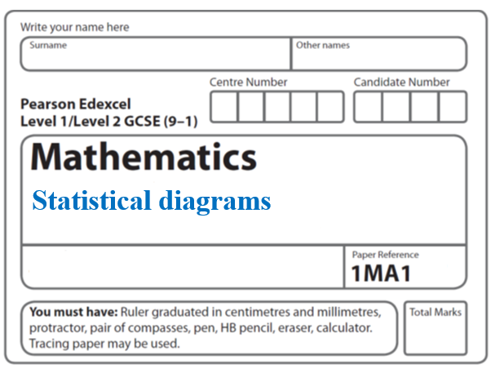**Instructions**

**Cumulative frequency**

* Use **black** ink or ball-point pen.
  + **Fill in the boxes** at the top of this page with your name,  
    centre number and candidate number.
* Answer **all** questions.
* Answer the questions in the spaces provided  
  *– there may be more space than you need.*
* You must **show all your working.**
* Diagrams are **NOT** accurately drawn, unless otherwise indicated.
* If your calculator does not have a *π* button, take the value of *π* to be3.142

unless the question instructs otherwise.

**Information**

* The total mark for this paper is **40**. There are **9** questions.
* Questions have been arranged in an ascending order of mean difficulty, as found by all students in the June 2017–November 2019 examinations.
* The marks for **each** question are shown in brackets  
  *– use this as a guide as to how much time to spend on each question.*

**Advice**

* Read each question carefully before you start to answer it.
* Keep an eye on the time.
* Try to answer every question.

Check your answers if you have time at the end.

**1** The cumulative frequency graph shows some information about the heights, in cm,

of 60 students.



Work out an estimate for the number of these students with a height greater than 160 cm.

......................................................

**(Total for Question 1 is 2 marks)**

**_____________________________________________________________________**

**2** The grouped frequency table gives information about the times, in minutes, that 80 office

workers take to get to work.

|  |  |
| --- | --- |
| **Time (*t* minutes)** | **Frequency** |
| 0 < *t* ⩽ 20 | 5 |
| 20 < *t* ⩽ 40 | 30 |
| 40 < *t* ⩽ 60 | 20 |
| 60 < *t* ⩽ 80 | 15 |
| 80 < *t* ⩽ 100 | 8 |
| 100 < *t* ⩽ 120 | 2 |

(*a*)Complete the cumulative frequency table.

|  |  |
| --- | --- |
| **Time (*t* minutes)** | **Cumulative frequency** |
| 0 < *t* ⩽ 20 |  |
| 0 < *t* ⩽ 40 |  |
| 0 < *t* ⩽ 60 |  |
| 0 < *t* ⩽ 80 |  |
| 0 < *t* ⩽ 100 |  |
| 0 < *t* ⩽ 120 |  |

**(1)**

(*b*)On the grid, draw the cumulative frequency graph for this information.

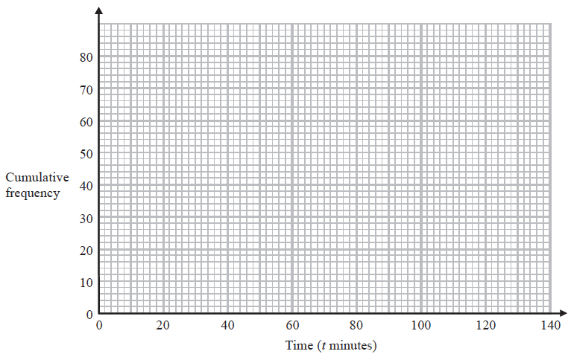

**(2)**

(*c*)Use your graph to find an estimate for the percentage of these office workers who

take more than 90 minutes to get to work.

.......................................................%

**(3)**

**(Total for Question 2 is 6 marks)**

**_____________________________________________________________________**

**3** The cumulative frequency table shows information about the times, in minutes, taken by

40 people to complete a puzzle.

|  |  |
| --- | --- |
| **Time (*m* minutes)** | **Cumulative frequency** |
| 20 < *m* ⩽ 40 | 5 |
| 20 < *m* ⩽ 60 | 25 |
| 20 < *m* ⩽ 80 | 35 |
| 20 < *m* ⩽ 100 | 38 |
| 20 < *m* ⩽ 120 | 40 |

(*a*)On the grid below, draw a cumulative frequency graph for this information.

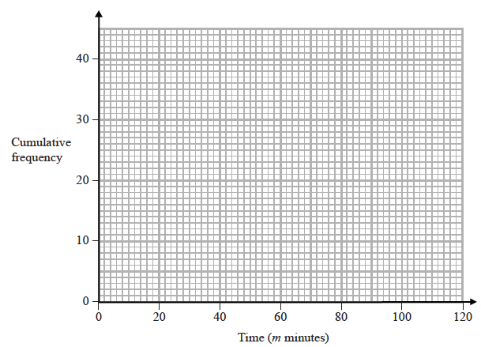

**(2)**

(*b*)Use your graph to find an estimate for the interquartile range.

....................................................... minutes

**(2)**

One of the 40 people is chosen at random.

(*c*)Use your graph to find an estimate for the probability that this person took between

50 minutes and 90 minutes to complete the puzzle.

.......................................................

**(2)**

**(Total for Question 3 is 6 marks)**

**_____________________________________________________________________**

**4** The cumulative frequency graph shows information about the weights of 60 potatoes.



(*a*)Use the graph to find an estimate for the median weight.

....................................................... g

**(1)**

Jamil says,

“80 – 40 = 40 so the range of the weights is 40 g.”

(*b*)Is Jamil correct?

You must give a reason for your answer.

..........................................................................................................................................

..........................................................................................................................................

**(1)**

(*c*)Show that less than 25% of the potatoes have a weight greater than 65 g.

**(2)**

**(Total for Question 4 is 4 marks)**

**5** Joan measured the heights of students in four different classes.

She drew a cumulative frequency graph and a box plot for each class.



Match each cumulative frequency graph to its box plot.

|  |  |
| --- | --- |
| **Cumulative frequency graph** | **Box plot** |
| **A** |  |
| **B** |  |
| **C** |  |
| **D** |  |

**(Total for Question 5 is 2 marks)**

**_____________________________________________________________________**

**6** The cumulative frequency table gives information about the time, in minutes, Jim took to go from his home to school each day last term.

|  |  |
| --- | --- |
| **Time taken (t minutes)** | **Cumulative frequency** |
| 0 < *t* ≤ 10 | 0 |
| 0 < *t* ≤20 | 7 |
| 0 < *t* ≤30 | 20 |
| 0 < *t* ≤40 | 64 |
| 0 < *t* ≤50 | 74 |
| 0 < *t* ≤60 | 80 |

(a) On the grid opposite, draw a cumulative frequency graph for this information.

**(2)**

Jane expects that it should take her *x* minutes to go from her home to school each day.

On 25% of the days last term, Jane took longer than *x* minutes to go from her home to school.

(b) Use your cumulative frequency graph to find an estimate for the value of *x*.

.........................................

**(3)**



Time taken (*t* minutes)

Cumulative frequency

**(Total for Question 6 is 5 marks)**

**_____________________________________________________________________**

**7** The stem and leaf diagram shows the ages, in years, of 25 people.

|  |  |  |  |  |  |  |  |  |  |  |  |  |  |  |  |  |  |  |
| --- | --- | --- | --- | --- | --- | --- | --- | --- | --- | --- | --- | --- | --- | --- | --- | --- | --- | --- |
| 1 | 7 | 7 | 8 | 9 |  |  |  |  |  |  |  | Key: 1 | 7 represents 17 years | | | | | | |
| 2 | 1 | 2 | 4 | 4 | 5 | 5 | 6 | 7 | 8 | 9 | 9 |  |  |  |  |  |  |  |
| 3 | 0 | 1 | 2 | 2 | 3 | 4 | 5 | 6 |  |  |  |  |  |  |  |  |  |  |
| 4 | 0 | 1 |  |  |  |  |  |  |  |  |  |  |  |  |  |  |  |  |

(*a*) (i) On the grid, draw a box plot for this information.



**(3)**

One of these people is chosen at random.

(ii) What is the probability that this person is 30 years of age or older?

.......................................................

**(2)**

The grouped frequency table gives information about the ages of a different group of people.

|  |  |
| --- | --- |
| **Age (*a* years)** | **Frequency** |
| 0 < *a* ⩽ 20 | 7 |
| 20 < *a* ⩽ 30 | 12 |
| 30 < *a* ⩽ 40 | 5 |
| 40 < *a* ⩽ 50 | 1 |

Anne drew this cumulative frequency table for this information.

|  |  |
| --- | --- |
| **Age (*a* years)** | **Cumulative frequency** |
| 0 < *a* ⩽ 20 | 7 |
| 20 < *a* ⩽ 30 | 19 |
| 30 < *a* ⩽ 40 | 24 |
| 40 < *a* ⩽ 50 | 25 |

The cumulative frequency table is **not** correct.

(*b*) Write down one thing that is wrong with the table.

..........................................................................................................................................

**(1)**

**(Total for Question 7 is 6 marks)**

**_____________________________________________________________________**

**8** Francesco carried out a survey about the ages of the people in his office.

The table shows information about his results.

|  |  |
| --- | --- |
| **Age (*a* years)** | **Cumulative frequency** |
| 20 < *a* ⩽ 30 | 10 |
| 20 < *a* ⩽ 40 | 26 |
| 20 < *a* ⩽ 50 | 58 |
| 20 < *a* ⩽ 60 | 66 |
| 20 < *a* ⩽ 70 | 70 |

(*a*) On the grid opposite, draw a cumulative frequency graph for this information.

**(2)**



(*b*) Use your graph to find an estimate for the median age.

.......................................................years

**(1)**

Francesco says,

“More than 60% of the people in the office are between 35 and 55 years old.”

(*c*)Use your graph to determine if Francesco is correct.

..........................................................................................................................................

**(3)**

**(Total for Question 8 is 6 marks)**

**_____________________________________________________________________**

**9** The cumulative frequency graph gives information about the number of minutes each of 60 people was in a shop.

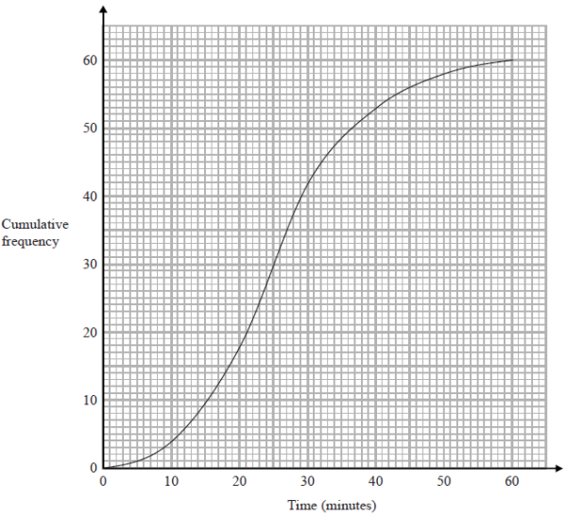

(a) Find an estimate for the number of people who were in the shop for more than 40 minutes.

.......................................................

**(2)**

Stan has to use the graph to find an estimate for the lower quartile of the times.

Stan writes,

60 people were in the shop.

25% of 60 = 15

So the lower quartile of the times is 15 minutes.

(b) What mistake has Stan made?

....................................................................................................................................

....................................................................................................................................

....................................................................................................................................

**(1)**

**(Total for Question 9 is 3 marks)**

**TOTAL MARKS FOR PAPER: 40**