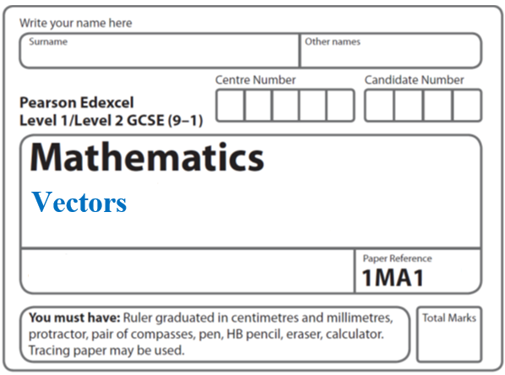**Instructions**

* Use **black** ink or ball-point pen.
  + **Fill in the boxes** at the top of this page with your name,  
    centre number and candidate number.
* Answer **all** questions.
* Answer the questions in the spaces provided  
  *– there may be more space than you need.*
* You must **show all your working.**
* Diagrams are **NOT** accurately drawn, unless otherwise indicated.
* If your calculator does not have a *π* button, take the value of *π* to be3.142

unless the question instructs otherwise.

**Information**

* The total mark for this paper is **52**. There are **12** questions.
* Questions have been arranged in an ascending order of mean difficulty, as found by all students in the June 2017–November 2019 examinations.
* The marks for **each** question are shown in brackets  
  *– use this as a guide as to how much time to spend on each question.*

**Advice**

* Read each question carefully before you start to answer it.
* Keep an eye on the time.
* Try to answer every question.
* Check your answers if you have time at the end.

**1 a** = and **b** = 

(a) Write down as a column vector

(i) **a** + **b**

.......................................................

(ii) 2**a** + 3**b**

.......................................................

**(3)**

The vector **c** is drawn on the grid.



(b) From the point *P*, draw the vector 2**c**

**(1)**

**(Total for Question 1 is 4 marks) _____________________________________________________________________**

**2**

**

*OABC* is a parallelogram.

 and 

*X* is the midpoint of the line *AC*.

*OCD* is a straight line so that *OC* : *CD* = *k* : 1

Given that **

find the value of *k*.

*k* = .......................................................

**(Total for Question 2 is 4 marks)**

**_____________________________________________________________________**

**3** *CDEF* is a quadrilateral.

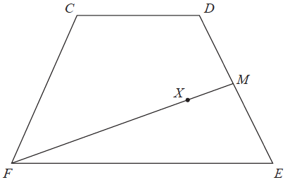

 = **a**,  = **b** and  = **a** – **b**.

(*a*)Express  in terms of **a** and/or **b**.

Give your answer in its simplest form.

.......................................................

**(2)**

*M* is the midpoint of *DE*.

*X* is the point on *FM* such that *FX* : *XM* = *n* : 1

*CXE* is a straight line.

(*b*)Work out the value of *n*.

*n* = .......................................................

**(4)**

**(Total for Question 3 is 6 marks)**

**_____________________________________________________________________**

**4** The vector **a** and the vector **b** are shown on the grid.



(*a*)On the grid, draw and label vector –2**a**

(**1**)

(*b*)Work out **a** + 2**b** as a column vector.



(**2**)

(**Total for Question 4 is 3 marks**)

**_____________________________________________________________________**

**5** The equation of a curve is *y* = *ax*

*A* is the point where the curve intersects the *y*-axis.

(*a*)State the coordinates of *A*.

( .......................... , ..........................)

**(1)**

The equation of circle **C** is *x*2 + *y*2 = 16

The circle **C** is translated by the vector  to give circle **B**.

(*b*)Draw a sketch of circle **B**.

Label with coordinates

the centre of circle **B**

and any points of intersection with the *x*-axis.

**(3)**

**(Total for Question 5 is 4 marks)**

**_____________________________________________________________________**

**6**



Triangle **A** is transformed by the combined transformation of a rotation of 180° about the

point (−2, 0) followed by a translation with vector 

One point on triangle **A** is invariant under the combined transformation.

Find the coordinates of this point.

(............................ , ............................)

**(Total for Question 6 is 2 marks)**

**_____________________________________________________________________**

**7** *OXYZ* is a parallelogram.

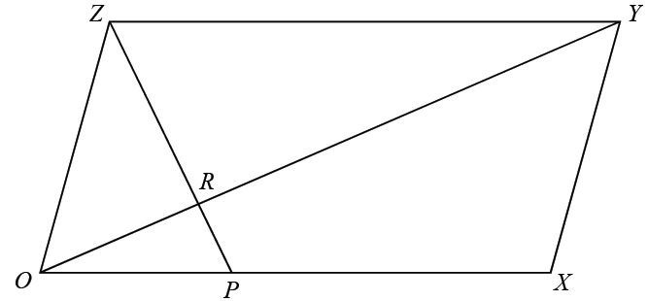

 = **a**

 = **b**

P is the point on *OX* such that *OP* : *PX* = 1 : 2

R is the point on *OY* such that *OR* : *RY* = 1 : 3

Work out, in its simplest form, the ratio *ZP* : *ZR*

You must show all your working.

.......................................................

**(Total for Question 7 is 5 marks)**

**8**



*OAB* is a triangle.

*OPM* and *APN* are straight lines.

*M* is the midpoint of *AB*.

** = **a **= **b**

*OP* : *PM* = 3 : 2

Work out the ratio *ON* : *NB*

......................................................

**(Total for Question 8 is 5 marks)**

**_____________________________________________________________________**

**9**

**

The diagram shows triangle *ABC*.

 = 3**a**

 = 2**b**

 = 3

*D* is the point on *BC* such that *BD* : *DC* = 3 : 1

Prove that *ADE* is a straight line.

**(Total for Question 19 is 4 marks)**

**_____________________________________________________________________**

**10** *OAB* is a triangle.

**

 = **a**

= **b**

*P* is the point on *AB* such that *AP* : *PB* = 3 : 2

Find  in terms of **a** and **b**.

Give your answer in its simplest form.

.......................................................

**(Total for Question 10 is 3 marks)**

**11**

**

*OAN*, *OMB* and *APB* are straight lines.

*AN* = 2*OA*.

*M* is the midpoint of *OB*.

** = **a** ** = **b**

** = *k*where *k* is a scalar quantity.

Given that *MPN* is a straight line, find the value of *k*.

........................................................

**(Total for Question 11 is 5 marks)**

**_____________________________________________________________________**

**12**



*OAB* is a triangle.

*A* is the midpoint of *OZ*

*Y* is the midpoint of *AB*

*X* is a point on *OB*

 = **a** ** = 2**b** ** = **b**

Prove that *XYZ* is a straight line.

**(Total for Question 12 is 5 marks)**

**____________________________________________________________________**

**TOTAL MARKS FOR PAPER: 52**