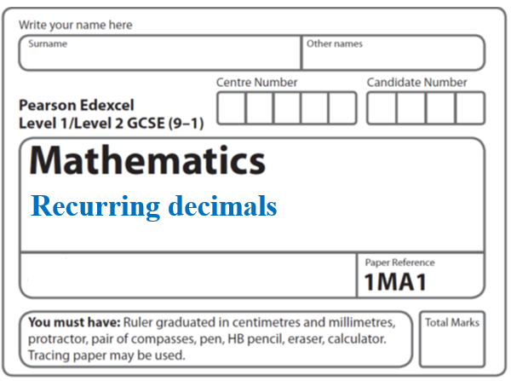**Instructions**

* Use **black** ink or ball-point pen.
  + **Fill in the boxes** at the top of this page with your name,  
    centre number and candidate number.
* Answer **all** questions.
* Answer the questions in the spaces provided  
  *– there may be more space than you need.*
* You must **show all your working.**
* Diagrams are **NOT** accurately drawn, unless otherwise indicated.
* If your calculator does not have a *π* button, take the value of *π* to be3.142

unless the question instructs otherwise.

**Information**

* The total mark for this paper is **22**. There are **8** questions.
* Questions have been arranged in an ascending order of mean difficulty, as found by all students in the June 2017–November 2019 examinations.
* The marks for **each** question are shown in brackets  
  *– use this as a guide as to how much time to spend on each question.*

**Advice**

* Read each question carefully before you start to answer it.
* Keep an eye on the time.
* Try to answer every question.
* Check your answers if you have time at the end.

**1** Using algebra, prove that  is equal in value to 

**(Total for Question 1 is 3 marks)**

**___________________________________________________________________________**

**2** Write these numbers in order of size.

Start with the smallest number.

|  |  |  |  |
| --- | --- | --- | --- |
|  |  |  |  |

..........................................................................................................................................

**(Total for Question 2 is 2 marks)**

**___________________________________________________________________________**

**3** Express  as a fraction.

You must show all your working.

.......................................................

**(Total for Question 3 is 3 marks)**

**___________________________________________________________________________**

**4** Prove algebraically that  can be written as 

**(Total for Question 4 is 3 marks)**

**___________________________________________________________________________**

**5** *x* = 

Prove algebraically that *x* can be written as 

**(Total for Question 5 is 3 marks)**

**___________________________________________________________________________**

**6** Prove that the recurring decimal  has the value 

**(Total for Question 6 is 2 marks)**

**___________________________________________________________________________**

**7** Write  as a fraction in its simplest form.

.........................................

**(Total for Question 7 is 3 marks)**

**___________________________________________________________________________**

**8** Prove algebraically that the recurring decimal  can be written as 

**(Total for Question 8 is 3 marks)**

**___________________________________________________________________________**

**TOTAL MARKS FOR PAPER: 22**