**Revision tips for Maths GCSE**

***The key to being successful at maths is to practice maths regularly***

**Maths Watch**

All students will be issued with log in details for Maths Watch (vle.mathswatch.co.uk). This is a very helpful course companion and we would encourage all students to use it regularly. Refer to the word document *‘MW Revision Clips for all Higher/ Foundation units’*

**Revision guides/ workbooks and Practise papers**

In the run up to the final exams in Y11 students will be given lots of practice and past papers to check their progress and help with identifying weak areas. In addition to this there are many excellent publications which you may wish to purchase for yourselves. For example;

**The Pearson range (**[**www.pearsonschoolsandfecolleges.co.uk/Secondary**](http://www.pearsonschoolsandfecolleges.co.uk/Secondary)**)**

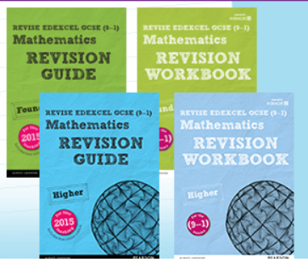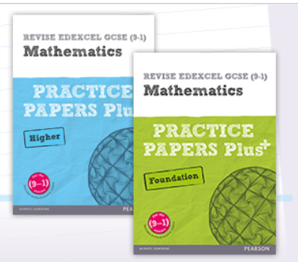

**The CGP range (**[**www.cgpbooks.co.uk**](http://www.cgpbooks.co.uk)**)**

