**GCSE Mathematics**

**Practice Tests: Set 7**

**Paper 1H (Non-calculator)**

**Time: 1 hour 30 minutes**

You should have: Ruler graduated in centimetres and millimetres, protractor, pair of compasses, pen, HB pencil, eraser, calculator. Tracing paper may be used.

**Instructions**

* Use **black** ink or ball-point pen.
* **Fill in the boxes** at the top of this page with your name,  
  centre number and candidate number.
* Answer **all** questions.
* Answer the questions in the spaces provided

– *there may be more space than you need*.

* **Calculators may be used.**
* Diagrams are NOT accurately drawn, unless otherwise indicated.
* You must **show all your working out.**

**Information**

* The total mark for this paper is 80
* The marks for **each** question are shown in brackets  
  – *use this as a guide as to how much time to spend on each question*.

**Advice**

* Read each question carefully before you start to answer it.
* Keep an eye on the time.
* Try to answer every question.
* Check your answers if you have time at the end.

**Answer ALL questions.**

**Write your answers in the spaces provided.**

**You must write down all the stages in your working.**

**1.** (*a*) Simplify, leaving your answers in index form,

(i) 75 × 72 × 7

................................

(ii) (47)2

................................

**(2)**

(*b*)  = 54

Find the value of *n*.

*n* = ................................

**(2)**

**(Total for Question 1 is 4 marks)**

**___________________________________________________________________________**

**2.** Find the highest common factor (HCF) of 147, 42 and 252

.............................................................................................

**(Total for Question 2 is 2 marks)**

**___________________________________________________________________________**

**3.** The total weight of 3 identical video games is 525 g.

Work out the total weight of 5 of these video games.

....................... g

**(Total for Question 3 is 2 marks)**

**___________________________________________________________________________**

**4.** The perimeter of a triangle is 90 cm.

The lengths of the sides of the triangle are in the ratios 3 : 5 : 7

Work out the length of the longest side of the triangle.

.................................... cm

**(Total for Question 4 is 3 marks)**

**___________________________________________________________________________**

**5.** There are

*x* stamps in a small packet

(*x* + 3) stamps in a medium packet

and (*x* + 4) stamps in a large packet

The total number of stamps in the three packets is *N*.

(i) Write down an equation for *N* in terms of *x*.

Give your equation in its simplest form.

.......................................................

**(2)**

There is a total of 61 stamps.

(ii) Work out the number of stamps in the medium packet.

.......................................................

**(3)**

**(Total for Question 5 is 5 marks)**

**___________________________________________________________________________**

**6.** (a) Write 75 000 in standard form.

.......................................................

**(1)**

A computer can carry out a simple calculation in 1 picosecond where

1 picosecond = 10–12 seconds.

(b) Write down in standard form the time, in seconds, for this computer to carry out 75 000 simple calculations.

....................................................... seconds

**(2)**

**(Total for Question 6 is 3 marks)**

**___________________________________________________________________________**

**7.** Sally got 32 out of 80 in a maths test.   
She got 38% in an English test.

Sally wants to know if she got a higher percentage in maths or in English.

Did Sally get a higher percentage in maths or in English? You must show your working.

**(Total for Question 7 is 2 marks)**

**___________________________________________________________________________**

**8.** The length of Emma’s journey from her home to her friends house is 72 km.

The journey takes 1 hour 20 minutes.

Work out her average speed in km/h.

............................... km/h

**(Total for Question 8 is 3 marks)**

**___________________________________________________________________________**

**9.** The mean of six numbers is 40

Three of the numbers are 102, 60 and 30

Each of the remaining three numbers is equal to *x*.

Find the value of *x*.

*x* = ……………………………

**(Total for Question 9 is 3 marks)**

**___________________________________________________________________________**

**10.** *y* varies inversely as the cube of *x*.

Given that *y* = 24 when *x* = 2 find the value of *x* when *y* = –3.

*x* = .......................................................

**(Total for Question 10 is 4 marks)**

**___________________________________________________________________________**

**11.**



*ABCDE* is a regular pentagon.

(a) Calculate the size, in degrees, of an interior angle of the pentagon.

..............................................................°

**(2)**

The point *F* lies inside the pentagon such that angle *CDF* = 70° and angle *FEA* = 85°

(b) Calculate the size, in degrees, of the **reflex** angle *DFE*.

..............................................................°

**(4)**

**(Total for Question 11 is 6 marks)**

**___________________________________________________________________________**

**12.** There are 32 students in a class. All the students are either left-handed or right-handed.

The ratio of the number of left-handed students to the number of right-handed students is 1 : 7

(a) Work out the number of right-handed students.

...................................................................

**(2)**

Sajid makes a scale model of a bus. He uses a scale of 1 : 32. The length of Sajid’s scale model is 45 cm.

Chitra makes a scale model of the same bus. She uses a scale of 1 : 48

(b) Work out the length of Chitra’s model bus.

................................................................... cm

**(3)**

**(Total for Question 12 is 5 marks)**

**___________________________________________________________________________**

**13.** A bank pays compound interest of 1% per annum on its savings accounts.

Evan invests £7500 for 2 years.

Calculate the total interest gained after 2 years.

£ ..............................................................

**(Total for Question 13 is 3 marks)**

**___________________________________________________________________________**

**14.** The first three terms of a different Fibonacci sequence are

*a         b         a + b*

(a)  Show that the 6th term of this sequence is 3*a* + 5*b*

**(2)**

Given that the 3rd term is 7 and the 6th term is 29,

(b)  find the value of *a* and the value of *b*.

...........................................................

**(3)**

**(Total for question 14 is 6 marks)**

**___________________________________________________________________________**

**15.** The probability that Mohammed is late for school tomorrow is 0.05.

The probability that Helen is late for school tomorrow is 0.15.

Sam says that the probability that Mohammed and Helen will both be late for school tomorrow is 0.0075 because 0.05 × 0.15 = 0.0075

What assumption has Sam made?

......................................................................................................................................................

......................................................................................................................................................

**(Total for Question 15 is 1 mark)**

**___________________________________________________________________________**

**16.** Find the value of *x* when 32*x* = 

*x* = .......................................................

**(Total for Question 16 is 2 marks)**

**___________________________________________________________________________**

**17.** The frequency table gives information about the lengths of time 100 people spent in a coffee shop.

|  |  |
| --- | --- |
| **Time (*t* minutes)** | **Frequency** |
| 0 < *t* ≤ 20 | 4 |
| 20 < *t* ≤ 40 | 12 |
| 40 < *t* ≤ 60 | 26 |
| 60 < *t* ≤ 80 | 42 |
| 80 < *t* ≤ 100 | 12 |
| 100 < *t* ≤ 120 | 4 |

(*a*)On the grid, draw a cumulative frequency graph for your table.



**(2)**

(*b*)Use your graph to find an estimate for the number of these people who spent longer than 70 minutes in the coffee shop.

.......................................................

**(2)**

**(Total for Question 17 is 4 marks)**

**___________________________________________________________________________**

**18.** £*N* is shared between three people in the ratio 2 : 3 : 7

The largest share is £540 more than the smallest share.

Calculate the value of *N*.

*N* = ...............................

**(Total for Question 18 is 3 marks)**

**___________________________________________________________________________**

**19.** Express √48 + √108 in the form *k√* 6 where *k* is a surd.

..............................................................

**(Total for Question 19 is 3 marks)**

**___________________________________________________________________________**

**20.** The histogram shows information about the time taken by cyclists to finish a cycle race.



7 cyclists took 80 minutes or less to finish the race.

(i) Work out an estimate for the number of cyclists who took more than 95 minutes to finish the race.

.......................................................

(ii) Explain why your answer to part (i) is only an estimate.

...............................................................................................................................................

...............................................................................................................................................

**(Total for Question 20 is 4 marks)**

**___________________________________________________________________________**

**21. C** is the curve with equation *y* = *x*2 – 4*x* + 4

**L** is the straight line with equation *y* = 2*x* – 4

**L** intersects **C** at two points, *A* and *B*.

Calculate the exact length of *AB*.

**(Total for Question 21 is 6 marks)**

**___________________________________________________________________________**

**22.** *x* = *a* × 10*n*, where *n* is an integer and √10 ≤ *a* < 10.

Find, in standard form, an expression for *x*2.

Give your expression as simply as possible.

............................................................

**(Total for Question 22 is 3 marks)**

**___________________________________________________________________________**

**23.** *A*, *B*, *C* and *D* are points on the circumference of a circle, centre *O*.

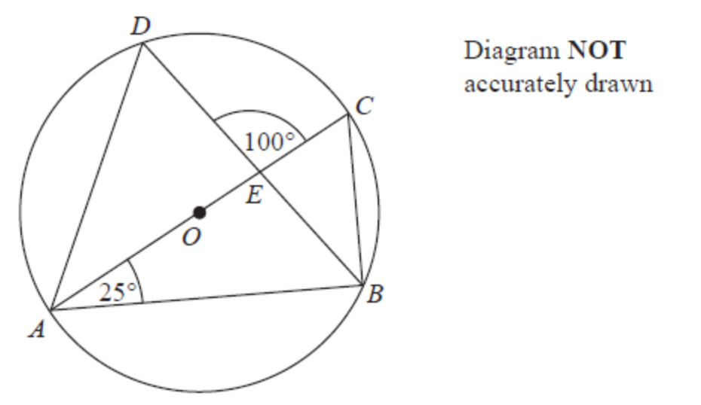

*AC* is a diameter of the circle.   
*AC* and *BD* intersect at *E*.

Angle *CAB* = 25°   
Angle *DEC* = 100°

Work out the size of angle *DAC*.   
You must show all your working.

........................................................... °

**(Total for question 23 is 4 marks)**

**TOTAL FOR PAPER IS 80 MARKS**