**A Level English Literature at LPGS**



**A Student Guide Booklet to the Edexcel (Pearson) A Level Course**

**Statement from the English department about the course**

The Edexcel English Literature course is unique in that it is the only exam board with open book examinations. We find this useful because it allows students to focus on thinking critically, crafting evaluative arguments whilst having the safety net of the text if they need to refer to it. Students cover a range of diverse material throughout the 2 years and independent learning is encouraged from the beginning.

We want our students to demonstrate:

* A good standard of written English. The course is all written examination/independent study (coursework).
* A willingness to participate in debate and discussion in order to prepare for critical and evaluative written responses.
* Regular wider reading of non-fiction and fiction texts. Students are expected to use their wider reading to enhance their written responses for the examinations and coursework.
* Ownership over their studies by completing homework and guided learning tasks on time.

**Resources within the English Department**

Students working within the English department can expect the following during their study of the course:

* Dedicated subject specialists with experience of teaching this specific course.
* Library access with support from Mrs Hall when selecting wider reading material.
* Access to *emagazine,* an online secondary reading archive which offers support on essay writing, contextual information around your set texts and critical interpretations.
* Opportunities to enter creative writing competitions.
* Visit to the National Theatre Archives to view *A Streetcar Named Desire*.
* Language and Literature workshops at The British Library.
* Guest speakers from universities including *Goldsmiths College* and *The University of Westminster.*
* Access to ICT facilities throughout the course.

**About your course**

**Edexcel (Pearson) English Literature**

What do students study over the 2 years?

* 2 drama texts (one Shakespearean tragedy and a modern tragedy).
* 2 prose texts for comparison (past texts have included *Beloved* by Toni Morrison + *Dracula* by Bram Stoker; *The Handmaid’s Tale* by Margaret Atwood + *War of the Worlds* by H.G. Wells.
* 2 poetry texts (*Poems of the Decade* and John Donne/Rossetti).
* 2 texts of the student’s choice for comparison (coursework option).

**Assessment:**

The course is aimed at those looking to study for the full 2 years and complete the full A-Level course.

80% of the course is examined.

20% of the course is a non-examined unit called ‘Independent Study’ where students produce a typed comparative essay of approximately 3,000 words.

The components hold the following weighting:

Component 1 (Drama), 30%, 2 hours, 15 minutes examination.

Component 2 (Prose), 20%, 1 hour, 15 minutes examination.

Component 3 (Poetry), 30%, 2 hours, 15 minutes examination.

Component 4 (Independent Study), 20%, 3,000 word essay.

**Wider Reading Text Recommendations:**



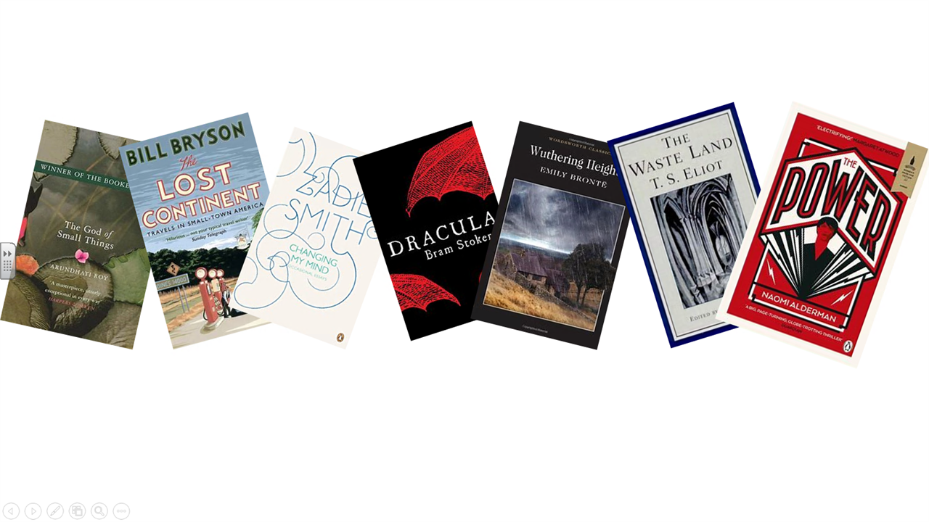

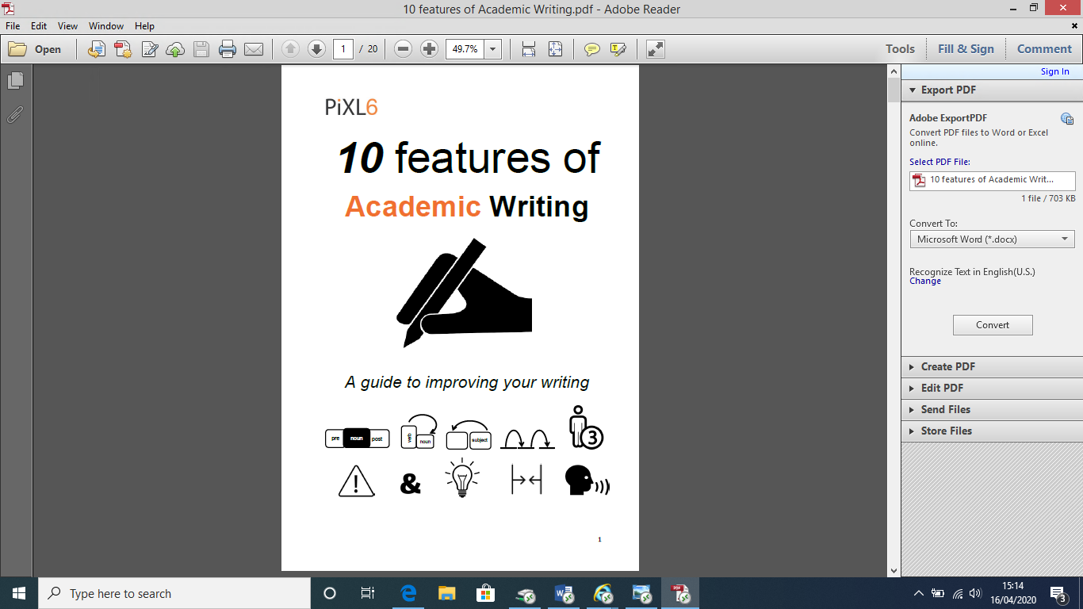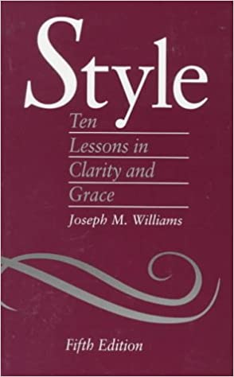We recommend that students also use the PiXL6 Academic Writing booklet (available under our ‘useful links’ to support with essay and critical writing. Another useful text is *Style* by Joseph Williams, any edition is suitable.

Another way to keep up with your wider reading is to use our subscription to the English and Media Centre’s archive on the emagazine database. Login by clicking on this link and these login details:

<https://www.englishandmedia.co.uk/e-magazine/emagazine-88>

Username: LPGS18

Password: english

**An Example of our Course Plan, Including Assessments**

|  |  |  |  |  |  |  |
| --- | --- | --- | --- | --- | --- | --- |
| **Teacher (initials)** | **Autumn 1** | **Autumn 2** | **Spring 1** | **Spring 2** | **Summer 1** | **Summer 2** |
| **Teacher A (TG/JCW)**  **4 periods** | Shakespeare play  *Othello/Hamlet*   * Plot * Context * Dramatic techniques and the Tragedy. | Shakespeare play  *Othello/ Hamlet* | Drama  *A Streetcar Named Desire* | Drama  *A Streetcar Named Desire* | Coursework Text 1  *Prose suggestions:*  *One Flew Over The Cuckoo’s Nest*  *The God of Small Things*  *The Bluest Eye* | Modern Poetry  10 poems:  ‘Eat Me’  ‘Chainsaw’  ‘Material’  ‘History’  ‘An Easy Passage’  ‘The Deliverer’  ‘Lammas’  ‘Nine Year Old Self’  ‘A Minor Role’  ‘The Gun’. |
| **Assessment** | **Baseline test**  **Extract provided for question.** | **Exam question (adapted from sample assessment material-without the critical reading)** | **Characterisation question.** | **Sample Exam question on *A Streetcar Named Desire*.** |  | **Draft coursework to be completed over the summer holidays.** |
| **Skills Teacher**  **1 Period (SAA/TG)** | **Writing an effective analytical paragraph** | **Academic writing (PiXL resources)** | **Unseen poem?** | **Modern poem?** | **Modern poem?** | **Modern poem?** |
| **Teacher B (HCC/RM)**  **4 periods** | Donne (approx. 15 poems)   * Introduction to Metaphysical poetry * Poetic terminology * Analytical skills | Donne (approx. 15 poems)   * Comparative skills * Relevant contextual factors | ***Pre-1900 Prose Text***  *The Picture of Dorian Gray/ Frankenstein* | ***Post-1900 Prose Text***  *The Handmaid’s Tale/ Beloved OR The Little Stranger* | Coursework Text 2  *Death of a Salesman*  *Equus* | Coursework: comparative skills. |
| **Assessment** | **Comparative question.** | **Exam question**  **Exemplars from last year’s students provided afterwards.** | **Question on narrative style of Pre-1990 text** | **Comparative question focussing on both texts use of narrative voices.** | **‘Compare the ways the writers create a sense of fear’**  **Comparative Analysis (sample exam paper)** | **Draft coursework to be completed over the summer holidays.** |
| **Guided Learning** | **Reading both prose texts and completing zigzag packs.** | | ***A Streetcar Named Desire* Zigzag pack** | **Reading satellite coursework texts from list.**  **Completing journal entries for Independent Study unit.** | | **Poems of the Decade Zigzag Guide.** |
| **Teacher (initials)** | **Autumn 1** | **Autumn 2** | **Spring 1** | **Spring 2** | **Summer 1** | **Summer 2** |
| **Teacher A**  **5 periods** | Shakespeare play critical theory  *Othello/Hamlet*   * Writing using critical theory | Poems of the Decade: all remaining poems and unseen material.  **JSS** | *A Streetcar Named Desire* | Shakespearian play revision |  |  |
| **1 period in a computer room** | **Coursework** | **Coursework** |
| **Assessment** |  | **Full exam question from the sample assessment materials.** | **Full exam question** |  |  |  |
| **Guided Learning** | **Shakespeare ZigZag pack** | **Reading and annotating another modern poetry anthology for unseen preparation. (Forward book of poetry)** | **Donne ZigZag pack** |  |  |  |
| **Teacher B**  **5 periods** | Dracula/ Beloved comp | Dracula/Beloved | Donne Revision | Prose Revision |  |  |
| **1 period in a computer room** | **Coursework** | **Coursework** |
| **Assessment** |  |  |  |  |  |  |