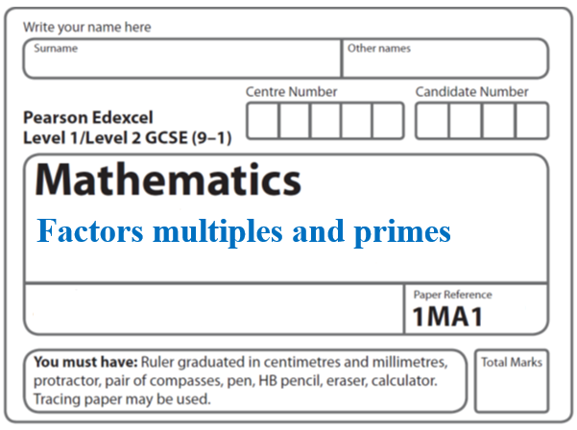**Instructions**

* Use **black** ink or ball-point pen.
  + **Fill in the boxes** at the top of this page with your name,  
    centre number and candidate number.
* Answer **all** questions.
* Answer the questions in the spaces provided  
  *– there may be more space than you need.*
* You must **show all your working.**
* Diagrams are **NOT** accurately drawn, unless otherwise indicated.
* If your calculator does not have a *π* button, take the value of *π* to be3.142

unless the question instructs otherwise.

**Information**

* The total mark for this paper is **23**. There are **8** questions.
* Questions have been arranged in an ascending order of mean difficulty, as found by all students in the June 2017–November 2019 examinations.
* The marks for **each** question are shown in brackets  
  *– use this as a guide as to how much time to spend on each question.*

**Advice**

* Read each question carefully before you start to answer it.
* Keep an eye on the time.
* Try to answer every question.
* Check your answers if you have time at the end.

**1** Express 56 as the product of its prime factors.

.......................................................

**(Total for Question 1 is 2 marks)**

**___________________________________________________________________________**

**2** Find the highest common factor (HCF) of 72 and 90

.......................................................

**(Total for Question 2 is 2 marks)**

**___________________________________________________________________________**

**3** Write 36 as a product of its prime factors.

.......................................................

**(Total for Question 3 is 2 marks)**

**___________________________________________________________________________**

**4** Find the Lowest Common Multiple (LCM) of 108 and 120

.......................................................

**(Total for Question 4 is 3 marks)**

**___________________________________________________________________________**

**5** (*a*)Find the lowest common multiple (LCM) of 40 and 56

......................................................

(**2**)

*A* = 23 × 3 × 5 *B* = 22 × 3 × 52

(*b*)Write down the highest common factor (HCF) of *A* and *B*.

......................................................

(**1**)

(**Total for Question 5 is 3 marks**)

**___________________________________________________________________________**

**6** Write 136 as a product of its prime factors.

.............................................................

**(Total for Question 6 is 3 marks)**

**___________________________________________________________________________**

**7** (*a*) Write 168 as a product of its prime factors.

You must show your working.

.......................................................

**(3)**

(*b*) Find the highest common factor (HCF) of 168 and 180.

.......................................................

**(2)**

**(Total for Question 7 is 5 marks)**

**___________________________________________________________________________**

**8** Here are three lamps.



Lamp **A** flashes every 20 seconds.

Lamp **B** flashes every 45 seconds.

Lamp **C** flashes every 120 seconds.

The three lamps start flashing at the same time.

How many times in one hour will the three lamps flash at the same time?

.......................................................

(**Total for Question 8 is 3 marks**)

**___________________________________________________________________________**

**TOTAL MARKS FOR PAPER: 23**