**Surface area and Volume**

**Foundation tier**

**Instructions**

* Use **black** ink or ball-point pen.
  + **Fill in the boxes** at the top of this page with your name,  
    centre number and candidate number.
* Answer **all** questions.
* Answer the questions in the spaces provided  
  *– there may be more space than you need.*
* You must **show all your working.**
* Diagrams are **NOT** accurately drawn, unless otherwise indicated.
* If your calculator does not have a *π* button, take the value of *π* to be3.142

unless the question instructs otherwise.

**Information**

* The total mark for this paper is **41**. There are **9** questions.
* Questions have been arranged in an ascending order of mean difficulty, as found by all students in the June 2017–November 2019 examinations.
* The marks for **each** question are shown in brackets  
  *– use this as a guide as to how much time to spend on each question.*

**Advice**

1. Read each question carefully before you start to answer it.
2. Keep an eye on the time.
3. Try to answer every question.
4. Check your answers if you have time at the end.

**1** Here is a 3-D shape.



(*a*)Write down the name of this 3-D shape.

.......................................................

**(1)**

(*b*)Write down the number of edges of this 3-D shape.

.......................................................

**(1)**

**(Total for Question 1 is 2 marks)**

**___________________________________________________________________________**

**2** A container is in the shape of a cuboid.

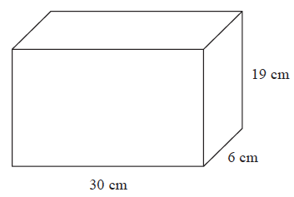

The container is  full of water.

A cup holds 275 m*l* of water.

What is the greatest number of cups that can be completely filled with water from the container?

.......................................................

**(Total for Question 2 is 4 marks)**

**___________________________________________________________________________**

**3** Chloe has a van.

She is going to use the van to deliver boxes.

Each box is a cuboid, 40 cm by 30 cm by 35 cm.



The space for boxes in the van has

maximum length 2.4 m

maximum width 1.5 m

maximum height 1.4 m

The space for boxes is empty.

Chloe wants to put as many boxes as possible into the van.

She can put 3 boxes into the van in one minute.

Assume that the space for boxes is in the shape of a cuboid.

(*a*)Work out how many minutes it should take Chloe to put as many boxes as possible

into the van.

....................................................... minutes

**(4)**

The space for boxes might **not** be in the shape of a cuboid.

(*b*)Explain how this could affect the time it would take Chloe to put as many boxes as

possible into the van.

......................................................................................................................................................

.....................................................................................................................................................

**(1)**

**(Total for Question 3 is 5 marks)**

**___________________________________________________________________________**

**4** Here is a solid square-based pyramid, *VABCD*.

**

The base of the pyramid is a square of side 6 cm.

The height of the pyramid is 4 cm.

*M* is the midpoint of *BC* and *VM* = 5 cm.

(*a*)Draw an accurate front elevation of the pyramid from the direction of the arrow.

(**2**)

(*b*)Work out the total surface area of the pyramid.

.......................................................

(**4**)

(**Total for Question 4 is 6 marks**)

**___________________________________________________________________________**

**5** Here is a triangular prism.



Work out the volume of the prism.

Give your answer correct to 3 significant figures.

...................................................... cm3

(**Total for Question 5 is 5 marks**)

**___________________________________________________________________________**

**6** The diagram shows a cube of side length 2 cm.



Vera says,

“The volume of any solid made with 6 of these cubes is 48 cm³ ”

(*a*)Is Vera correct?

You must show your working.

......................................................................................................................................................

......................................................................................................................................................

**(2)**

(*b*)(i) Draw a cuboid that can be made with 6 of these cubes.

Write the dimensions of the cuboid on your diagram.

**(1)**

(ii) Work out the surface area of your cuboid.

.......................................................cm2

**(2)**

**(Total for Question 6 is 5 marks)**

**___________________________________________________________________________**

**7** The total surface area of a cube is 294 cm2.

Work out the volume of the cube.

....................................................... cm3

**(Total for Question 7 is 4 marks)**

**___________________________________________________________________________**

**8** The diagram shows a cube and a cuboid.

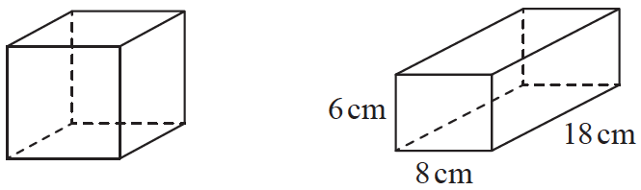

The total surface area of the cube is equal to the total surface area of the cuboid.

Janet says,

“The volume of the cube is equal to the volume of the cuboid.”

Is Janet correct?

You must show how you get your answer.

**(Total for Question 8 is 5 marks)**

**9** The diagram shows a fish tank in the shape of a cuboid.



The dimensions of the tank are 50 cm by 32 cm by 20 cm.

The tank is  full of water and sand.

The ratio of the volume of water to the volume of sand is 5 : 1

Work out the number of litres of water in the tank.

You must show all your working.

.......................................................litres

**(Total for Question 9 is 5 marks)**

TOTAL MARKS FOR PAPER: 41