**Foundation Tier**

**Circles – Area and Perimeter**

**Instructions**

* Use **black** ink or ball-point pen.
  + **Fill in the boxes** at the top of this page with your name,  
    centre number and candidate number.
* Answer **all** questions.
* Answer the questions in the spaces provided  
  *– there may be more space than you need.*
* You must **show all your working.**
* Diagrams are **NOT** accurately drawn, unless otherwise indicated.
* If your calculator does not have a *π* button, take the value of *π* to be3.142

unless the question instructs otherwise.

**Information**

* The total mark for this paper is **48**. There are **11** questions.
* Questions have been arranged in an ascending order of mean difficulty, as found by all students in the June 2017–November 2019 examinations.
* The marks for **each** question are shown in brackets  
  *– use this as a guide as to how much time to spend on each question.*

**Advice**

* Read each question carefully before you start to answer it.
* Keep an eye on the time.
* Try to answer every question.
* Check your answers if you have time at the end.

**1** A farmer has a field in the shape of a semicircle of diameter 50 m.



The farmer asks Jim to build a fence around the edge of the field.

Jim tells him how much it will cost.

|  |
| --- |
| Total cost = £29.86 per metre of fence plus £180 for each day’s work |

Jim takes three days to build the fence.

Work out the total cost.

£......................................................

(**Total for Question 1 is 5 marks**)

___________________________________________________________________________

**2** Balena has a garden in the shape of a circle of radius 10 m.

He is going to cover the garden with grass seed to make a lawn.

Grass seed is sold in boxes.

Each box of grass seed will cover 46 m2 of garden.

Balena wants to cover all the garden with grass seed.

(*a*)Work out an estimate for the number of boxes of grass seed Balena needs.

You must show your working.

.......................................................

**(4)**

(*b*)Is your estimate for part (*a*)an underestimate or an overestimate?

Give a reason for your answer.

......................................................................................................................................................

......................................................................................................................................................

......................................................................................................................................................

......................................................................................................................................................

**(1)**

**(Total for Question 2 is 5 marks)**

**___________________________________________________________________________**

**3 A** is in the shape of a quarter circle of radius 15 cm.

**B** is in the shape of a circle.

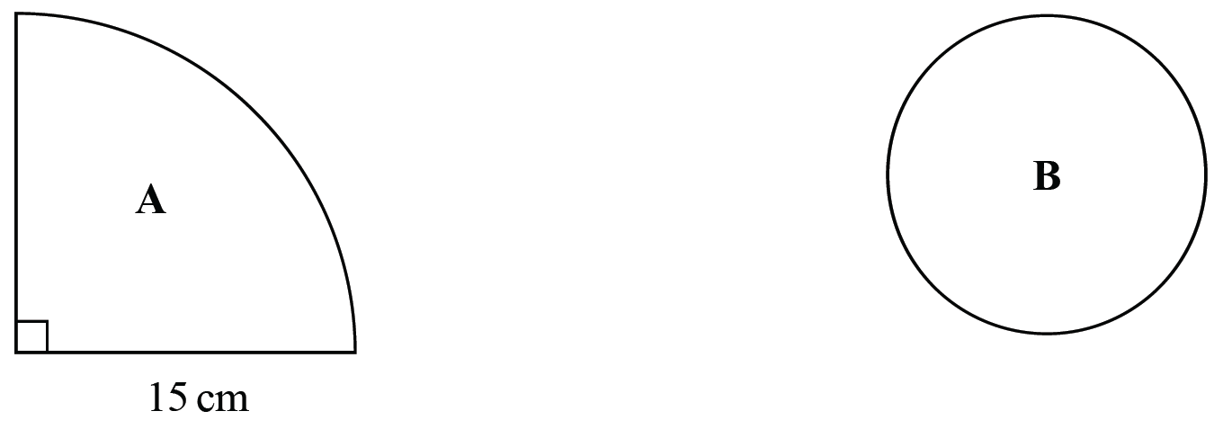

The area of **A** is 9 times the area of **B**.

Show that the radius of **B** is 2.5 cm.

**(Total for Question 3 is 3 marks)**

**4** Hasmeet walks once round a circle with diameter 80 metres.



There are 8 points equally spaced on the circumference of the circle.

(*a*)Find the distance Hasmeet walks between one point and the next point.

......................................................m

**(2)**

Four of the points are moved, as shown in the diagram below.



Hasmeet walks once round the circle again.

(*b*)Has the mean distance that Hasmeet walks between one point and the next point changed?

You must give a reason for your answer.

...................................................................................................................................................... ......................................................................................................................................................

**(1)**

**(Total for Question 4 is 3 marks)**

**___________________________________________________________________________**

**5** The diagram shows a logo made from three circles.



Each circle has centre *O*.

Daisy says that exactly  of the logo is shaded.

Is Daisy correct?

You must show all your working.

**(Total for Question 5 is 4 marks)**

**6** A garden is in the shape of a rectangle, *ABCD*, and a semicircle.

*AD* is the diameter of the semicircle.

**

Carol is going to cover the garden with fertiliser.

A box of fertiliser costs £4.99

Carol has been told that one box of fertiliser will cover 12 m2 of garden.

(a)Work out the cost of buying enough fertiliser to cover the garden completely.

£ .......................................................

**(5)**

Carol finds out that one box of fertiliser will cover more than 12 m2 of garden.

(b)Explain how this might affect the number of boxes she needs to buy.

......................................................................................................................................................

......................................................................................................................................................

**(1)**

**(Total for Question 6 is 6 marks)**

**___________________________________________________________________________**

**7** The diagram shows a shape made from a trapezium *ABCD* and a semicircle with diameter *DC*.



*DC* = 8 cm.

The shape has area 64 cm2

The height of the trapezium is 5 cm.

Work out the length of *AB*.

Give your answer correct to 1 decimal place.

....................................................... cm

**(Total for Question 7 is 5 marks)**

**___________________________________________________________________________**

**8** The diagram shows a cycle track.



The track has two straight sides each of length 40 m.

Each end of the track is a semicircle of radius 27 m.

The diameter of each wheel of Ian’s bike is 590 mm.

Ian is going to ride his bike around the track once.

Calculate how many complete revolutions each wheel of his bike will make.

.......................................................

**(Total for Question 8 is 5 marks)**

**___________________________________________________________________________**

**9** The diagram shows a square *ABCD* of side 8 cm inside a circle, centre *O*.

The vertices of the square lie on the circle.



Work out the total area of the four shaded segments.

Give your answer correct to 3 significant figures.

.......................................................cm2

**(Total for Question 9 is 5 marks)**

**___________________________________________________________________________**

**10** Here is a diagram showing a rectangle, *ABCD*, and a circle.

**

*BC* is a diameter of the circle.

Calculate the percentage of the area of the rectangle that is shaded.

Give your answer correct to 1 decimal place.

......................................................%

**(Total for Question 10 is 4 marks)**

**___________________________________________________________________________**

**11**



The arc *ABC* is a quarter of a circle with centre *O* and radius 4.8 cm.

*AC* is a chord of the circle.

Work out the area of the shaded segment.

Give your answer correct to 3 significant figures.

.......................................................cm2

**(Total for Question 11 is 3 marks)**

**TOTAL MARKS FOR PAPER: 48**