**Translating graphs**

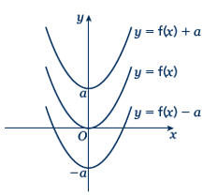Key points

* The transformation *y* = f(*x*) ± *a* is a translation of *y* = f(*x*) parallel to the *y*-axis; it is a vertical translation.

As shown on the graph,

* + *y* = f(*x*) + *a* translates *y* = f(*x*) up
  + *y* = f(*x*) – *a* translates *y* = f(*x*) down.
* 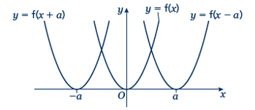The transformation *y =* f(*x ± a*) is a translation of *y* = f(*x*) parallel to the *x*-axis; it is a horizontal translation.

As shown on the graph,

* + *y* = f(*x* + *a*) translates *y* = f(*x*) to the left
  + *y* = f(*x* – *a*) translates *y* = f(*x*) to the right.

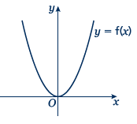Examples

**Example 1** The graph shows the function *y* = f(*x*).

Sketch the graph of *y* = f(*x*) + 2.

|  |  |
| --- | --- |
|  | For the function *y* = f(*x*) + 2 translate the function *y* = f(*x*) 2 units up. |

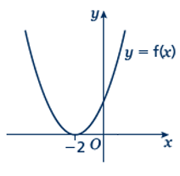**Example 2** The graph shows the function *y* = f(*x*).

Sketch the graph of *y* = f(*x* − 3).

|  |  |
| --- | --- |
|  | For the function *y* = f(*x* − 3) translate the function *y* = f(*x*) 3 units right. |

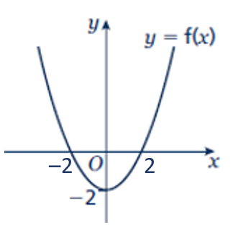Practice

**1** The graph shows the function *y* = f(*x*).   
Copy the graph and on the same axes sketch and label the graphs of *y* = f(*x*) + 4 and *y* = f(*x* + 2).

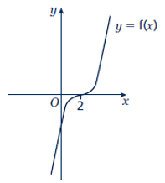

**2** The graph shows the function *y* = f(*x*).  
Copy the graph and on the same axes sketch and label the graphs of *y* = f(*x* + 3) and *y* = f(*x*) – 3.

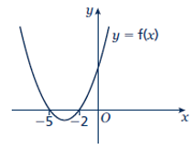

**3** The graph shows the function *y* = f(*x*).  
Copy the graph and on the same axes sketch the graph of *y* = f(*x* – 5).

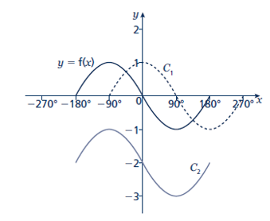**4** The graph shows the function *y* = f(*x*) and two transformations of *y* = f(*x*), labelled *C*1 and *C*2.  
Write down the equations of the translated curves *C*1 and *C*2 in function form.

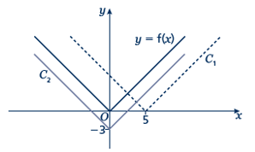

**5** The graph shows the function *y* = f(*x*) and two transformations of *y* = f(*x*), labelled *C*1 and *C*2.  
Write down the equations of the translated curves *C*1 and *C*2 in function form.

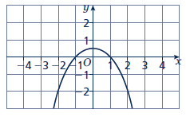

**6** The graph shows the function *y* = f(*x*).

**a** Sketch the graph of *y* = f(*x*) + 2

**b** Sketch the graph of *y* = f(*x* + 2)

**Stretching graphs**

**A LEVEL LINKS**

**Scheme of work:** 1f. Transformations – transforming graphs – f(*x*) notation

**Textbook:**Pure Year 1, 4.6 Stretching graphs

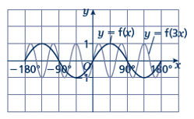Key points

* The transformation *y* = f(*ax*) is a horizontal stretch of *y* = f(*x*) with scale factor  parallel to the *x*-axis.

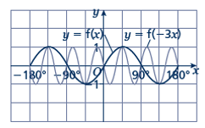

* The transformation *y* = f(–*ax*) is a horizontal stretch of *y* = f(*x*) with scale factor  parallel to the *x*-axis and then a reflection in the *y*-axis.

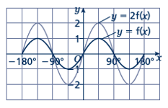

* The transformation *y* = *a*f(*x*) is a vertical stretch of *y* = f(*x*) with scale factor *a* parallel to the *y*-axis.

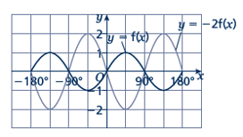

* The transformation *y* = –*a*f(*x*) is a vertical stretch of *y* = f(*x*) with scale factor *a* parallel to the *y*-axis and then a reflection in the *x*-axis.

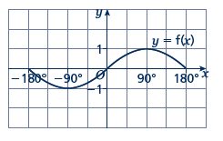Examples

**Example 3** The graph shows the function *y* = f(*x*).

Sketch and label the graphs of   
 *y* = 2f(*x*) and *y* = –f(*x*).

|  |  |
| --- | --- |
|  | The function *y* = 2f(*x*) is a vertical stretch of *y* = f(*x*) with scale factor 2 parallel to the *y*-axis.  The function *y* = −f(*x*) is a reflection of *y* = f(*x*) in the  *x*-axis. |

**Example 4** The graph shows the function *y* = f(*x*).

Sketch and label the graphs of   
 *y* = f(2*x*) and *y* = f(–*x*).

|  |  |
| --- | --- |
|  | The function *y* = f(2*x*) is a horizontal stretch of *y* = f(*x*) with scale factor  parallel to the *x*-axis.  The function *y* = f(−*x*) is a reflection of *y* = f(*x*) in the *y*-axis. |

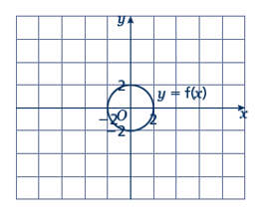Practice

**7** The graph shows the function *y* = f(*x*).

**a** Copy the graph and on the same axes sketch and label the graph of *y* = 3f(*x*).

**b** Make another copy of the graph and on the same axes sketch and label the graph of *y* = f(2*x*).

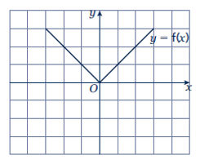

**8** The graph shows the function *y* = f(*x*).  
Copy the graph and on the same axes   
sketch and label the graphs of  
*y* = –2f(*x*) and *y* = f(3*x*).

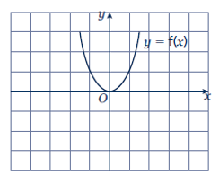

**9** The graph shows the function *y* = f(*x*).   
Copy the graph and, on the same axes,   
sketch and label the graphs of   
*y* = –f(*x*) and *y* =.

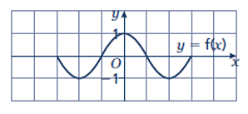**10** The graph shows the function *y* = f(*x*).  
Copy the graph and, on the same axes,   
sketch the graph of *y* = –f(2*x*).

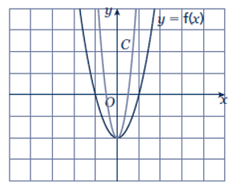

**11** The graph shows the function *y* = f(*x*) and a transformation, labelled *C*.  
Write down the equation of the translated curve *C* in function form.

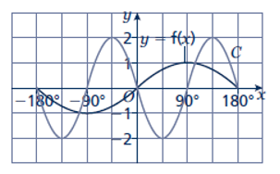**12** The graph shows the function *y* = f(*x*) and a transformation labelled *C*.  
Write down the equation of the translated curve *C* in function form.

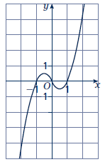

**13** The graph shows the function *y* = f(*x*).

**a** Sketch the graph of *y* = −f(*x*).

**b** Sketch the graph of *y* = 2f(*x*).

Extend

**14 a** Sketch and label the graph of *y* = f(*x*), where f(*x*) = (*x* – 1)(*x* + 1).

**b** On the same axes, sketch and label the graphs of *y* = f(*x*) – 2 and *y* = f(*x* + 2).

**15** **a** Sketch and label the graph of *y* = f(*x*), where f(*x*) = –(*x* + 1)(*x* – 2).

**b** On the same axes, sketch and label the graph of *y* = .

Answers

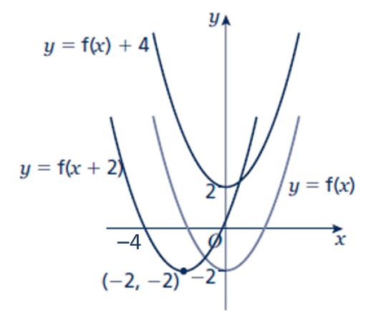**1****2**

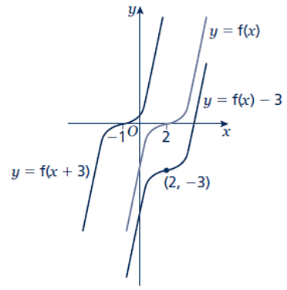

**3**

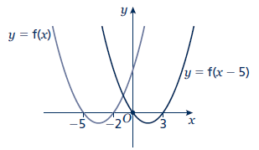

**4** *C*1: *y* = f(*x* – 90°)  
 *C*2: *y* = f(*x*) – 2

**5** *C*1: *y* = f(*x* – 5)  
 *C*2: *y* = f(*x*) – 3

**6 a b**

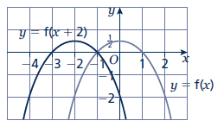 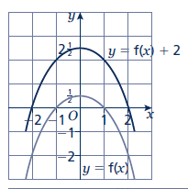

**7 a b**

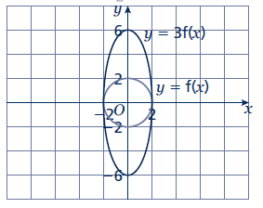 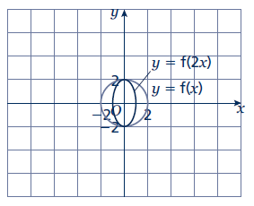

**8 9**

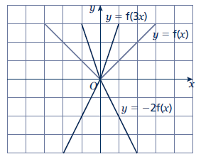 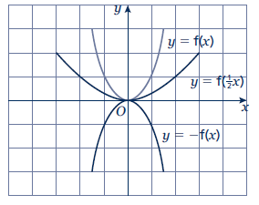

**10**

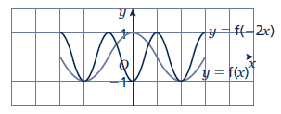

**11** *y* = f(2*x*)

**12** *y* = –2f(2*x*) or *y* = 2f(–2*x*)

**13 a b**

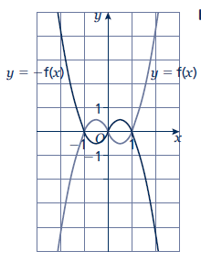 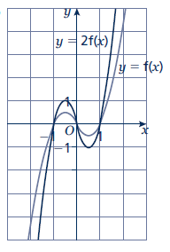

**14**

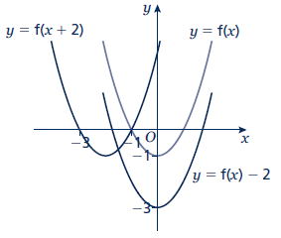

**15**

