**Foundation Tier**

**Area and perimeter**

**Instructions**

* Use **black** ink or ball-point pen.
  + **Fill in the boxes** at the top of this page with your name,  
    centre number and candidate number.
* Answer **all** questions.
* Answer the questions in the spaces provided  
  *– there may be more space than you need.*
* You must **show all your working.**
* Diagrams are **NOT** accurately drawn, unless otherwise indicated.
* If your calculator does not have a *π* button, take the value of *π* to be3.142

unless the question instructs otherwise.

**Information**

* The total mark for this paper is **53**. There are **14** questions.
* Questions have been arranged in an ascending order of mean difficulty, as found by all students in the June 2017–November 2019 examinations.
* The marks for **each** question are shown in brackets  
  *– use this as a guide as to how much time to spend on each question.*

**Advice**

* Read each question carefully before you start to answer it.
* Keep an eye on the time.
* Try to answer every question.
* Check your answers if you have time at the end.

**1** The length of a rectangle is twice as long as the width of the rectangle.

The area of the rectangle is 32 cm2.

Draw the rectangle on the centimetre grid.



**(Total for Question 1 is 2 marks)**

**___________________________________________________________________________**

**2** Here is a rectangle.

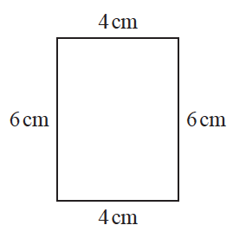

The 6-sided shape below is made from two of these rectangles.

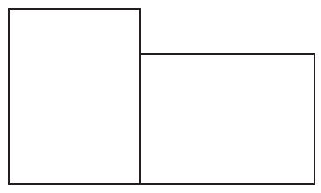

Work out the perimeter of this 6-sided shape.

....................................................... cm

**(Total for Question 2 is 3 marks)**

**___________________________________________________________________________**

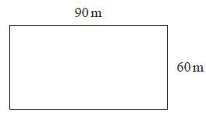**3** A garden is in the shape of a rectangle 90 m by 60 m.

Flowers are grown in 40% of the garden.

The rest of the garden is grass.

Work out the area of the garden that is grass.

.......................................................m2

**(Total for Question 3 is 4 marks)**

**___________________________________________________________________________**

**4** A square has an area of 81 cm2



(*a*)Find the perimeter of the square.

.......................................................cm

**(2)**

The diagram shows a right-angled triangle and a parallelogram.



The area of the parallelogram is 5 times the area of the triangle.

The perpendicular height of the parallelogram is *h* cm.

(*b*)Find the value of *h*.

*h* = .......................................................

**(3)**

**(Total for Question 4 is 5 marks)**

**___________________________________________________________________________**

**5** Here are a triangle and a rectangle.



The area of the rectangle is 6 times the area of the triangle.

Work out the width of the rectangle.

...................................................... cm

**(Total for Question 5 is 4 marks)**

**___________________________________________________________________________**

**6** The diagram shows two shapes drawn on a centimetre grid.



(*a*)Find the area of shape **P**.

......................................................

**(2)**

(*b*)Write down the mathematical name of quadrilateral **Q**.

......................................................

**(1)**

**(Total for Question 6 is 3 marks)**

**___________________________________________________________________________**

**7** The diagram shows a rectangular garden path.

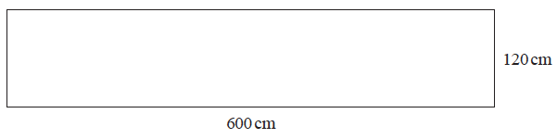

Wasim is going to cover the path with paving stones.

Each paving stone is a square of side 30 cm.

Each paving stone costs £2.50

Wasim has £220 to spend on paving stones.

Show that he has enough money to buy all the paving stones he needs.

**(Total for Question 7 is 4 marks)**

**___________________________________________________________________________**

**8** Here are two rectangles.

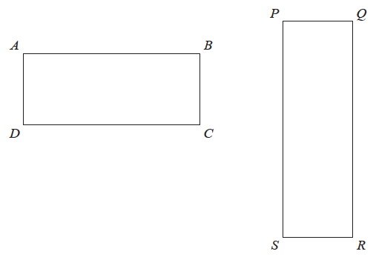

*QR* = 10 cm

*BC* = *PQ*

The perimeter of *ABCD* is 26 cm

The area of *PQRS* is 45 cm2

Find the length of *AB*.

....................................................... cm

**(Total for Question 8 is 4 marks)**

**___________________________________________________________________________**

**9** The diagram shows a floor in the shape of a trapezium.



John is going to paint the floor.

Each 5 litre tin of paint costs £16.99

1 litre of paint covers an area of 2m2

John has £160 to spend on paint.

Has John got enough money to buy all the paint he needs?

You must show how you get your answer.

**(Total for Question 9 is 5 marks)**

**___________________________________________________________________________**

**10** Here is a trapezium drawn on a centimetre grid.



On the grid, draw a triangle equal in area to this trapezium.

(**Total for Question 10 is 2 marks**)

**___________________________________________________________________________**

**11** *ABC* is an isosceles right-angled triangle.

**

The area of the triangle is 162 cm2

Work out the value of *x*.

*x* = .......................................................

(**Total for Question 11 is 3 marks**)

**___________________________________________________________________________**

**12** Here is a rectangle.

**

All measurements are in centimetres.

The area of the rectangle is 48 cm2.

Show that *y* = 3

**(Total for Question 12 is 4 marks)**

**___________________________________________________________________________**

**13** Jeremy has to cover 3 tanks completely with paint.

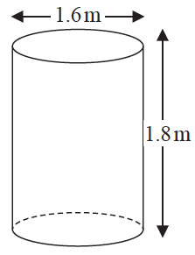Each tank is in the shape of a cylinder with a top and a bottom.

The tank has a diameter of 1.6 m and a height of 1.8 m.

Jeremy has 7 tins of paint.

Each tin of paint covers 5 m2

Has Jeremy got enough paint to cover completely the 3 tanks?

You must show how you get your answer.

**(Total for Question 13 is 5 marks)**

**___________________________________________________________________________**

**14** Here is a rectangle.



The length of the rectangle is 7 cm longer than the width of the rectangle.

4 of these rectangles are used to make this 8-sided shape.



The perimeter of the 8-sided shape is 70 cm.

Work out the area of the 8-sided shape.

...................................................... cm2

**(Total for Question 14 is 5 marks)**

**___________________________________________________________________________**

**TOTAL MARKS FOR PAPER: 53**