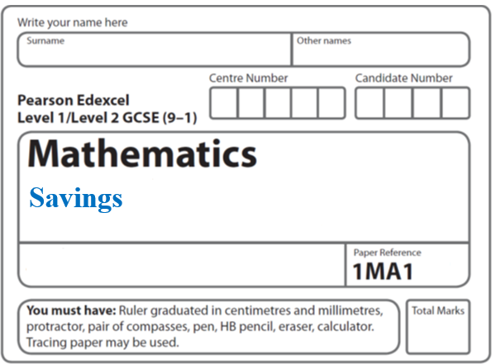**Instructions**

**Percentages – Increase Decrease**

* Use **black** ink or ball-point pen.
  + **Fill in the boxes** at the top of this page with your name,  
    centre number and candidate number.
* Answer **all** questions.
* Answer the questions in the spaces provided  
  *– there may be more space than you need.*
* You must **show all your working.**
* Diagrams are **NOT** accurately drawn, unless otherwise indicated.
* If your calculator does not have a *π* button, take the value of *π* to be3.142

unless the question instructs otherwise.

**Information**

* The total mark for this paper is **34**. There are **10** questions.
* Questions have been arranged in an ascending order of mean difficulty, as found by all students in the June 2017–November 2019 examinations.
* The marks for **each** question are shown in brackets  
  *– use this as a guide as to how much time to spend on each question.*

**Advice**

* Read each question carefully before you start to answer it.
* Keep an eye on the time.
* Try to answer every question.
* Check your answers if you have time at the end.

**1** A force of 70 newtons acts on an area of 20 cm2

The force is increased by 10 newtons.

The area is increased by 10 cm2

Helen says,

“The pressure decreases by less than 20%”

Is Helen correct?

You must show how you get your answer.

(**Total for Question 1 is 3 marks**)

**___________________________________________________________________________**

**2** *T* = 

*w* = 5.6 × 10–5

*d* = 1.4 × 10–4

(*a*)Work out the value of *T*.

Give your answer in standard form correct to 3 significant figures.

*T* = .......................................................

(**2**)

*w* is increased by 10%

*d* is increased by 5%

Lottie says,

“The value of *T* will increase because both *w* and *d* are increased.”

(*b*)Lottie is wrong.

Explain why.

......................................................................................................................................................

......................................................................................................................................................

(**2**)

(**Total for Question 2 is 4 marks**)

**___________________________________________________________________________**

**3** Last year Jo paid £245 for her car insurance.

This year she has to pay £883 for her car insurance.

Work out the percentage increase in the cost of her car insurance.

.......................................................%

**(Total for Question 3 is 3 marks)**

**___________________________________________________________________________**

**4** The price of all rail tickets increased by 5 %.

The price of a rail ticket from London to Ipswich increased by £2.30

Work out the price of the ticket before the increase.

£ .......................................................

**(Total for Question 4 is 2 marks)**

**___________________________________________________________________________**

**5** Becky buys a new car for £25 000

The value of this car will depreciate

by 20% at the end of the first year

and then by 12% at the end of every year after the first year.

Work out the value of the car at the end of 3 years.

£.......................................................

**(Total for Question 5 is 3 marks)**

**___________________________________________________________________________**

**6** In 2016 the population of the UK was 6.5 × 107

Laura wants to calculate an estimate for the population of the UK in 2020.

She assumes that the population increases by 0.6% each year.

(*a*) Using Laura’s assumption, calculate an estimate for the population of the UK in 2020.

.......................................................

**(2)**

Kieran also assumes that the population of the UK increases by 0.6% each year.

He says that it will take over 80 years for the population to increase by 50% because 

Kieran’s method is wrong.

(*b*) Explain what is wrong with his method.

......................................................................................................................................................

......................................................................................................................................................

**(1)**

Assuming that the population of the UK increases by 0.6% each year,

(*c*)show that the population of the UK each year forms a geometric progression.

**(2)**

**(Total for Question 6 is 5 marks)**

**___________________________________________________________________________**

**7** Jack and Sadia work for a company that sells boxes of breakfast cereal.

The company wants to have a special offer.

Here is Jack’s idea for the special offer.

|  |
| --- |
| Put 25% more cereal into each box and do **not** change the price. |

Here is Sadia’s idea.

|  |
| --- |
| Reduce the price and do **not** change the amount of cereal in each box. |

Sadia wants her idea to give the same value for money as Jack’s idea.

By what percentage does she need to reduce the price?

...................................................... %

**(Total for Question 7 is 3 marks)**

**___________________________________________________________________________**

**8** In a sale, the price of a jacket is reduced.

The jacket has a normal price of £52

The jacket has a sale price of £41.60

Work out the percentage reduction in the price of the jacket.

......................................... %

**(Total for Question 8 is 3 marks)**

**___________________________________________________________________________**

**9** In a sale, the price of a TV is reduced by 25%.

A week later, the sale price of the TV is reduced by 15%.

The price of the TV is now £293.25.

What was the price of the TV before the sale?

£ .......................................................

**(Total for Question 9 is 3 marks)**

**___________________________________________________________________________**

**10** Natasha pays £13 995 for a car.

Lauren pays £14 495 for a car.

Assume that

the rate of depreciation for Natasha’s car is 12% per annum

and the rate of depreciation for Lauren’s car is 13% per annum.

(a) Work out whose car will have the greater value at the end of 3 years?

You must show all your working.

**(4)**

The rate of depreciation assumed for Natasha’s car was too low.

(b) How does this affect the value of her car at the end of 3 years?

......................................................................................................................................................

......................................................................................................................................................

**(1)**

**(Total for Question 10 is 5 marks)**

**TOTAL MARKS FOR PAPER: 34**