**Height, Length and Weight**

**Instructions**

* Use **black** ink or ball-point pen.
  + **Fill in the boxes** at the top of this page with your name,  
    centre number and candidate number.
* Answer **all** questions.
* Answer the questions in the spaces provided  
  *– there may be more space than you need.*
* You must **show all your working.**
* Diagrams are **NOT** accurately drawn, unless otherwise indicated.
* If your calculator does not have a *π* button, take the value of *π* to be3.142

unless the question instructs otherwise.

**Information**

* The total mark for this paper is **58**. There are **20** questions.
* Questions have been arranged in an ascending order of mean difficulty, as found by all students in the June 2017–November 2019 examinations.
* The marks for **each** question are shown in brackets  
  *– use this as a guide as to how much time to spend on each question.*

**Advice**

1. Read each question carefully before you start to answer it.
2. Keep an eye on the time.
3. Try to answer every question.
4. Check your answers if you have time at the end.

**1** The table shows the lengths of five rivers.

|  |  |
| --- | --- |
| **River** | **Length (km**) |
| Trent | 297 |
| Don | 112 |
| Severn | 354 |
| Thames | 346 |
| Mersey | 113 |

(*a*)Write down the rivers in order of length.

Start with the shortest river.

......................................................................................................................................................

......................................................................................................................................................

**(1)**

Ami says,

“The River Thames is more than three times as long as the River Don.”

(*b*)Show that Ami is correct.

......................................................................................................................................................

......................................................................................................................................................

**(1)**

**(Total for Question 1 is 2 marks)**

**___________________________________________________________________________**

**2** A piece of wire is 240 cm long.

Peter cuts two 45 cm lengths off the wire.

He then cuts the rest of the wire into as many 40 cm lengths as possible.

Work out how many 40 cm lengths of wire Peter cuts.

.......................................................

(**Total for Question 2 is 3 marks**)

**___________________________________________________________________________**

**3** Write down the ratio of 450 grams to 15 grams.

Give your answer in its simplest form.

.......................................................

**(Total for Question 3 is 2 marks)**

**___________________________________________________________________________**

**4** Prasha has five blocks of wood.

The total weight of all five blocks of wood is 3 kilograms.

4 of the blocks of wood each have a weight of 650 grams.

Work out the weight, in grams, of the other block of wood.

**(Total for Question 4 is 3 marks)**

**___________________________________________________________________________**



**5** Work out 15% of 160 grams.

....................................................... grams

**(Total for Question 5 is 1 mark)**

**6** Shaun is 1.88 m tall.

David is 6 cm taller than Shaun.

How tall is David?

.......................................................

**(Total for Question 6 is 2 marks)**

**___________________________________________________________________________**

**7** The diagram shows nine identical squares inside a rectangle.

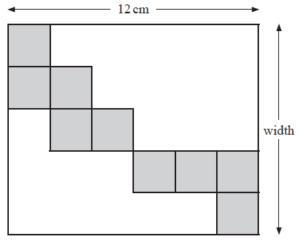

The length of the rectangle is 12 cm.

Work out the width of the rectangle.

.......................................................cm

**(Total for Question 7 is 3 marks)**

**___________________________________________________________________________**

**8** You can use this graph to change between inches and centimetres.



(*a*)Change 74 cm to inches.

...................................................... inches

**(1)**

Daniel’s height is 6 feet 3 inches.

1 foot = 12 inches

(*b*)What is Daniel’s height in centimetres?

...................................................... centimetres

**(3)**

**(Total for Question 8 is 4 marks)**

**___________________________________________________________________________**

**9** You can use this graph to change between stones and kilograms.

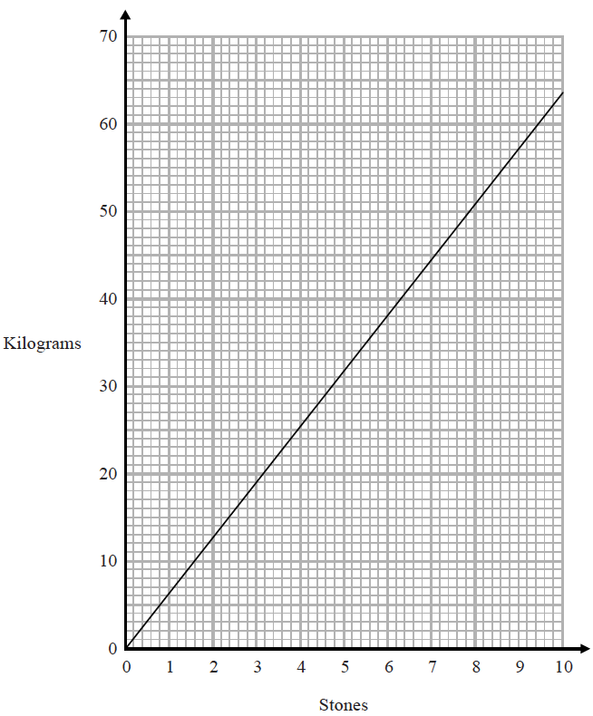

(*a*)Change 3 stones to kilograms.

....................................................... kilograms

**(1)**

(*b*)Change 80 kilograms to stones.

....................................................... stones

**(2)**

**(Total for Question 9 is 3 marks)**

**___________________________________________________________________________**

**10** *ABC* is a straight line.

**

The length *AB* is five times the length *BC*.

*AC* = 90 cm.

Work out the length *AB*.

.......................................................cm

**(Total for Question 10 is 3 marks)**

**___________________________________________________________________________**

**11** Here are five straight rods.

**

All measurements are in centimetres.

The total length of the five rods is *L* cm.

Find a formula for *L* in terms of *a*.

Write your formula as simply as possible.

.......................................................

**(Total for Question 11 is 3 marks)**

**___________________________________________________________________________**

**12** 3 jars of paprika and 4 packets of sage have a total weight of 290 grams.

7 jars of paprika have a total weight of 210 grams.

Work out the total weight of 2 jars of paprika and 2 packets of sage.

......................................... g

**(Total for Question 12 is 4 marks)**

**___________________________________________________________________________**

**13** The length of a plane is 19.2 metres.

Lukas buys a scale model of the plane.

The scale of the model is 1 : 24

Work out the length of the scale model of the plane.

Give your answer in centimetres.

....................................................... centimetres

**(Total for Question 13 is 3 marks)**

**___________________________________________________________________________**

**14** This rectangular frame is made from 5 straight pieces of metal.



The weight of the metal is 1.5 kg per metre.

Work out the total weight of the metal in the frame.

...................................................... kg

**(Total for Question 14 is 5 marks)**

**___________________________________________________________________________**

**15** The length of a pencil is 128 mm correct to the nearest millimetre.

Complete the error interval for the length of the pencil.

......................... mm ⩽ length < ......................... mm

**(Total for Question 15 is 2 marks)**

**___________________________________________________________________________**



**16** 4 red bricks have a mean weight of 5 kg.

5 blue bricks have a mean weight of 9 kg.

1 green brick has a weight of 6 kg.

Donna says,

“The mean weight of the 10 bricks is less than 7 kg.”

Is Donna correct?

You must show how you get your answer.

**(Total for Question 16 is 3 marks)**

**17** A metal box has a weight of 8 × 103 grams.

Find, in standard form, the weight of 10 of these metal boxes.

.........................................

**(Total for Question 17 is 1 mark)**

**___________________________________________________________________________**

**18** A road map has a scale of 1 : 50 000

The length of a road on the map is 8.5 cm.

Work out the length of the real road in kilometres.

....................................................... km

**(Total for Question 18 is 3 marks)**

**___________________________________________________________________________**

**19** The stem and leaf diagram shows information about the heights, in cm, of the boys in a class.



(a) Find the median height.

......................................... cm

**(1)**

The girls in the class have a median height of 162 cm.

Their heights have a range of 45 cm.

(b)Compare the distribution of the heights of the boys with the distribution of the

heights of the girls.

......................................................................................................................................................

......................................................................................................................................................

......................................................................................................................................................

......................................................................................................................................................

**(2)**

**(Total for Question 19 is 3 marks)**

**___________________________________________________________________________**

**20** The table shows information about the heights of 60 trees.

|  |  |
| --- | --- |
| **Height (*h* metres)** | **Frequency** |
| 0 < *h* ≤ 4 | 13 |
| 4 < *h* ≤ 8 | 24 |
| 8 < *h* ≤ 12 | 15 |
| 12 < *h* ≤ 16 | 6 |
| 16 < *h* ≤ 20 | 2 |

Jacob drew this frequency polygon for the information in the table.

The frequency polygon is **not** correct.



Write down **two** things that are wrong with the frequency polygon.

1....................................................................................................................................................

2....................................................................................................................................................

**(Total for Question 20 is 2 marks)**

**___________________________________________________________________________**

**TOTAL MARKS FOR PAPER: 58**