# Bar model worksheet

Draw bar models to help you solve these problems:

1. Anna and Bill share £48 in the ratio 3 : 5.   
   How much do they each receive?
2. Chris, Danni and Elsa share 36 biscuits in the ratio 2 : 3 : 4.   
   How many do they each get?
3. 40% of the ice-creams sold by an ice-cream van are vanilla flavour.   
   Half of the remaining ice creams sold are chocolate.   
   What percentage are chocolate?
4. A farmer has 35 cows.   
   of them are brown, and the rest are white.   
   How many of them are white?
5. At a pantomime 60% of the audience are children.   
   of the remaining audience are men. The rest of the audience are women.   
   There are 45 women in the audience.   
   How many people are at the pantomime?
6. Paul has 254 friends on Facebook. Alan has 189 friends.   
   How many more friends on Facebook does Paul have than Alan?
7. Greg has £10. Hitesh has £4.50 less.   
   How much does Hitesh have?
8. Megan and Tom share some money in the ratio 3 : 5.   
   Megan gets £30 less than Tom.   
   How much do they share between them?
9. Liam, Sarah and Emily shared some money in the ratio 2 : 3 : 7.   
   Emily got £80 more than Liam.   
   How much money did Sarah get?
10. **Challenge question:** Flu is passed around an accounts department.   
    The clerk has  times the days off sick that the accountant has.   
    The accountant has of the time off sick that the book-keeper has.   
    In total they take 10 sick days. How many sick days do they each take?
11. **Challenge question:** 8 boys and 12 girls go to swimming lessons.  
    In one lesson, the mean number of lengths swum by the boys is 4.5, and the mean number of lengths swum by the girls is 2.   
    Work out the mean number of lengths swum by all the children in that lesson.

Hint: Draw a bar model to represent all the swimmers.

When 12 girls swim a mean of 2 lengths each, how many lengths is that altogether?

# Bar model worksheet answers

**1**

£48

£6



48 ÷ 8 = 6

Anna 3 × £6 = £18

Bill 5 × £6 = £30

**2**



36

4

36 ÷ 9 = 4

Chris 2 × 4 = 8 biscuits

Danni 3 × 4 = 12 biscuits

Elsa 4 × 4 = 16 biscuits

**3**

10%



Chocolate 3 × 10% = 30%

**4**



35

5

35 ÷ 7 = 5

5 × 5 = 25

There are 25 white cows.

**5**



45

women

men

children

45 ÷ 3 = 15

15 × 10 = 150

There are a 150 people at the pantomime.

**6**



254

189

?

254 – 186 = 65

Paul has 65 more friends than Alan.

**7**

?

£10

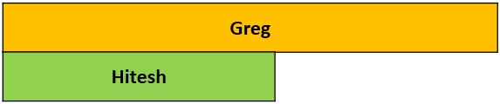

£4.50

£10 – £4.50 = £5.50

Hitesh has £5.50.

**8**

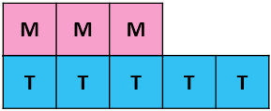

£30

£30 ÷ 2 = £15

£15 × 8 = £120

They share a total of £120 between them.

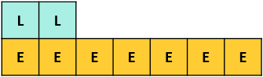

£80

£16

**9**



£16

£48

3 × £16 = £48 Sarah got £48.

**10** A = B, so B = A or 1A



10 days

1

1

2



1 + 2 + 1 = 5

10 ÷ 5 = 2

A = 2

C = 2 × 2 = 5

B = 2 × 1 = 3

Accountant 2 days, Clerk 5 days, Book-keeper 3 days



60 lengths

12 girls

24 lengths

36 lengths

8 boys

20 children

**11**

60 ÷ 20 = 3

The mean number of lengths swum by all children in that lesson is 3.