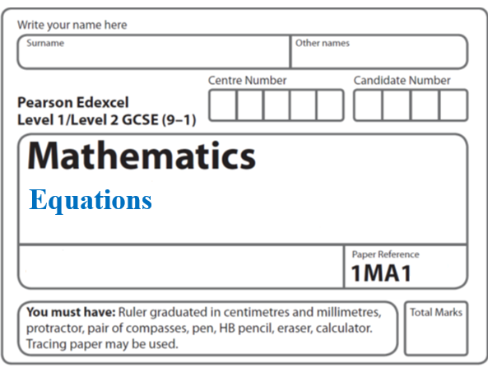**Instructions**

**Change the subject**

* Use **black** ink or ball-point pen.
  + **Fill in the boxes** at the top of this page with your name,  
    centre number and candidate number.
* Answer **all** questions.
* Answer the questions in the spaces provided  
  *– there may be more space than you need.*
* You must **show all your working.**
* Diagrams are **NOT** accurately drawn, unless otherwise indicated.
* If your calculator does not have a *π* button, take the value of *π* to be3.142

unless the question instructs otherwise.

**Information**

* The total mark for this paper is **25**. There are **9** questions.
* Questions have been arranged in an ascending order of mean difficulty, as found by all students in the June 2017–November 2019 examinations.
* The marks for **each** question are shown in brackets  
  *– use this as a guide as to how much time to spend on each question.*

**Advice**

1. Read each question carefully before you start to answer it.
2. Keep an eye on the time.
3. Try to answer every question.
4. Check your answers if you have time at the end.

**1** Make *v* the subject of the formula 

.......................................................

**(3)**

**(Total for Question 1 is 3 marks)**

**___________________________________________________________________________**

**2** Make *m* the subject of the formula *f* = 

.......................................................

**(Total for Question 2 is 3 marks)**

**___________________________________________________________________________**

**3** Make *s* the subject of *v*2 = *u*2 + 2*as*

........................................................................................

**(2)**

**(Total for Question 3 is 4 marks)**

**___________________________________________________________________________**



**4** *T* =  + 5

Here is Spencer’s method to make *q* the subject of the formula.

2 × *T* = *q* + 5

*q* = 2*T* – 5

What mistake did Spencer make in the first line of his method?

......................................................................................................................................................

......................................................................................................................................................

......................................................................................................................................................

**(Total for Question 4 is 1 mark)**

**___________________________________________________________________________**

**5** Make *k* the subject of the formula *y* = 

..................................................................................

**(Total for Question 5 is 2 marks)**

**___________________________________________________________________________**

**6** Make *t* the subject of *p* = **

.......................................................

**(Total for Question 6 is 3 marks)**

**___________________________________________________________________________**

**7** *u* =  + 2

Make *t* the subject of the formula.

.......................................................

**(3)**

**(Total for Question 7 is 7 marks)**

**___________________________________________________________________________**



**8** Make *t* the subject of the formula *k* = 

..................................................................................

**(Total for Question 8 is 4 marks)**

**___________________________________________________________________________**

**9** Make *m* the subject of



.......................................................

**(Total for Question 9 is 4 marks)**

**___________________________________________________________________________**

**TOTAL MARKS FOR PAPER: 25**