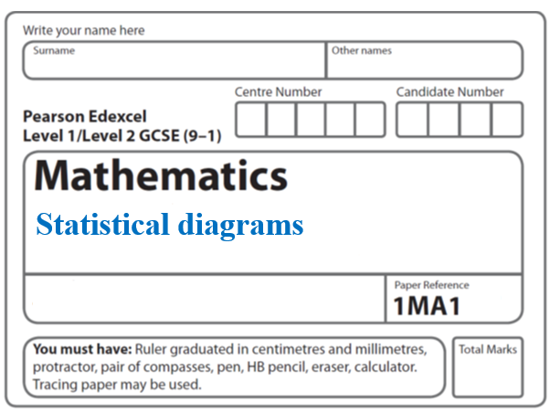**Instructions**

**Tree diagrams**

* Use **black** ink or ball-point pen.
  + **Fill in the boxes** at the top of this page with your name,  
    centre number and candidate number.
* Answer **all** questions.
* Answer the questions in the spaces provided  
  *– there may be more space than you need.*
* You must **show all your working.**
* Diagrams are **NOT** accurately drawn, unless otherwise indicated.
* If your calculator does not have a *π* button, take the value of *π* to be3.142

unless the question instructs otherwise.

**Information**

* The total mark for this paper is **33**. There are **8** questions.
* Questions have been arranged in an ascending order of mean difficulty, as found by all students in the June 2017–November 2019 examinations.
* The marks for **each** question are shown in brackets  
  *– use this as a guide as to how much time to spend on each question.*

**Advice**

* Read each question carefully before you start to answer it.
* Keep an eye on the time.
* Try to answer every question.

Check your answers if you have time at the end.

**1** Mary travels to work by train every day.

The probability that her train will be late on any day is 0.15

(*a*)Complete the probability tree diagram for Thursday and Friday.

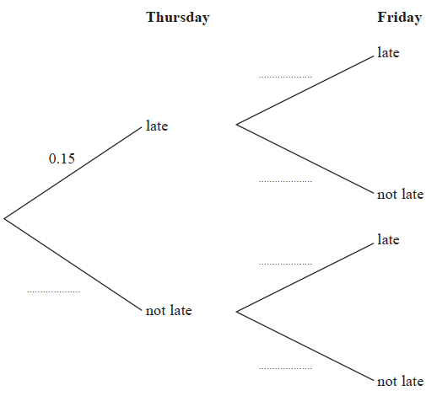

**(2)**

(*b*) Work out the probability that her train will be late on at least one of these two days.

.......................................................

**(3)**

**(Total for Question 1 is 5 marks)**

**_____________________________________________________________________**

**2** A darts team is going to play a match on Saturday and on Sunday.

The probability that the team will win on Saturday is 0.45

If they win on Saturday, the probability that they will win on Sunday is 0.67

If they do **not** win on Saturday, the probability that they will win on Sunday is 0.35

(*a*)Complete the probability tree diagram.



(**2**)

(*b*)Find the probability that the team will win exactly one of the two matches.

......................................................

(**3**)

(**Total for Question 2 is 5 marks**)

**_____________________________________________________________________**

**3** The probability tree diagram shows the probabilities that Bismah will be late for work on two days next week.

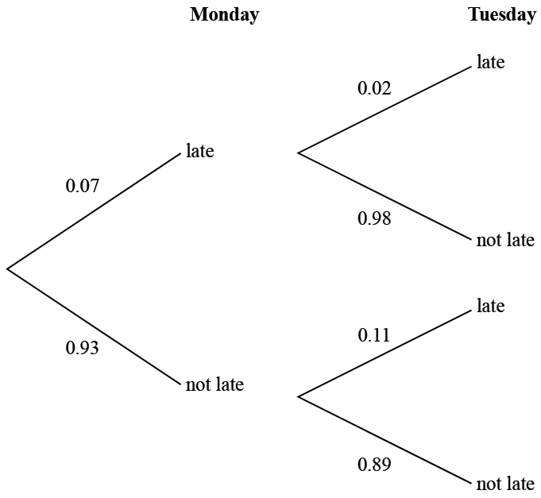

Calculate the probability that Bismah will be late on exactly one of the two days.

.......................................................

**(Total for Question 3 is 3 marks)**

**_____________________________________________________________________**

**4** Alan has two spinners, spinner **A** and spinner **B**.

Each spinner can land on only red or white.

The probability that spinner **A** will land on red is 0.25.

The probability that spinner **B** will land on red is 0.6.

The probability tree diagram shows this information.



Alan spins spinner **A** once and he spins spinner **B** once.

He does this a number of times.

The number of times **both** spinners land on red is 24.

Work out an estimate for the number of times **both** spinners land on white.

.......................................................

**(Total for Question 4 is 3 marks)**

**_____________________________________________________________________**

**5** Sameena has a round pencil case and a square pencil case.

There are 4 blue pens and 3 red pens in the round pencil case.

There are 3 blue pens and 5 red pens in the square pencil case.

Sameena takes at random one pen out of each pencil case.

(a)Complete the probability tree diagram.

 **(2)**

(b)Work out the probability that the pens Sameena takes are both red.

.......................................................

**(2)**

**(Total for Question 5 is 4 marks)**

**_____________________________________________________________________**

**6** Graham has a fair red 6-sided dice and a fair blue 8-sided dice.

The red dice can land on 1, 2, 3, 4, 5 or 6

The blue dice can land on 1, 2, 3, 4, 5, 6, 7 or 8

Graham is going to roll both dice.

(a) Complete the probability tree diagram.

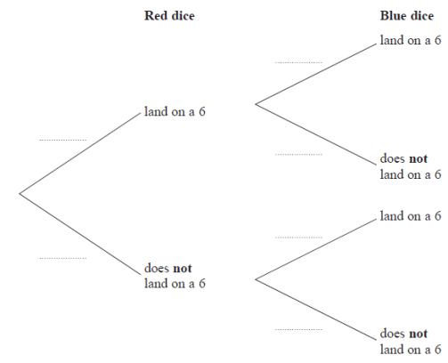

**(2)**

(b) Work out the probability that neither dice will land on a 6

.........................................

**(2)**

**(Total for Question 6 is 4 marks)**

**_____________________________________________________________________**

**7** The diagram shows a fair 4-sided spinner.



Hasmeet is going to spin the spinner twice.

(*a*) Complete the probability tree diagram.



**(2)**

(*b*) Work out the probability that the spinner will land on A on the first spin and will land on B on the second spin.

.......................................................

**(2)**

**(Total for Question 7 is 4 marks)**

**_____________________________________________________________________**

**8** When Lee goes to work, he either travels by car or by bus.

The probability that on any day Lee goes to work he travels by car is 0.2

When Lee travels to work by car, the probability that he is late is 0.35

When Lee travels to work by bus, the probability that he is late is 0.15

(a) Complete the probability tree diagram for this information.



**(2)**

(b) Work out the probability that on any day Lee goes to work he is late.

.......................................................

**(3)**

**(Total for Question 8 is 5 marks)**

**TOTAL MARKS FOR PAPER: 33**