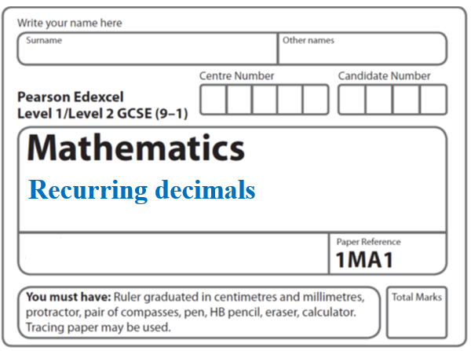**Instructions**

**3D Trigonometry**

* Use **black** ink or ball-point pen.
  + **Fill in the boxes** at the top of this page with your name,  
    centre number and candidate number.
* Answer **all** questions.
* Answer the questions in the spaces provided  
  *– there may be more space than you need.*
* You must **show all your working.**
* Diagrams are **NOT** accurately drawn, unless otherwise indicated.
* If your calculator does not have a *π* button, take the value of *π* to be3.142

unless the question instructs otherwise.

**Information**

* The total mark for this paper is **31**. There are **7** questions.
* Questions have been arranged in an ascending order of mean difficulty, as found by all students in the June 2017–November 2019 examinations.
* The marks for **each** question are shown in brackets  
  *– use this as a guide as to how much time to spend on each question.*

**Advice**

* Read each question carefully before you start to answer it.
* Keep an eye on the time.
* Try to answer every question.
* Check your answers if you have time at the end.

**1** Here is a solid square-based pyramid, *VABCD*.

**

The base of the pyramid is a square of side 6 cm.

The height of the pyramid is 4 cm.

*M* is the midpoint of *BC* and *VM* = 5 cm.

(*a*)Draw an accurate front elevation of the pyramid from the direction of the arrow.



(**2**)

(*b*)Work out the total surface area of the pyramid.

.......................................................

(**4**)

(**Total for Question 1 is 6 marks**)

**___________________________________________________________________________**

**2** *ABCDEFGH* is a cuboid.

**

*AB* = 7.3 cm

*CH* = 8.1 cm

Angle *BCA* = 48°

Find the size of the angle between *AH* and the plane *ABCD*.

Give your answer correct to 1 decimal place.

..................................................... °

(**Total for Question 2 is 4 marks**)

**___________________________________________________________________________**

**3** The diagram shows a triangular prism.

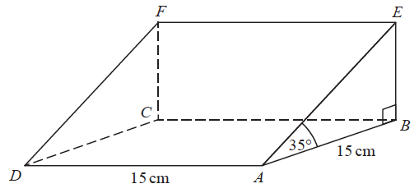

The base, *ABCD*, of the prism is a square of side length 15 cm.

Angle *ABE* and angle *CBE* are right angles.

Angle *EAB* = 35°

*M* is the point on *DA* such that

*DM* : *MA* = 2 : 3

Calculate the size of the angle between *EM* and the base of the prism.

Give your answer correct to 1 decimal place.

....................................................... °

**(Total for Question 3 is 4 marks)**

**___________________________________________________________________________**

**4** The diagram shows a metal rod, *AB*, resting inside a cylindrical tin.

**

The tin is on a horizontal table.

*AC* is a diameter of the base of the tin.

*B* is on the top edge of the tin.

*BC* is vertical.

The radius of the base of the tin is 5 cm.

The volume of the tin is 1178 cm3.

Find the angle between the rod and the base of the tin.

Give your answer correct to the nearest degree.

.......................................................°

**(Total for Question 4 is 4 marks)**

**___________________________________________________________________________**

**5** *ABCDEFGH* is a cuboid.

**

Angle *EDH* = 64°

Angle *ACD* = 28°

*EH* = 15 cm

Work out the size of angle *AHD*.

Give your answer correct to 1 decimal place.

....................................................... °

**(Total for Question 5 is 4 marks)**

**___________________________________________________________________________**

**6** Here is a pyramid with a square base *ABCD*.

**

*AB* = 5 m

The vertex *T* is 12 m vertically above the midpoint of *AC*.

Calculate the size of angle *TAC*.

.......................................................°

**(Total for Question 6 is 4 marks)**

**__________________________________________________________________________**

**7** The diagram shows a pyramid with base *ABC*.



*CD* is perpendicular to both *CA* and *CB*.

Angle *CBD* = 34° Angle *ADB* = 45° Angle *DBA* = 60°

*BC* = 20 cm.

Calculate the size of the angle between the line *AD* and the plane *ABC*.

Give your answer correct to 1 decimal place.

....................................................... °

**(Total for Question 7 is 5 marks)**

**___________________________________________________________________________**

**TOTAL MARKS FOR PAPER: 31**