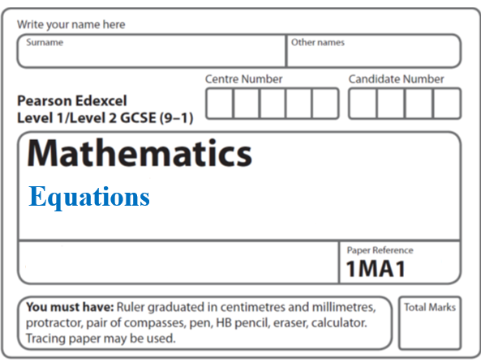**Instructions**

**Complete the square**

* Use **black** ink or ball-point pen.
  + **Fill in the boxes** at the top of this page with your name,  
    centre number and candidate number.
* Answer **all** questions.
* Answer the questions in the spaces provided  
  *– there may be more space than you need.*
* You must **show all your working.**
* Diagrams are **NOT** accurately drawn, unless otherwise indicated.
* If your calculator does not have a *π* button, take the value of *π* to be3.142

unless the question instructs otherwise.

**Information**

* The total mark for this paper is **32**. There are **9** questions.
* Questions have been arranged in an ascending order of mean difficulty, as found by all students in the June 2017–November 2019 examinations.
* The marks for **each** question are shown in brackets  
  *– use this as a guide as to how much time to spend on each question.*

**Advice**

* Read each question carefully before you start to answer it.
* Keep an eye on the time.
* Try to answer every question.
* Check your answers if you have time at the end.

**1** Given that *x*2 – 6*x* + 1 = (*x* – *a*)2 – *b* for all values of *x*,

(i) find the value of *a* and the value of *b*.

*a* = .......................................................

*b* = .......................................................

**(2)**

(ii) Hence write down the coordinates of the turning point on the graph of *y* = *x*2 – 6*x* + 1

(............................ , ............................)

**(1)**

**(Total for Question 1 is 3 marks)**

**___________________________________________________________________________**

**2** Write *x*2 + 2*x* – 8 in the form (*x* + *m*)2 + *n*

where *m* and *n* are integers.

......................................................

**(Total for Question 2 is 2 marks)**

**___________________________________________________________________________**

**3** Sketch the graph of

*y* = 2*x*2 – 8*x* – 5

showing the coordinates of the turning point and the exact coordinates of any intercepts

with the coordinate axes.

**(Total for Question 3 is 5 marks)**

**___________________________________________________________________________**

**4** By completing the square, find the coordinates of the turning point of the curve with

equation *y* = *x*2 + 10*x* + 18

You must show all your working.

(............................ , ............................)

**(Total for Question 4 is 3 marks)**

**___________________________________________________________________________**

**5** (*x* − 8)(*x* + 4) = (*x* − *a*)2 + *b* for all values of *x*.

Find the value of *a* and the value of *b*.

*a* = .......................................................

*b* = .......................................................

**(Total for Question 5 is 4 marks)**

**___________________________________________________________________________**

**6** (*a*)Write 2*x*2 + 16*x* + 35 in the form *a*(*x* + *b*)2 + *c* where *a*, *b*, and *c* are integers.

.......................................................

**(3)**

(*b*)Hence, or otherwise, write down the coordinates of the turning point of the graph

of *y* = 2*x*2 + 16*x* + 35

.......................................................

**(1)**

**(Total for Question 6 is 4 marks)**

**___________________________________________________________________________**

**7** Here is a sketch of a vertical cross section through the centre of a bowl.

**

The cross section is the shaded region between the curve and the *x*-axis.

The curve has equation *y =*  where *x* and *y* are both measured in centimetres.

Find the depth of the bowl.

......................................... cm

**(Total for Question 7 is 4 marks)**

**___________________________________________________________________________**

**8** Here is a sketch of a curve.

**

The equation of the curve is *y* = *x*2 + *ax* + *b* where *a* and *b* are integers.

The points (0, −5) and (5, 0) lie on the curve.

Find the coordinates of the turning point of the curve.

( .......................... , ..........................)

**(Total for Question 8 is 4 marks)**

**___________________________________________________________________________**

**9** A particle *P* is moving in a straight line.

*O* is a fixed point on the straight line.

The distance, *s* metres, of *P* from *O* at time *t* seconds is given by

*s* = 80*t* – 5*t*2

Use algebra to find the greatest distance of *P* from *O* when 0 ⩽ *t* ⩽ 16

.......................................................metres

**(Total for Question 9 is 4 marks)**

**___________________________________________________________________________**

**TOTAL MARKS FOR PAPER: 32**